The Big Move Exercise
  - After-Action Report/Improvement Plan
June 25, 2017
The After-Action Report/Improvement Plan (AAR/IP) aligns exercise objectives with preparedness doctrine to include the National Preparedness Goal and related frameworks and guidance. Exercise information required for preparedness reporting and trend analysis is included; users are encouraged to add additional sections as needed to support their own organizational needs.

Exercise Overview
Exercise Name | The Big Move
Exercise Dates | This exercise took place from February 22-March 1, 2017.
Scope | Evacuation considerations and implications for coastal healthcare coalitions in eastern North Carolina. The exercise will focus on the period 120 hours to 36 hours prior to landfall.
Mission Area(s) | Response
Core Capabilities | HPP Capabilities:  #3 – Emergency Operations Coordination  #6 – Information Sharing
Objectives | Objectives and the corresponding preparedness capabilities are listed below in the Analysis of Core Capabilities section.
Threat or Hazard | Hurricane
Scenario | A weather advisory is issued on September 16th that indicates the development of a tropical depression in the Caribbean. Hurricane Hans strengthens to a Major Hurricane on September 18th (120 Hours). During the track of the storm, initial land fall occurs in Haiti as a Category 4 Hurricane on September 19th, then hits lower Florida on the early morning of September 22nd as a Category 3 Hurricane. The last advisory demonstrates the land fall of Hurricane Hans as a Category 4 storm near Topsail Beach on September 23rd with wind speeds of 130 mph.  The last advisory also reports that the Hurricane will decrease in forward movement and remain a strong hurricane as it moves inland. Coastal storm surge is expected to be 15 to 20 feet above mean sea level. This projection will prompt the activation of the Coastal Region Evacuation and Sheltering Plan as well as trigger agencies to perform their pre-landfall operations for a severe hurricane threat. The impact from the storm is predicted to be widespread on Eastern North Carolina’s healthcare and critical infrastructure.
Sponsor | Eastern Healthcare Preparedness Coalition (EHPC) and Southeastern Healthcare Preparedness Region (SHPR)
Participating Organizations | Hospitals  EMS  Local and State Emergency Management  Local and State Public Health  Additional community partners and coalition members  (see Appendix B for the full list)
Point of Contact | Chris Starbuck, Eastern Healthcare Preparedness Coalition  CStarbuc@vidanthealth.com  252-847-6634  Hans Edwards, Southeastern Healthcare Preparedness Region  Hans.Edwards@NHRMC.org  910-667-4877  Will Moorhead, All Clear Emergency Management Group  WillM@AllClearEMG.com  336-802-1800

Exercise Activity Summary
The Big Move Exercise was a multi-day examination of the coordination and communication related to movement of patients in the healthcare system across the 29 counties comprising the Eastern Healthcare Preparedness Coalition and Southeastern Healthcare Preparedness Region. The exercise objectives were developed to examine and test the interaction that takes place beginning when a hurricane is forecast to make landfall within 120 hours.
The Big Move is a part of the 120 to Landfall Exercise Series. The 120 to Landfall exercise series was an escalating succession that included the Stay or Go Tabletop Exercise in September 2015 as well as the Assess and Allocate Functional Exercise in June 2016. The Big Move included discussion-based and operations-based exercise activities. The exercise was designed as a multi-day exercise to allow sufficient examination and testing of a variety of functions, plans, and processes that take place on the state, regional, local, and facility level when a hurricane is forecast to impact the coast of North Carolina.
Each day of the exercise was organized around a set of objectives that guided the design and evaluation of that day’s activities. Involvement during the exercise included in-person interaction while others utilized virtual meetings or the communications methodologies that would be employed during a real event. Participants were asked to provide feedback and input about lessons learned for each day of participation.

Summary of Exercise Outcomes
The six days of exercise activity produced numerous observations, lessons learned, and suggestions for facilities, local jurisdictions, healthcare coalitions, and state agencies involved in patient movement. Information captured during the exercise provides guidance for improving the capability and capacity necessary to manage the movement of a significant portion of the State’s healthcare population.
Of the information gleaned from the exercise, themes emerged and priority began to be assigned to certain tasks. The themes and higher priority items are summarized in this section. This information is discussed in conjunction with other lessons learned during the exercise in the “Analysis of Core Capabilities” section of this document. The information in this section is not provided in a particular order of priority.
Finalize regional hospital evacuation toolkit
The regional hospital evacuation toolkit provides planning considerations along with incident and planning tools in addition to resources to support regional healthcare facilities in the improvement of their capability as well as capacity to efficiently evacuate. Once finalized the healthcare evacuation planning and response education efforts previously undertaken by the coalitions should be continued.

State-level healthcare evacuation plan development and exercise
The necessity of a fully-integrated state-level plan for managing a large-scale healthcare evacuation was identified early in the 120 to Landfall series. This plan has been under development throughout the Big Move exercise project. The plan was tested and refined during the Big Move exercise activities.
Content of the state-level plan has included coordination of mass evacuation of healthcare patients, identification and allocation of medical transport assets to move the evacuating healthcare population, identification of healthcare beds to receive the patients, and direction of placing patients. The Big Move exercise lessons learned included numerous suggestions and details related to the content of the state-level plan. Finalizing a state-level plan and educating those operating under the plan is vital to improving the patient movement capability at all levels.
Upon completion of agency education, the coordination should be fully exercised. The Big Move demonstrated the need for operations-based exercising of incident management concepts related to evacuation of healthcare facilities. Many of the tasks and activities necessary to complete the evacuation objective are time consuming, rely on the proficiency of a large number of personnel, and depend on efficient communications among involved agencies. A detailed operations-based exercise would provide an opportunity to understand the realistic timeframe of activities within the plan, identify training needs, and improve proficiency of all partners.
Senior healthcare administration education
Senior healthcare administrators leading the facilities that may be impacted by a pending hurricane or storm are an integral part of the regional and statewide ability to effectively evacuate any portion of the healthcare population. The timeline required to identify transportation resources and available beds is only extended by the time required to physically move a patient from the coast to an inland receiving facility.
The exercise highlighted the need for healthcare leaders to examine the challenges of evacuation timelines with state, regional, and local agencies. A particular need noted was timely notification to partner agencies of a healthcare facility’s inclination toward evacuation or shelter-in-place. Communication about decisions to evacuate, whether sheltering-in-place or evacuating, should be communicated early to the Healthcare Preparedness Coordinator as well as the local emergency manager.
Additionally, it will be important for senior leaders to understand how patient management and coordination will take place during a large-scale evacuation. A state-level patient movement coordinating group will manage the identification of patients, allocation of transportation in addition to bed availability when an agency requests assistance from the state.
The communications throughout an event will involve WebEOC and SMARTT. Senior leaders will be involved in ensuring their agency’s proficiency in utilizing these systems. See comments below regarding WebEOC utilization.

WebEOC utilization and integration
WebEOC is widely utilized among hospitals and Healthcare Preparedness Coordinators (HPCs) but there is a lack of integration between the emergency management WebEOC (NC SPARTA) and the healthcare WebEOC. Additionally, there are corporate healthcare WebEOC accounts that don’t integrate with the healthcare WebEOC.
Proficiency based education and exercising should continue or be expanded to ensure that all agencies expected to utilize WebEOC can efficiently perform their expected role within the system. This education should focus on demonstration of capability of the individual user and the affiliated agency.
Currently North Carolina has multiple avenues or platforms for agencies to request support and provide situational information. The state can benefit from a single platform for agencies to communicate status and request support. Integrating the emergency management version of WebEOC with the healthcare version and corporate accounts would move the state toward a single platform for information exchange.
Despite identification of several opportunities for improvement, the exercise provided an opportunity to reiterate emergency management strengths within every level of participant from the facility level to the state level.
Specific details about areas for improvement were captured. These details provide planners with an outline for the state-level patient management process as well as improvements to the tools and resources used to capture information from evacuating and receiving facilities.
The exercise also provided several opportunities for healthcare and emergency management agencies to practice or test redundancy within their communication systems. Real-world events simultaneous with the exercise as well as personnel involvement in the exercise generated training activities that allowed players a realistic test of systems and a mechanism to enhance user knowledge.

Summary of Data Obtained During the Exercise
Prior to the exercise a request for completed Hospital Disaster Patient Transfer Forms was sent to all hospitals in the regions. The information returned by February 24 illustrates the challenges presented by a significant storm threat and provides planning assumptions for less severe storms. Of the 28 facilities surveyed, 22 responded. The surveys identified 473 evacuees from the 22 facilities. The data utilized for three facilities was the data received during the Assess and Allocate Functional Exercise.
The types of patients represented within the 473 included 40 wheel chair patients, 170 requiring Basic Life Support (BLS) transport, 115 requiring Advanced Life Support (ALS) transport, and 103 requiring Critical Care transport. This information provided a framework for evacuation planning and an understanding of the complexity of allocating bed and transport resources.
The North Carolina Office of Emergency Medical Services (NC OEMS) state and regional personnel surveyed the availability of transportation assets across the state including county EMS agencies as well as State and regional agencies that manage patient transportation assets. The summary of the survey is based on those agencies that responded within the exercise timeline. In an actual event NC OEMS would begin surveying the availability of resources as a storm approaches and as the need from coastal hospitals increases based on the ongoing analysis of the storm track. The timeline of a real-world situation would allow for an increase in the number of available agencies.
Available transportation assets identified during the time allotted during exercise play include 5 BLS, 32 ALS, and 10 critical care transport resources. Additionally, 10 BLS ambulance buses were available. The buses can transport 177 ambulatory patients, 166 patients on stretchers, or 75 patients in wheelchairs. Other resources available include 3 critical care helicopters, 3 quick response vehicles, 3 ambulance strike team SUVs, and 1 ambulance strike team trailer.
*Note, these resource totals do not include units that were in service for daily operations.
Summary of data:
28 facilities surveyed | 22 facilities responded | 473 evacuees identified

Summary of evacuees:
Wheel Chair | BLS | ALS | Critical Care
40 | 170 | 115 | 103

Summary of Transportation Assets:
BLS | ALS | Critical Care | Ambulance Busses
5 | 32 | 10 | 10

Ambulance bus capability:
Ambulatory | Stretcher | Wheelchair
177 | 166 | 75
Other resources:
Critical Care Helicopters | Quick Response Vehicles (QRV) | Ambulance Strike Team SUVs | Ambulance Strike Team trailer
3 | 3 | 3 | 1

Analysis of Core Capabilities

Day 1 – February 22, 2017

Scenario
A weather advisory is issued on September 16th that indicates the development of a tropical depression in the Caribbean. Hurricane Hans strengthens to a major hurricane on September 18th (120 Hours). During the track of the storm, initial land fall occurs in Haiti as a Category 4 Hurricane on September 19th, then hits lower Florida on the early morning of September 22nd as a Category 3 Hurricane. The last advisory demonstrates the land fall of Hurricane Hans as a Category 4 storm near Topsail Beach on September 23rd with wind speeds of 130 mph.

The last advisory also reports that the hurricane will decrease in forward movement and remain a strong hurricane as it moves inland. Coastal storm surge is expected to be 15 to 20 feet above mean sea level. This projection will prompt the activation of the Coastal Region Evacuation and Sheltering Plan as well as trigger agencies to perform their pre-landfall operations for a severe hurricane threat. The impact from the storm is predicted to be widespread on Eastern North Carolina’s healthcare and critical infrastructure.

Observations and summary of lessons learned
The state-level discussion identified numerous strengths due to well-tested current processes and procedures related to activation and the early stages of hurricane monitoring. The discussion also revealed gaps related to the integration of healthcare into the existing processes.

Agency plans include numerous forms of communication and steps to disseminate information. Some of the regional partners that may be involved in healthcare evacuation are not included in the pre-landfall communication processes.

The communication among state level agencies can be expanded. The coastal region healthcare agencies should be a specific area of focus for improved communications and dissemination of information.

Some of the authorities and resources necessary for healthcare operations prior to landfall are not clearly understood by the impacted agencies. In particular, understanding and utilizing waivers of operational requirements is an area where several outstanding questions remain.

Objective 1 - Test the actions taken after state level declarations of an emergency.
The strengths and areas for improvement for each core capability aligned to this objective are described in this section.

Core Capability - Emergency Operations Coordination

Strengths
Strength 1: The coastal hospitals will begin preparing to evacuate when it is announced they are in the track of a hurricane so as not to put their most vulnerable populations at risk.
Strength 2: North Carolina Emergency Management (NCEM) utilizes the North Carolina Coastal Region Evacuation and Sheltering Standard Operations Guide (CRES SOG) to help determine what actions they should take starting at 120 hours to landfall.
Strength 3: Plans and processes are in place at the state, regional, and local level to monitor storms and initiate communication among partner agencies.

Objective 2 – Ensure sufficient communication takes place and appropriate resources are mobilized with the declaration of emergency.

Core Capability – Emergency Operations Coordination

Strengths
Strength 1: There is a strong communication between state agencies and some local partners via phone conferences and emails to ensure that everyone is aware of who is taking what actions as the hurricane approaches.
Strength 2: The NC EM does a good job of scheduling their weather update calls to avoid conflict with other national calls that partners may be on, such as the National Weather Service briefings.
Strength 3: Once the first call happens there is a set schedule of when subsequent calls will occur that is posted to WebEOC for all state and local partners to see.

Areas for Improvement
The following areas require improvement to achieve the full capability level:
Area for Improvement 1: State-level notification checklists and processes
Analysis: The agencies that coordinate dissemination of information from the state-level to the local level efficiently follow their plans. Healthcare agencies are not involved in conference calls about the storm at 120 hours to landfall. Some agencies noted that healthcare entities are not included in activation and hurricane planning checklists.
Several agencies have communication task lists that begin at 120 hours to landfall. The Healthcare Preparedness Coordinators (HPCs) are provided information from state-level agencies. Conference calls are held at the regional level. Healthcare agencies are not formally included in many of the pre-landfall planning and coordination conference calls and notifications organized by state agencies. Inclusion of healthcare agencies increases coordination among agencies, ensures consistent information, and provides an opportunity for agencies to discuss potential impact to healthcare.

Recommendation: Review the process and invitee list for the conference call that includes state agencies and HPCs held at 120 hours to landfall. Update plans and processes to ensure healthcare agencies are included at the appropriate time or that healthcare representatives are provided specific directives to disseminate information to healthcare entities. Formalize a process for providing notification to hospitals at 120 hours to landfall about state and regional communications initiated.

Plans and processes should reflect that the notification activity would be dependent on the storm. The plans should discuss evaluating the need for formalizing storm-specific communications and establishing a schedule for regional status update conference calls.

Area for Improvement 2: Healthcare agency notification checklists and processes
Analysis: Several healthcare entities do not include in their plans a process to notify external or non-healthcare partners such as emergency management, the healthcare coalition, or local EMS agencies about pre-landfall status or considerations.

Although many notifications that are made as the storm is monitored, details about the notification are not captured in a plan. The timeline to trigger notification, the process for delivering the message, suggested wording of the message, and the party responsible to complete the notification may not be addressed in a plan. The lack of formality creates inconsistent notification or leads to information not being communicated.

Recommendation: All healthcare agencies should include in their plans a process for notifying external and non-healthcare partners. The processes should include defining the party responsible for completing the notifications. This should also include updating WebEOC facility status.

Recommendation: Consider developing a regional checklist for hospitals as a guide for pre-storm information exchange. The checklist could include topics such as utilization of WebEOC to share facility status or understand the status of other agencies, the schedule for updating SMARTT, and formalizing local preparedness activities as the storm approaches.

Objective 5 – Identify at-risk populations within the potentially impacted areas of the State.

Core Capability – Emergency Operations Coordination

Strengths
Strength 1: The state has access to a significant amount of data regarding the at-risk populations of North Carolina. Data about this population is derived from a variety of sources including durable medical equipment (DME) providers, Department of Defense (DOD) Tricare, special needs registries within counties, and the HHS emPOWER map.

Areas for Improvement
The following areas require improvement to achieve the full capability level:
Area for Improvement 1: Data set utilization
Analysis: Data sets, in particular the Centers for Medicare and Medicaid Services (CMS) data, were discussed as a resource that is not currently maximized during response planning. The CMS data provided is extensive, although few participants could describe the process to best access and utilize the data. Once access to the data is accomplished the data requires a timely process of manipulation before it is useful. Utilization of data is not consistent among agencies and not built into planning processes and standard operations. The problem is further complicated by redundancy that may need to be deconflicted. For example, some portion of the DOD Tricare data may be repeated within the CMS data.

Compiling information from raw data to functional data can be an overwhelming task due to the magnitude of available data. Planning and organization prior to an event is needed to deconflict the data sets and share information with appropriate stakeholders during an event.
Who are the responsible agencies? How do you notify people and prepare for movement? Who manages the use of the data? Data type dependent.

Recommendation: Determine key data related to at-risk populations that will be used during a variety of events. Develop a process to mine and summarize the data.
Recommendation: Educate healthcare response coordinating agencies about what information is available, how the information is accessed, who is responsible for managing and utilizing data, and when data is most useful during planning and response activities.
Recommendation: Gather stakeholders with data access to discuss deconflicting data to provide accurate and useful information during an event. Ensure that the stakeholders provide guidance about the utilization of the data and identify the agencies responsible for the data during use.
Area for Improvement 2: Education on different types of waivers
Analysis: Statewide education is needed regarding the different types of waivers available. Details of the education include who can activate them, the process for activation, instances for utilization or activation, and what is allowed once activated. This is especially important for an 1135 waiver (a waiver where the HHS secretary may, under declaration of emergency, waive or modify certain Medicare, Medicaid, Children’s Health Insurance Program (CHIP) and Health Insurance Portability and Accountability Act (HIPAA) requirements).
Waivers also become vital when EMS providers are needed to support evacuation activities. The reciprocity of EMS providers from other states is not fully understood.
Recommendation: Develop training and education about waivers. Include information about triggers for utilizing waivers, agencies and associated regulations where waivers exist, and the scope of activity allowable under the waiver.
As part of the education about waivers, ask legal staff from OEMS and NCEM to create a quick reference guide that outlines current flexibility available through waivers. The education may include checklists for waiver implementation and definitions of terminology. Educational information and resources should address common misunderstandings about what is or is not required when a waiver is utilized, address facts and myths, and include a summary of commonly asked questions.
Recommendation: Determine a location where information about utilization of waivers can be shared during an event. i.e. a document stored within WebEOC
Recommendation: Consider developing a state level plan to provide crisis policy guidance for altering normal healthcare operations and address waivers related to provision of healthcare during crisis situations.

Day 2 – February 23, 2017

Scenario
Today is September 20. A weather advisory was issued on September 16th that indicated the development of a tropical depression in the Caribbean. Hurricane Hans strengthened to a Major Hurricane on September 18th. During the track of the storm, initial land fall occurred in Haiti as a Category 4 Hurricane on September 19th. The storm is forecast to hit lower Florida on the early morning of September 22nd as a Category 3 Hurricane. The last advisory demonstrates the land fall of Hurricane Hans as a Category 4 storm near Topsail Beach on September 23rd with wind speeds of 130 mph.

The last advisory also reports that the Hurricane will decrease in forward movement and remain a strong hurricane as it moves inland. Coastal storm surge is expected to be 15 to 20 feet above mean sea level. This projection will prompt the activation of the Coastal Region Evacuation and Sheltering Plan as well as trigger agencies to perform their pre-landfall operations for a severe hurricane threat. The impact from the storm is predicted to be widespread on Eastern North Carolina’s healthcare and critical infrastructure.

Observations and summary of lessons learned
OEMS plans for evacuation management are in draft form. Several specific improvements were captured related to finalizing the plans and educating stakeholders.

Information gathering and notification is not coordinated. There are numerous conduits of information. Not everyone has access to some conduits such as NC SMARTT.

Gaps exist in the information sharing process. Notification of external, or non-healthcare, partners by healthcare entities needs to be included in the healthcare facility plans to ensure consistent notification. The utilization of WebEOC among agencies should be formalized.

Non-hospital healthcare providers should be educated about the process for requesting assistance from local, regional, or state agencies.

Objective 1 - Activate hospital command centers.
The strengths and areas for improvement for each core capability aligned to this objective are described in this section.

Core Capability - Emergency Operations Coordination

Strengths
Strength 1: Hospitals understand command center activation and have experience with the process from hurricane response.
Strength 2: Internal communications are well planned and most facilities know who to contact to get the correct information rather than making several contacts and consuming extensive amounts of time.

Areas for Improvement
The following areas require improvement to achieve the full capability level:
Area for Improvement 1: Utilization of communication systems
Analysis: Education and practice is needed for healthcare agencies who may be asked to submit updates in WebEOC or update SMARTT.

Recommendation: Continue with monthly WebEOC testing.
Recommendation: Expand WebEOC exercises so that facilities will utilize the system in a practical manner. The exercises should require participation that involves developing and reinforcing WebEOC skills and habits that will be relied upon during an emergency.
Area for Improvement 2: Coalition participation
Analysis: Not all hospitals participated in the exercise. The exercise was focused on hospital participation but a significant portion of the non-hospital coalition partners are not involved in the coalition.
Recommendation: Educate senior healthcare leaders about the function and importance of the healthcare coalition. This educational effort should include the NC Hospital Association and similar associations for non-hospital healthcare providers.
Recommendation: Provide, through the coalition, education and pre-event emergency management support to benefit the healthcare agencies not currently involved in the coalition with emergency preparedness efforts. Specific focus should be given to including the non-hospital healthcare providers operating within the coalition geographic area.
Area for Improvement 3: Vidant Health system-wide coordination
Analysis: The regional exercise drew attention to the reality that Vidant Health system can heavily influence the regional healthcare capability and capacity due to the size of the organization. This exercise highlighted that pre-landfall, all Vidant facilities would be watching the forecast and staying informed of the updates regarding the storm. There is no Vidant Health system-wide emergency manager that coordinates among the entire Vidant Health system.
When multiple healthcare facilities are simultaneously impacted, a lack of coordination within a wide-reaching healthcare system like Vidant Health exacerbates the confusion presented by the event. Prior to an event, the lack of emergency management coordination at the system level creates inconsistency among the Vidant Health facilities that are independently conducting planning activities.
A central point of emergency management coordination within the system to ensure planning coordination, minimize inconsistent information from being provided across the system, facilitate clinic and home health participation, and improve information sharing would benefit the Vidant Health system as well as the coastal region.
Recommendation: Incorporate a system emergency manager to coordinate the emergency management efforts of the health system.

Objective 2 – Examine the various triggers and considerations before hospital evacuation

Core Capability – Emergency Operations Coordination

Strengths
Strength 1: Most, if not all, hospitals have good plans in place for rapid decompression of patient census.
Strength 2: Home health keeps detailed records of their patients and maintains good data about patient status. This information is useful to regional and state evacuation coordination and planning efforts.

Areas for Improvement
The following areas require improvement to achieve the full capability level:
Area for Improvement 1: No definitive ‘trigger’ for evacuation or shelter in place
Analysis: Due to the varying nature of hurricanes, there is no definitive trigger for deciding to evacuate or shelter in place. The decision is heavily impacted by the current operational status of each facility as well as the intensity of the storm or event occurring.
Recommendation: Develop regional considerations for evacuation and shelter-in-place so that all facilities are utilizing a similar decision-making resource. Considerations may include building construction, the emergency management capability of the facility, and the ability of regional partners to support one another during the particular event.
Area for Improvement 2: A lack of standardized definitions across the healthcare community
Analysis: There are different definitions across healthcare facilities and this is confusing when one facility is talking to another regarding transport types, bed typing, patient acuity, and diversion.
Recommendation: Develop a crosswalk of definitions or a list of agreed upon definitions, and other operational information related to the provision of assistance to support healthcare within the region.
Area for Improvement 3: Home Health data
Analysis: Although Home Health agencies have detailed data regarding patient needs and location, partners in the region are unsure of how to best utilize it.
Recommendation: Convene agencies to determine a process and best practice for gathering and utilizing data related to at risk populations.
Recommendation: Expand involvement of non-hospital healthcare partners in the coalition.

Objective3 – Determine if local agencies, facilities, special needs populations, and communities are provided sufficient time to respond once evacuation is initiated.

Core Capability – Emergency Operations Coordination

Strengths
Strength 1: For home health facilities, patient acuity is assessed on the first visit and reassessed at each subsequent visit, giving the Home Health provider a good picture of all of their patients should an evacuation be ordered.

Areas for Improvement
The following areas require improvement to achieve the full capability level:
Area for Improvement 1: Understanding of impacts related to the pre-landfall timeline
Analysis: Additional education is needed among all healthcare, EMS, and EM partners on the timeline of when communication and response activities need to occur. Some actions need to occur 96 hours to landfall where others may not be necessary until 24 hours to landfall. There are a variety of conditions that will trigger the various actions. The trigger points should be understood by coalition partners.
Recommendation: Educate healthcare providers and staff about the pre-landfall timeline and associated trigger points.
Recommendation: Educate senior leadership about the pre-landfall timeline and trigger points as well as the role of senior officials during an event.

Objective 4 – Implement internal and external communications systems to coordinate the evacuation.

Core Capability – Information Sharing

Strengths
Strength 1: Hospitals have access to an extensive amount of information to help guide their decisions to evacuate or shelter-in-place.
Strength 2: Information sharing during the initial stages of pre-landfall activation is something that emergency management and healthcare agencies at the facility, local, regional, and state level have plans and processes to implement. These processes have been implemented in exercises and actual events.

Areas for Improvement
The following areas require improvement to achieve the full capability level:
Area for Improvement 1: The distance among coastal region partners requires a specific process for communication.
Analysis: When a hospital system has facilities located within multiple counties, it is important to share accurate and relevant information across the whole system due to the different needs from facilities in different parts of the state. Inland facilities may not be attuned to the storm or particularly concerned about the storm track based on the proximity of the facility to areas that may be impacted by the storm. Information shared pre-landfall will vary according to the location of impact and threat by the storm.
Recommendation: Engage healthcare partners in the coalition and develop a process within the coalition for pre-landfall communication.
Area for Improvement 2: Healthcare facility situation status
Analysis: Hospital notification of status is inconsistent. Some agencies notify Healthcare Preparedness Coordinators (HPCs), local emergency managers, or local response and support agencies about their status. Other hospitals and healthcare agencies initiate their response to problems without any communication to outside partners. A status update that does not require support is also useful to local and regional planners but not consistently communicated by hospitals and healthcare providers.

Recommendation: Establish a coalition process for communication among healthcare agencies so that the agencies can update their status for the benefit of regional situational awareness. As part of the established process, develop an standard format for providing a situation report so that consistent information is shared.

Area for Improvement 3: Education and involvement of ancillary healthcare providers
Analysis: Ancillary, or non-hospital, healthcare providers are unfamiliar with the processes to request assistance or obtain information from, as well as provide updates to local, regional, or state level support and emergency management agencies.

Recommendation: Develop and implement training and education opportunities for ancillary healthcare providers to better understand emergency management concepts related to local, regional, and state level communication and coordination of information and support.

Recommendation: Ensure that ancillary healthcare providers understand the function and capability of the healthcare coalition, how to request support from coalition partners, and the benefit of and need for providing status updates within the coalition.

Day 3 – February 24, 2017

Scenario
The hospital has made the decision to evacuate a significant portion of the current census. During pre-landfall hurricane conditions, many hospitals often choose to decompress and only move a few patients and others do not choose to evacuate. For exercise purposes, assume that your facility has made the decision to evacuate 50 to 75 percent of the current census. The evacuation will begin in the next two to four hours.

The healthcare coalition has requested that the hospital complete the “NC Hospital Disaster Patient Tracking Form” and submit it to the Healthcare Preparedness Coordinator

Observations and summary of lessons learned
Several updates to the Hospital Disaster Patient Transfer Form were identified as data was compiled and transmitted. The process of compiling and transferring data highlighted the need to agree upon a standard for facilities to follow when providing status updates.

The compilation and exchange of information and data reiterated the need for a finalized state-level plan, inclusive of regions, to manage significant movement of healthcare patients from one facility to another. This process should be carefully implemented to include education of participating agencies and an operations-based exercise.

Practical steps and suggestions were identified to improve the coordination of a large-scale healthcare evacuation. Utilization of hospital electronic medical record systems would help facilities populate the Hospital Disaster Patient Transfer Form more quickly. Determining a schedule for updating SMARTT would facilitate more accurate information.

An exercise of the operational components of the evacuation management process would allow an opportunity to practice communicating the appropriate level of detail within an agreed upon timeline as well as address less common, but potentially challenging, issues such as a patient refusing to be transported to a particular facility.

Objective 1 - Using a real-time scenario, determine the number of patients requiring outside resources for evacuation.
The strengths and areas for improvement for each core capability aligned to this objective are described in this section.

Core Capability - Emergency Operations Coordination

Strengths
Strength 1: Most facilities were able to compile patient status numbers and use that information to populate the Hospital Disaster Patient Transfer Form.
Strength 2: One facility demonstrated capability to mine electronic medical record data to efficiently complete the Hospital Disaster Patient Transfer Form rather than manually gathering and inserting the data.

Areas for Improvement
The following areas require improvement to achieve the full capability level:
Area for Improvement 1: Patient choice of facility
Analysis: The discussion revealed that there are several questions surrounding the scenario of a patient refusing to be evacuated or refusing to be transported to the hospital where they have been assigned.
Recommendation: Include guidelines for managing patient refusal in regional and state plans for coordinating hospital evacuation.
Area for Improvement 2: Refine the tools to assist the bed coordination group
Analysis: Adjustments to the content of the Hospital Disaster Patient Transfer Form were identified. An extensive list was captured by the HPCs.
Once the bed coordination group receives the Hospital Disaster Patient Transfer Forms from facilities, there is not a clearly defined process defining management of forms and utilization of information. The group manages data including the number of available beds in other regions, available transport assets, and the number of patients being evacuated. There is no central location for this data to be compiled.
Recommendation: Incorporate the changes to the Hospital Disaster Patient Transfer Form.
Recommendation: Continue to develop bed coordination plans and processes so that information gleaned from Hospital Disaster Patient Transfer Forms is managed consistently according to an agreed upon and efficient process. For the facilities that utilize EPIC, how it can be utilized to maximize the sharing of information. As bed coordination plans are developed expand the involvement of hospital emergency management in the transfer center.
Recommendation: Create a summary sheet for regional planners to compile the data received from the Hospital Disaster Patient Transfer Forms and information about available beds in other regions. This summary may be most effective as a WebEOC board that would summarize the number of evacuating patients, available transport resources, and the number of available beds.

Area for Improvement 3: Real time testing of the bed management process

Analysis: The need to exercise the functional components of patient movement through a detailed operations-based exercise was identified. The exercise would not require movement of assets but would test the entire process of identifying needs and resources as well as the tools and communications processes utilized to accomplish the steps within the process.

Recommendation: Test the process for patient movement by including all involved partners and the various tools and resources utilized within the process.

Objective 2 – Submit completed Hospital Disaster Patient Transfer Form to HPCs (forms distributed on Day 1).

Core Capability – Emergency Operations Coordination

Strengths
Strength 1: Most facilities successfully completed some portion of the Hospital Disaster Patient Transfer Form and submitted the form to their HPC.

Areas for Improvement
The following areas require improvement to achieve the full capability level:
Area for Improvement 1: Efficiently populating the Hospital Disaster Patient Transfer Form
Analysis: Participants noted that the Hospital Disaster Patient Transfer Form provided consistent information but the form required an extensive amount of time to populate. During the exercise many of the forms received by the HPCs were not completely populated and several arrived past the requested deadline.
A discrepancy arose related to the amount of information begin captured. Some evacuating facilities indicated that too much information is being gathered through the form. Receiving agencies indicated that not enough information is captured.
Recommendation: Work with healthcare systems to develop a mechanism to mine a significant portion of the requested data from the systems’ electronic medical record (EMR) system. Mining data from an EMR system will shorten the amount of data requiring manual input. EPIC should be considered for use among the facilities that use it as part of patient record management.
Recommendation: Continue to practice and exercise the process of populating the Disaster Patient Transfer Form. Participants noted that familiarity with the form and how to interpret what the form is requesting would speed their completion of the form.
Recommendation: Partners in evacuating and receiving regions coordinate to strike a balance for the level of detail and information captured by evacuating facilities.
Recommendation: Educate users on the Hospital Disaster Patient Transfer Form about the purpose and utilization of the tool.

Area for Improvement 2: Submission of Hospital Disaster Patient Transfer Forms was delayed

Analysis: Several facilities waited until just before the requested deadline to complete the forms. Some participants indicated that in a real scenario their decision to evacuate would be made later in the landfall timeline.
Recommendation: Facilities considering evacuation, even if evacuation is decided against, should initiate completion of the Hospital Disaster Patient Transfer Form to keep it updated in real time so they can quickly send an accurate form to the HPC if evacuation is initiated.

Objective 3 – Utilize normal and backup methods of communication to share information among regional partners about the number and type of patients evacuating.

Core Capability – Information Sharing

Strengths
Strength 1: When an HPC finds out that they have a facility that is leaning towards evacuating they will let the Office of Emergency Medical Services (OEMS), as well as Emergency Management, know as soon as possible to allow them to start to work on the logistics and additional support.
Strength 2: A specific mission request is not necessary for OEMS to begin to address patient transfer logistics. OEMS can initiate planning and information gathering in order to fully implement a support process when there is a specific mission request.
Strength 3: The coordination group responsible for identifying receiving beds has plans to bring in patient placement staff from hospitals to assist with the volume of communications required during a large-scale event.

Areas for Improvement
The following areas require improvement to achieve the full capability level:
Area for Improvement 1: Information sharing with partners
Analysis: When a hospital is considering evacuation it is important that the facility communicate the possibility to the HPC and the local Emergency Manager (EM). The HPC and local EM require as much warning as possible in order to begin identifying resources so the resources can be mobilized as soon as the decision to evacuate is made.
Recommendation: Continue to educate all coalition partners of the need to share information via WebEOC, conference calls, and email with the HPCs early in the event timeline so that regional and state-level agencies can begin to identify available resources, even if the resources are not needed.

Objective 4 – Participate on a regional conference call to discuss data and communication needs

Core Capability – Information Sharing

Strengths
Strength 1: The SHPR coalition conducted a coordination conference call to promote consistent dissemination of state-level information and provide an opportunity to share local information.

Areas for Improvement
The following areas require improvement to achieve the full capability level:
Area for Improvement 1: Timeliness of the bed coordination
Analysis: The bed coordination group may pull a report that says a hospital has a certain number of beds available, but when the evacuating hospital makes the decision to evacuate, the bed coordination center will need to call the receiving hospital to ensure the bed space is still available. Receiving facilities need information about estimated time of arrival and whether beds will actually be utilized in order to provide accurate data about availability. If receiving facilities alter operations in order to receive patients a cost is incurred. If the receiving facility isn’t utilized because a patient is never sent then the cost of altering operations becomes the burden of that facility. These factors create a delay for response by receiving hospitals.
Recommendation: Continue to develop a statewide plan for coordinated evacuation planning. A plan should clarify during an event bed availability, whether beds will actually be utilized, and timelines for utilization.
Recommendation: Develop coalition coordination conference calls with other regions to promote consistent dissemination of information.
Area for Improvement 2: Receiving facility census numbers
Analysis: During an event where a storm is threatening landfall and is severe enough to necessitate facility evacuation, the regional and facility plans for healthcare evacuation management do not establish a timeline to trigger specific actions. For example, there is not a defined condition that triggers inland facilities to initiate a regularly scheduled updated of bed count.
Recommendation: Include inland and receiving facilities in the activation and response timelines established in regional and facility plans.

Objective 5 – Query for open beds in other regions.

Core Capability – Emergency Operations Coordination

Strengths
Strength 1: The bed coordination group, part of OEMS, will be open 96 – 72 hours before a storm is predicted to make landfall, even if there are not hospitals reporting they will be evacuating.

Areas for Improvement
The following areas require improvement to achieve the full capability level:
Area for Improvement 1: Staffed bed vs licensed beds
Analysis: Hospitals report numbers of beds that are currently open. During an event that allows for some notice, those hospitals may be able to make available more beds by staffing some of the licensed bed space. During emergencies, there is not clarity about how many beds can be available because the provided bed numbers do not clearly reflect what is immediately available and what can be made available in the near future.
An update of SMARTT would be useful during each operational period. This is a step to build into all provider plans across the regions as well as into regional plans for communicating the initiation of the schedule.
Recommendation: Define within plans the timelines, considerations, and definitions of immediately available beds and surge capacity beds that can be staffed.
Recommendation: Incorporate into all provider plans across the regions, as well as regional plans, a process for communicating the initiation of a schedule to update SMARTT during each operational period.

Day 4 – February 27, 2017

Scenario
A weather advisory is issued on September 16th that indicates the development of a tropical depression in the Caribbean. Hurricane Hans strengthens to a Major Hurricane on September 18th (120 Hours). During the track of the storm, initial land fall occurs in Haiti as a Category 4 Hurricane on September 19th, then hits lower Florida on the early morning of September 22nd as a Category 3 Hurricane. The last advisory demonstrates the land fall of Hurricane Hans as a Category 4 storm near Topsail Beach on September 23rd with wind speeds of 130 mph.

The last advisory also reports that the Hurricane will decrease in forward movement and remain a strong hurricane as it moves inland. Coastal storm surge is expected to be 15 to 20 feet above mean sea level. This projection will prompt the activation of the Coastal Region Evacuation and Sheltering Plan as well as trigger agencies to perform their pre-landfall operations for a severe hurricane threat. The impact from the storm is predicted to be widespread on Eastern North Carolina’s healthcare and critical infrastructure.

It is 48 hours to landfall and hospitals that will be evacuating have identified the patients that will be moved off the coast. Available beds throughout the state have been located. Regional and State coordinators have been asked to organize transportation for the patients.

Observations and summary of lessons learned
Exercise participants were able to identify, in real time, a variety of transportation assets to support the identified healthcare evacuation needs. Suggestions were provided for improving the efficiency of the resource identification process and maximizing the statewide situational awareness tools available in WebEOC and SMARTT.

The exercise activity reiterated the need for development and exercising of state-level plans with regional considerations to manage a large-scale movement of healthcare patients.

Objective 1 - Assess the available statewide transportation assets to support the requested healthcare evacuation needs (based on information from Day 3).
The strengths and areas for improvement for each core capability aligned to this objective are described in this section.

Core Capability

FEMA – Critical Transportation

HPP – Emergency Operations Coordination

Areas for Improvement
The following areas require improvement to achieve the full capability level:
Area for Improvement 1: Process for identifying available EMS resources

Analysis: The current process to identify available EMS resources is labor and time intensive. More people may be needed to assist with gathering information and some automation or efficiency may be able to be built into the process.

Recommendation: Continue to develop a state-level plan for coordinating healthcare evacuation.

Recommendation: Determine a trigger for when to initiate identification of additional EMS resources from out of state. It was suggested that an appropriate trigger would be when 70% of available assets have been utilized, or when planners realize that 70% of the assets will soon be utilized.

Recommendation: Analyze the cost and benefits of the National EMS Contract and compare those to the same information for the Emergency Management Assistance Compact (EMAC). Determine which process is most efficient for identifying and allocating out-of-state EMS resources.

Objective 2 – Obtain real-time data from local transport agencies about actual availability of transport assets.

Core Capability

FEMA - Operational Coordination

HPP - Information Sharing

Strengths
Strength 1: Available transportation assets identified during the time allotted during exercise play include 5 BLS, 32 ALS, 10 critical care transport resources, and 10 ambulance busses.

Areas for Improvement
The following areas require improvement to achieve the full capability level:
Area for Improvement 1: A WebEOC dashboard to show availability of EMS assets.

Analysis: There is not a single point for compiling available EMS assets across the state. A WebEOC dashboard could be viewed by a variety of agencies and populated upon request to minimize the time required by state-level coordinators to compile data.

The dashboard could be within SMARTT and fused into WebEOC. A real-time update of healthcare WebEOC by EMS agencies or OEMS is another option to accomplish the intended result.

A dashboard could be populated with the types of information needed by OEMS when polling for availability of assets. Any information input by agencies would to facilitate efficiency and ensure consistency of information gathered when multiple individuals within OEMS are gathering information.

Recommendation: Agree upon a statewide process to show availability of EMS assets.

Objective 3 – Establish an understanding of the types of transport assets available

FEMA - Operational Coordination

HPP - Emergency Operations Coordination

Strengths
Strength 1: Some air transport programs are able to bring additional critical care aircraft into NC. More information is needed in order to fully understand what assets can be incorporated into plans.

Areas for Improvement
The following areas require improvement to achieve the full capability level:
Area for Improvement 1: Procedure for transport agencies supporting evacuation
Analysis: The Ambulance Strike Team Field Operating Guide (AST FOG) should include a set maximum wind speed for responding ambulance operations. A clarification should be made that responding EMS units will follow the AST FOG if there is a conflict between the FOG and their agency protocols.
Participants were unclear whether the license of nurses and paramedics coming into North Carolina from out of state and conducting point to point transfers within North Carolina is recognized for that activity. This situation is different from a common, non-disaster process where nurses and paramedics enter North Carolina and transport a North Carolina patient out of the state.

Recommendation: Finalize a procedure to be utilized by transport agencies that will support evacuation. Educate all agencies that may be utilizing the procedure.
Ensure that the procedure addresses dissemination of traffic information to all involved agencies so that road status is understood and efficient transport routes can be developed.

Objective 4 – Determine the amount of local coordination taking place among healthcare and transportation agencies prior to State assistance being provided.

FEMA - Critical Transportation

HPP - Emergency Operations Coordination

Strengths
Strength 1: Participating agencies utilize local emergency plans and transportation assets to effectively move patients out of a facility or potentially impacted area.

Areas for Improvement
The following areas require improvement to achieve the full capability level:
Area for Improvement 1: Communications and transport coordination plan for mass patient movement.

Analysis: Patient movement will be managed by a state-level patient coordination group not at the Regional Coordination Center (RCC) level. Hospital requests for mass movement to should be communicated to the HPC and the local emergency manager. The multi-jurisdictional nature of mass patient movement necessitates a state-level plan with regional considerations.

A communications plan is needed for mass patient movement to outline which frequencies are utilized, how information is disseminated from ambulance to hospital or vice versa.

Transport coordination plans should include the utilization of a division supervisor of transportation per county during mass patient movement. Include in the plan which person determines the check in location for responding assets.

This plan should be tested along with the functional elements of the patient movement process.

Recommendation: Develop and exercise a statewide healthcare transportation coordination plan.

Area for Improvement 2: Define the healthcare coalition role in bed and transport coordination.
Analysis: The role of the coalitions, related bed and transport coordination, is not clearly defined. The coalitions are involved in coordination of assets and as facilitators of communication among entities. Every coalition in North Carolina has limited manpower. A large-scale event may increase the reliance that coalition and state-level partners have on the coalition coordinators. The coalition coordinators have not defined triggers or a process for requesting support from the state for coalition activities.
Recommendation: Define within each coalition their role in the bed coordination activity and the process for requesting assistance from the state to support their bed coordination role.

Day 5 – February 28, 2017

Scenario
The HPCs participated in the North Carolina Statewide Hurricane Exercise. The statewide exercise focused on a similar hurricane track as The Big Move but utilized a lower category storm intensity.

Observations and summary of lessons learned
The draft NC OEMS Bed Coordination Plan was further reviewed and proposed updates were organized. An outline of the Bed Coordination Group was developed by NC OEMS, HPCs, and NC EM representatives who participated in the exercise.

Objective 1 - Test the actions taken after state level declarations of an emergency.
The strengths and areas for improvement for each core capability aligned to this objective are described in this section.

Core Capability - Emergency Operations Coordination

Strengths
Strength 1: Regional and state level coordinators have established processes that are implemented following a declaration of emergency. These initiate an increased level of readiness and communication.

Objective 2 – Ensure sufficient communication takes place and appropriate resources are mobilized with the declaration of emergency.

Core Capability – Emergency Operations Coordination

Strengths
Strength 1: Following a declaration the HPCs and state agency coordinators immediately begin to communicate about potential impacts to healthcare.

Objective 3 – Examine the local emergency manager’s decision-making process and considerations for evacuation at 120 hours to landfall.

Core Capability – Information Sharing

Areas for Improvement
The following areas require improvement to achieve the full capability level:
Area for Improvement 1: Healthcare facility vulnerability data

Analysis: Exercise participants identified the need for wind speed ratings of healthcare facilities to be compiled into an existing hazard analysis database. NC has significant data about flood vulnerability and flood impact. Adding the wind speed rating of healthcare facilities to the flood data would provide additional understanding about the vulnerability of healthcare during pre-storm activities and storm response.

Recommendation: Incorporation healthcare facility data into existing flood impact data.

Objective 4 – Discuss the process to assess current hospital status with WebEOC and SMARTT requests. Establish a time for completion of the assessment.

Core Capability – Information Sharing

Strengths
Strength 1: The WebEOC and SMARTT systems are in place and have potential to provide good situational awareness of the status of healthcare facilities during an event.

Day 6 – March 1, 2017

Scenario
Today is September 22. A weather advisory was issued on September 16th that indicated the development of a tropical depression in the Caribbean. Hurricane Hans strengthened to a Major Hurricane on September 18th (120 Hours). During the track of the storm, initial land fall occurred in Haiti as a Category 4 Hurricane on September 19th, then hit lower Florida early this morning, September 22nd, as a Category 3 Hurricane. The last advisory demonstrates the land fall of Hurricane Hans tomorrow as a Category 4 storm near Topsail Beach on September 23rd with wind speeds of 130 mph.

The last advisory also reports that the Hurricane will decrease in forward movement and remain a strong hurricane as it moves inland. Coastal storm surge is expected to be 15 to 20 feet above mean sea level. This projection will prompt the activation of the Coastal Region Evacuation and Sheltering Plan as well as trigger agencies to perform their pre-landfall operations for a severe hurricane threat. The impact from the storm is predicted to be widespread on Eastern North Carolina’s healthcare and critical infrastructure.

Healthcare facilities have decompressed or evacuated. Evacuations for the general population are taking place.

Observations and summary of lessons learned
The exercise activity provided opportunities to test communications processes among emergency management agencies and healthcare coordinators and providers. Enhancing WebEOC was the primary opportunity for improvement identified. The specific details of improvements are included in the analysis and recommendations below.

Objective 1 - Test the ability of regional healthcare providers to coordinate support for one another and ensure provision of healthcare when some portion of the regional healthcare capability is impacted.
The strengths and areas for improvement for each core capability aligned to this objective are described in this section.

Core Capability - Emergency Operations Coordination

Strengths
Strength 1: Healthcare providers utilized coordination resources such as WebEOC, SMARTT, and conference calls to address needs within their region.
Strength 2: Participants were able to work with facilities that they don’t commonly coordinate with for patient movement or exchange of information.

Areas for Improvement
The following areas require improvement to achieve the full capability level:
Area for Improvement 1: Healthcare facility situation report

Analysis: The need to standardize the healthcare facility situation report was identified to ensure central elements of information are communicated consistently by all facilities.

Recommendation: Develop a standardized healthcare facility situation report and educate all users on the expectation of facilities and the utilization of the information.

Objective 2 – Exercise the communications and information sharing steps required to move and track patients or equipment between healthcare providers.

Core Capability – Information Sharing

Strengths
Strength 1: Redundancy was tested by several facilities. Some facilities experienced real-world interruptions of systems and successfully communicated with HPCs. Many facilities were provided an opportunity to explore redundancy related to location or coordination of assets if primary systems were unavailable. Other facilities successfully reviewed and practiced processes for accessing WebEOC and communicating using that resource.

Areas for Improvement
The following areas require improvement to achieve the full capability level:
Area for Improvement 1: Utilization of WebEOC to manage healthcare events
Analysis: Several issues related to WebEOC surfaced during the exercise. Some operational glitches were identified and submitted for resolution.
Aside from operational glitches, the design of WebEOC in North Carolina with multiple platforms creates some issues with consistency of information. Primarily the systems are NC SPARTA, the NC EM version of WebEOC and Healthcare WebEOC that healthcare entities utilize. There are also corporate versions of WebEOC within the state and some of the corporate versions are utilized by healthcare systems. The request process across the various systems is also not integrated. With multiple systems that don’t fuse information, a regional or state level coordinator is forced to go to multiple places to locate and mine information. Some agencies can’t view status of other facilities, for example local emergency managers are unable to monitor healthcare WebEOC.
As a result of multiple systems and the high volume of activity and traffic on WebEOC during an event, requests for resources often go unseen or get lost in the volume of information.
Whether integrated or not, an additional level of hospital status could be included in WebEOC. Hospital status is currently indicated as red, yellow, or green. If an evacuating status were included, a fourth status, other hospitals could be aware that transfers and referrals should be avoided prior to the evacuation. Even though a hospital could be considering evacuation, that hospital may still be accepting patients from within their community but want to avoid transfers or referrals.

In order to facilitate requests and situational awareness at various levels (local, regional, and state) a separate request board should be created within healthcare WebEOC so healthcare facilities can make healthcare-specific requests for information, resources, or support.

Recommendation 1: Implement reliable fusion of the various WebEOC platforms.
Recommendation 2: Develop an additional level of hospital status within healthcare WebEOC to indicate when a hospital is planning to evacuate.
Recommendation 3: Develop a separate request board within healthcare WebEOC for healthcare facilities to make healthcare-specific requests.

Objective 3 – Determine gaps in regional healthcare coordination processes and communications.

Core Capability – Emergency Operations Coordination

Strengths
Strength 1: Participants provided specific suggestions to improve healthcare coordination with the region.
Strength 2: Participants were provided with a real-time opportunity to practice using WebEOC and to learn more about the capability and functionality of the system.

Areas for Improvement
The following areas require improvement to achieve the full capability level:
Area for Improvement 1: WebEOC and SMARTT utilization
Analysis: WebEOC and SMARTT are not regularly utilized by many of the participating healthcare facilities. When the system is utilized during an event or exercise many users require a refresher. The just-in-time training consumes manpower resources and slows the capture and sharing of information. As a result of infrequent use of the two systems they are not readily utilized to provide information and status updates during an emergency.
Recommendation 1: Continue to work with healthcare facilities to educate staff on WebEOC and to utilize the system on a regular basis.
Recommendation 2: Incorporate into facility and regional plans to update WebEOC and SMARTT when a facility is altering regular operations so that other facilities can understand the status of regional healthcare resources participating in the systems.

Exercise Observations
Throughout the exercise suggestions were made for improving the regional and state capability to coordinate evacuation of a large number of healthcare facilities simultaneously. Some of the information provided did not directly correspond with a particular day or objective. That information is included below.
Area for Improvement 1: Integrated Exercise Design

Analysis: The Big Move exercise included two days of exercise activity that were simultaneous with the statewide emergency management exercise. County emergency managers participated in both exercises. During the overlapping days of exercise activity it was not clear how exercise injects could be made from the statewide exercise to players within the Big Move exercise. The intent of the overlapping days of exercise activity was to incorporate more agencies and maximize interaction. The practical application of the integration was readily utilized.

Recommendation 1: Expand exercise planning to include statewide, regional, and local players within both exercises. Ensure that planners provide adequate mechanism to inject and receive information so that players can realistically test applicable processes.
Area for Improvement 2: Include access and functional needs individuals in the exercise analysis
Analysis: The exercise activity intentionally focused primarily on hospital activity to establish a foundation for understanding the scope of healthcare evacuation. Some groups of patients and individuals were not fully addressed. Exercise planners and participants recognize the additional work that needs to be completed to fully address planning for evacuation of access and functional needs individuals. These individuals may likely consume many of the same transportation resources and will present challenges not addressed by this exercise.
Additional activity will be necessary to expand current preparedness and coordination efforts that address the access and functional needs population. Plans will need to be expanded. More exercises will need to include objectives about supporting this portion of the population.
Recommendation 1: Expand planning and exercise activities to further address evacuation of the access and functional needs population.
Area for Improvement 3: Address deceased management
Analysis: Questions arose during the exercise about management of deceased patients during the evacuation. Concerns include managing a large number of deceased as well as the expected process when a patient dies while in transit. Evacuation planning assumptions indicate a small percentage of the patients being moved may expire during the process.
This presents issues for local agencies managing a higher than normal volume of deceased while a hurricane threatens the area. An ambulance transporting a patient who dies may be faced with the decision to return to the evacuating facility, stopping in the county where the death occurred, or continuing to the destination facility. Questions arose about which county would issue the death certificate. This issue should be further explored and clarification of these topics included in plans or operational guides.
Recommendation 1: Include deceased management in plans related to evacuation management and support. Ensure that field operating guides include direction for transport units to follow.
Area for Improvement 4: Involve non-hospital healthcare providers
Analysis: The exercise activity intentionally focused primarily on hospital activity to establish a foundation for understanding the scope of healthcare evacuation. Some types of healthcare facilities were not fully addressed. Exercise planners and participants recognize the additional work that needs to be completed to fully address planning for evacuation of non-hospital healthcare facilities.
All licensed care facilities are required to have a plan to evacuate their residents. These plans vary in detail and realistic operational capability. There is not an understanding at the local, regional, or state level about the scope of plans, the transport resources to be utilized, or the communication process to share situational status to and from the facilities.
Healthcare coalitions are working to identify agency points of contact in order to include non-hospital healthcare providers in the coalition activity. As more providers are included in coalition activities plans should be reviewed to ensure full involvement of these providers. These agencies should be included in exercises to determine the realistic operational capability of their plans and resources.
The non-hospital healthcare providers can provide data about in-patient and at-home populations that may require evacuation assistance. The providers with robust plans and processes should be included in evacuation coordination activities to minimize duplication of effort and roadway congestion.
Recommendation 1: Include non-hospital healthcare providers in planning and exercise activities.

Conclusion
The Big Move provided valuable insight about the challenges of evacuating the healthcare population. Agencies at every level have identified specific steps to improve the coordination required to evacuate a significant portion of the healthcare population. Much of the improvement being implemented will benefit healthcare preparedness activities across North Carolina.
Exercise participants clearly communicated that improvement will be an ongoing process. A commitment to implementing the areas for improvement is required by all participating agencies. Numerous opportunities for improvement were defined. Participants clearly communicated the challenge facing all agencies is to complete the necessary work to accomplish the recommendations for improvement. This document captures steps that need to be taken and serves as a guideline for improvement.
To continue the exercise momentum the healthcare coalitions will prioritize the areas for improvement and the activities to address those. The prioritization will allow focus on the activities that most contribute to change and can be accomplished in a timely manner.
As areas for improvement are addressed several tasks will permeate multiple activities. A state-level plan, including region-specific plans as support, for managing healthcare evacuation is the foundation to many of the areas for improvement. Portions of the plan are under development. It will be important to garner support from healthcare partners and the senior leaders of healthcare agencies to develop a fully operational plan. Finalizing the plan and conducting a detailed operations-based exercise of the plan will be an important step toward addressing the improvements identified during The Big Move.
Formalizing communication processes was identified during The Big Move as a necessary step in numerous areas for improvement. Inclusion of the North Carolina Hospital Association and similar healthcare coordinating bodies will be an important step to ensure effective emergency management communications with all facilities in the state.
Establishing a timeline for evacuation and the associated state and regional-level support will be a part of the plans that are currently under development. Educating healthcare leaders about mutual expectations and the realities of the timeline for access to evacuation support is an important step. Limited resources, prioritization of resources, and the realistic timelines for access to evacuation assistance are important tactical considerations that all healthcare leaders must understand.
The Big Move exercise required an investment in time and money. In order for this investment to be justified the partner agencies at the facility, local, region, and state levels must all commit to accomplishing the improvements outlined by exercise participants in the Improvement Plan.

Appendix A: Improvement Plan
This IP has been developed specifically for the EHPC and SHPR as a result of The Big Move conducted on February 22 – March 1, 2017.
Core Capability | Issue/ Area for Improvement | Corrective Action | Capability Element | Primary Responsible Organization | Organization POC | Start Date | Completion Date
Emergency Operations Coordination | 1. State-level notification checklists and processes | Update plans and processes to ensure healthcare agencies are included at the appropriate time or that healthcare representatives are provided specific directives to disseminate information to healthcare entities.  These processes are being reviewed by OEMS and state-level agencies to determine additional needs.  Communication from coalitions to partners should be formalized. |  | HPC  NC OEMS | Chris Starbuck  Hans Edwards  Joe Comello |  | June 30, 2017
 | 2. Healthcare agency notification checklists and processes | All healthcare agencies should include in their plans a process for notifying external and non-healthcare partners. The processes should include defining the party responsible for completing the notifications. This should also include updating WebEOC facility status. |  | Healthcare agencies | Agency EM or emergency preparedness coordinator |  | End 2017
 | 3. Data set utilization | Gather stakeholders with data access to discuss deconflicting data to provide accurate and useful information during an event. Determine key data related to at-risk populations that will be used during a variety of events. Develop a process to mine and summarize the data. |  | NCEM  OEMS  PHP&R | Will Ray  Amanda Moore  Brian Barnes |  | 6 months
 |  | Educate healthcare response coordinating agencies about what information is available, how the information is accessed, who is responsible for managing and utilizing data, and when data is most useful during planning and response activities. |  | HPCs  Regional Public Health Offices  NC EM Area Coordinators | Chris Starbuck  Hans Edwards  Shanae Godley |  | TBD
 | 4. Education on different types of waivers | Develop training and education about waivers. Include information about triggers for utilizing waivers, agencies and associated regulations where waivers exist, and the scope of activity allowable under the waiver. |  | OEMS | Will Ray |  | 12 months
 |  | Consider developing a state level plan to provide crisis policy guidance for altering normal healthcare operations and address waivers related to provision of healthcare during crisis situations. |  | OEMS | Joe Comello |  | 18 months
 | 5. Utilization of communication systems | Continue with monthly WebEOC testing. |  | HPCs | Chris Starbuck  Hans Edwards |  | ongoing
 |  | Expand WebEOC exercises so that facilities will utilize the system in a practical manner. The exercises should require participation that involves developing and reinforcing WebEOC skills and habits that will be relied upon during an emergency. |  | HPCs | Chris Starbuck  Hans Edwards |  | TBD based on merging WebEOC systems
 | 6. Coalition participation | Educate senior healthcare leaders about the function and importance of the healthcare coalition. |  | NC Hospital Emergency Managers Council (NCHEMC)  (formerly known as Disaster Roundtable) | Kiplan Clemmons |  | December 2017
 |  | Provide, through the coalition, education and pre-event emergency management support to benefit the uninvolved agencies in their emergency preparedness efforts. |  | HPCs | Chris Starbuck  Hans Edwards |  | Ongoing
 | 7. Vidant Health system coordination | Incorporate a system emergency manager to coordinate the emergency management efforts of the health system. |  | Vidant Health | Kiplan Clemmons
 | 8. No definitive ‘trigger’ for evacuation or shelter in place | Develop regional considerations for evacuation and shelter-in-place so that all facilities are utilizing a similar decision-making resource. |  | Healthcare coalitions and healthcare facilities | Chris Starbuck  Hans Edwards |  | 12 months
 | 9. A lack of standardized definitions across the healthcare community | Develop a crosswalk of definitions or a list of agreed upon definitions, and other operational information related to the provision of assistance to support healthcare within the region. |  | OEMS and user workgroup to be defined | Brad Thompson |  | 12 months
 | 10. Home Health data | Convene agencies to determine a process and best practice for gathering and utilizing data related to at risk populations. |  | HPCs
 |  | Expand involvement of non-hospital healthcare partners in the coalition. |  | HPCs | Chris Starbuck  Hans Edwards |  | ongoing
 | 11. Understanding of impacts related to the pre-landfall timeline | Educate healthcare providers and staff about the pre-landfall timeline and associated trigger points. |  | HPCs  NC Hospital Association  NCHEMC
 |  | Educate senior leadership about the pre-landfall timeline and trigger points as well as the role of senior officials during an event. |  | HPCs  NC Hospital Association  NCHEMC
 | 12. Patient choice of facility | Include guidelines for managing patient refusal in regional and state plans for coordinating hospital evacuation. |  | OEMS  NC Hospital Association
 | 13. Refine the tools to assist the bed coordination group | Incorporate the changes to the Hospital Disaster Patient Transfer Form. |  | HPCs  OEMS
 |  | Continue to develop bed coordination plans and processes so that information gleaned from Hospital Disaster Patient Transfer Forms is managed consistently according to an agreed upon and efficient process. |  | HPCs  OEMS
 |  | Create a summary sheet for regional planners to compile the data received from the Hospital Disaster Patient Transfer Forms and information about available beds in other regions. This summary may be most effective as a WebEOC board that would summarize the number of evacuating patients, available transport resources, and the number of available beds. |  | HPCs  OEMS
 | 14. Real time testing of the bed management process | Test the process for patient movement by including all involved partners and the various tools and resources utilized within the process. |  | HPCs  OEMS  Hospitals
 | 15. Efficiently populating the Hospital Disaster Patient Transfer Form | Work with healthcare systems to develop a mechanism to mine a significant portion of the requested data from the systems’ electronic medical record (EMR) system. Mining data from an EMR system will shorten the amount of data requiring manual input. |  | Hospitals  OEMS  NCHEMC
 |  | Continue to practice and exercise the process of populating the Disaster Patient Transfer Form. Participants noted that familiarity with the form and how to interpret what the form is requesting would speed their completion of the form. |  | HPCs  Hospitals
 |  | Partners in evacuating and receiving regions coordinate to strike a balance for the level of detail and information captured by evacuating facilities. |  | Hospitals  OEMS  NCHEMC
 |  | Educate users on the Hospital Disaster Patient Transfer Form about the purpose and utilization of the tool. |  | HPCs | Chris Starbuck  Hans Edwards
 | 16. Submission of Hospital Disaster Patient Transfer Forms was delayed | Facilities considering evacuation, even if evacuation is decided against, should initiate completion of the Hospital Disaster Patient Transfer Form to keep it updated in real time so they can quickly send an accurate form to the HPC if evacuation is initiated. |  | Hospitals
 | 17. Staffed bed vs licensed beds | Define within plans the timelines, considerations, and definitions of immediately available beds and surge capacity beds that can be staffed. |  | NCHEMC
 |  | Incorporate into all healthcare provider emergency operations plans, as well as regional plans, a process for communicating the initiation of a revised schedule to update SMARTT during each operational period. Rather than daily updates, facilities may be asked to update SMARTT every six or twelve hours. |  | Healthcare providers
 | 18. Process for identifying available EMS resources | Continue to develop a state-level plan for coordinating healthcare evacuation. |  | OEMS
 |  | Determine a trigger for state-level coordinators to initiate identification of additional EMS resources from out of state (i.e. EMAC or National EMS Contract support). It was suggested that an appropriate trigger would be when 70% of assets have been utilized, or when planners realize that 70% of the assets will soon be utilized. The reference to assets describes those assets that have been activated by regional or state coordinators to support the evacuation and are being managed at the regional or state level, not local mutual aid requests. |  | OEMS  NCEM
 |  | Analyze the cost and benefits of the National EMS Contract and compare those to the same information for the Emergency Management Assistance Compact (EMAC). Determine which process is most efficient for identifying and allocating out-of-state EMS resources. |  | OEMS  NCEM
 | 19. Procedure for transport agencies supporting evacuation | Finalize a procedure for transport agencies supporting evacuation and educate all agencies that may be impacted by the procedure. |  | OEMS | Roger Kiser
 | 20. Communications and transport coordination plan for mass patient movement. | Develop and exercise a statewide healthcare transportation coordination plan. |  | OEMS | Joe Comello
 |  | Define the healthcare coalition role in bed and transport coordination. |  | OEMS  HPCs
 | 21. Healthcare facility situation report | Develop a standardized healthcare facility situation report and educate all users on the expectation of facilities and the utilization of the information.  Possibly build the situation report into WebEOC. It was suggested to include an indicator that if a facility changes their status to evacuating it allows a view link button to appear on their dashboard linking them to a secondary data input. The data would include number of current patients, number evacuating, triage, number requiring transport for and category of transport. |  | OEMS and NCHEMC | Brad Thompson  Mark Bennett
 | 22. WebEOC and SMARTT utilization | Continue to work with healthcare facilities to educate staff on WebEOC and to utilize the system on a regular basis. |  | HPCs as part of region-specific training
 |  | Incorporate into facility and regional plans to update WebEOC and SMARTT when a facility is altering regular operations so that other facilities can understand the status of regional healthcare resources participating in the systems. |  | OEMS and NCHEMC | Brad Thompson  Mark Bennett
Information Sharing | 1. The distance among coastal region partners requires a specific process for communication. | Engage healthcare partners in the coalition and develop a process within the coalition for pre-landfall communication. |  | HPCs as part of region-specific training
 | 2. Healthcare facility situation status | Establish a coalition process for communication among healthcare agencies so that the agencies can update their status for the benefit of regional situational awareness. As part of the established process, develop a standard format for providing a situation report so that consistent information is shared. |  | OEMS and NCHEMC and HPCs as part of region-specific training
 | 3. Education and involvement of ancillary healthcare providers | Develop and implement training and education opportunities for ancillary healthcare providers to better understand emergency management concepts related to local, regional, and state level communication and coordination of information and support. |  | HPCs
 |  | Ensure that ancillary healthcare providers understand the function and capability of the healthcare coalition, how to request support from coalition partners, and the benefit of and need for providing status updates within the coalition. |  | HPCs
 | 4. Information sharing with partners | Continue to educate all coalition partners of the need to share information via WebEOC, conference calls, and email with the HPCs early in the event timeline so that regional and state-level agencies can begin to identify available resources, even if the resources are not needed. |  | HPCs
 | 5. Timeliness of the bed coordination | Continue to develop a statewide plan for coordinated evacuation planning. A plan should clarify during an event bed availability, whether beds will actually be utilized, and timelines for utilization. |  | OEMS as part of patient movement plan working with the NCHEMC
 |  | Develop internal coalition coordination conference calls within coalitions to promote consistent dissemination of information received from state-level calls. |  | HPCs
 | 6. Receiving facility census numbers | Include inland and receiving facilities in the activation and response timelines established in regional and facility plans. |  | HPCs and local facilities
 | 7. A WebEOC dashboard to show availability of EMS assets. | Agree upon a statewide process to show availability of EMS assets. |  | OEMS and NCEM | Brad Thompson
 | 8. Healthcare facility vulnerability data | Incorporation of healthcare facility data into existing flood impact data. |  | NCEM and OEMS | Brad Thompson
 | 9. Utilization of WebEOC to manage healthcare events | Implement reliable fusion of the various WebEOC platforms. |  | OEMS
 |  | Develop an additional level of hospital status within healthcare WebEOC to indicate when a hospital is planning to evacuate. |  | OEMS
 |  | Develop a separate request board within healthcare WebEOC for healthcare facilities to make healthcare-specific requests. |  | OEMS and NCEM

Appendix B: Exercise Participants
A total of 44 separate organizations participated in the 120toLandfall Exercise Series in 2017. The list below shows which days individual organizations participated.

Participating Organizations
February 22, 2017- Kickoff
February 22, 2017
Capital Area Regional Advisory Committee (CapRAC)
Eastern Healthcare Preparedness Coalition
Marine Corps Base Camp Lejeune G-315
North Carolina Emergency Management
North Carolina Office of EMS
North Carolina Public Health Preparedness & Response
Pitt County Health Department
Southeastern Healthcare Preparedness Region
The Outer Banks Hospital
February 23, 2017
All Clear Emergency Management Group
Bladen County Health Department
Cape Fear Valley Health
Columbus County Emergency Services
Dosher Memorial Hospital
Duplin County Emergency Services
Eastern Healthcare Preparedness Coalition
Edgecombe County EMS
Greenville – Vidant
Marine Corps Air Station Cherry Point
Martin-Tyrrell-Washington District Health Department
Nash Health Care
New Hanover Regional Medical Center
New Hanover Regional Medical Center EMS
North Carolina Emergency Management
North Carolina Emergency Management – Eastern Branch Office
North Carolina Office of EMS
North Carolina Public Health Preparedness & Response
Pender Memorial Hospital
Pitt County Health Department
Public Health Preparedness & Response
The Outer Banks Hospital
Vidant Bertie Hospital
Vidant Chowan Hospital
Vidant Duplin Hospital
Vidant Edgecombe Hospital
Vidant Home Health & Hospice
Vidant Medical Center
Vidant Roanoke – Chowan Hospital
Washington County Emergency Management
Wilson Medical Center
February 24, 2017 - AM
All Clear Emergency Management Group
Bladen Healthcare, LLC
Columbus County Emergency Services
Dosher Memorial Hospital
Eastern Healthcare Preparedness Coalition
Martin-Tyrrell-Washington District Health Department
New Hanover Regional Medical Center
North Carolina Office of EMS
North Carolina Public Health Preparedness & Response
Pender Memorial Hospital
Southeastern Healthcare Preparedness Region
The Outer Banks Hospital – Dare County
Vidant Beaufort
Vidant Duplin Hospital
Vidant Edgecombe Hospital
Vidant Home Health and Hospice
February 24, 2017 - PM
All Clear Emergency Management Group
Capital Area Regional Advisory Council
Eastern Healthcare Preparedness Coalition
North Carolina Office of EMS
Southeastern Healthcare Preparedness Region
Triad Healthcare Preparedness Coalition
February 27, 2017 - AM
Bladen County EMS
Columbus County Emergency Services
Eastern Healthcare Preparedness Coalition
Edgecombe County Emergency Services
Halifax County
New Hanover Regional Medical Center EMS
North Carolina Emergency Management
North Carolina Emergency Management - EBO
North Carolina Office of EMS
Southeastern Healthcare Preparedness Region
United States Marine Corps G-315
University of North Carolina Lenoir Health Care
Vidant East Care
Vidant Health
February 27, 2017 - PM
Edgecombe County Emergency Services
Edgecombe County EMS
North Carolina Emergency Management
February 28, 2017
All Clear Emergency Management Group
Eastern Healthcare Preparedness Coalition
North Carolina Emergency Management
North Carolina Office of EMS
Southeastern Healthcare Preparedness Region
Vidant Duplin Hospital
Vidant East Care
Vidant Medical Center
March 1, 2017
Beaufort County Emergency Services
Bladen County Health Department
Columbus County Emergency Services
Dosher Memorial Hospital
Marine Corps Base camp Lejeune
Nash Health Care
North Carolina Office of EMS
Pasquotank Camden Emergency Management
The Outer Banks Hospital
Vidant Beaufort Hospital
Vidant Bertie
Vidant Chowan
Vidant Edgecombe
Vidant Roanoke Chowan
March 2, 2017
The Outer Banks Hospital

Tuesday, February 22, 2017
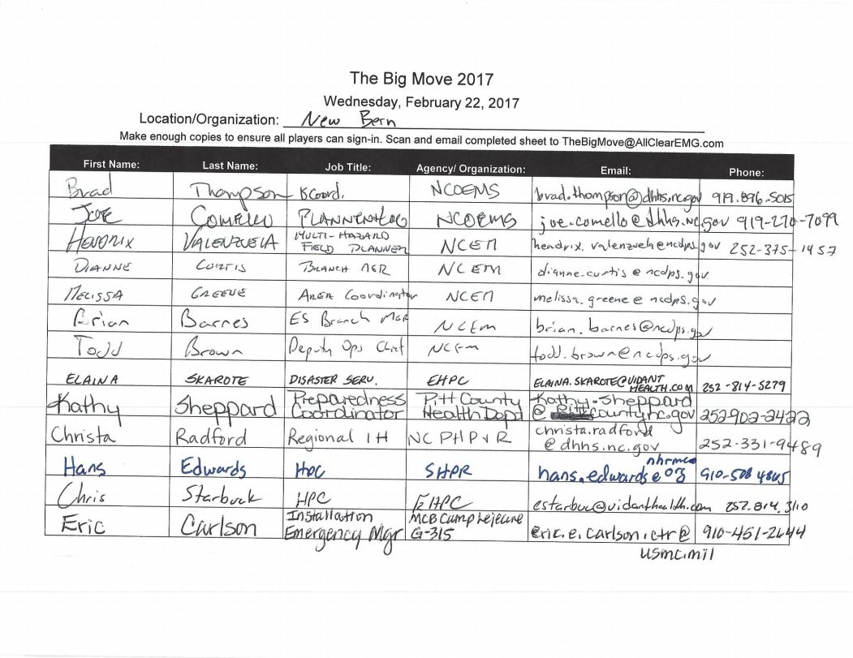

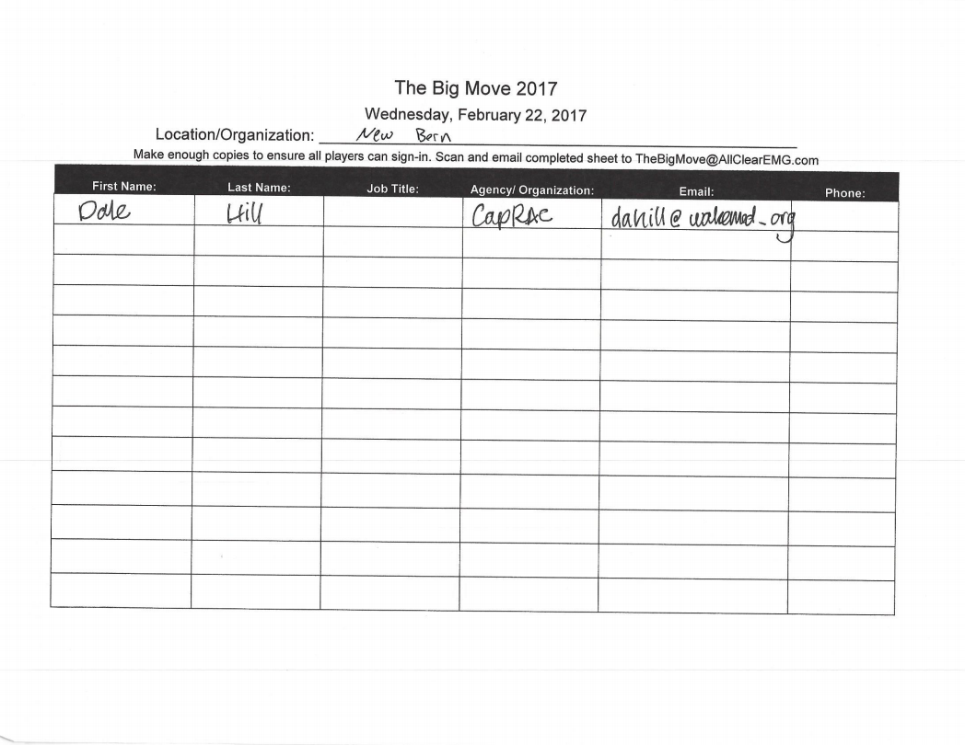

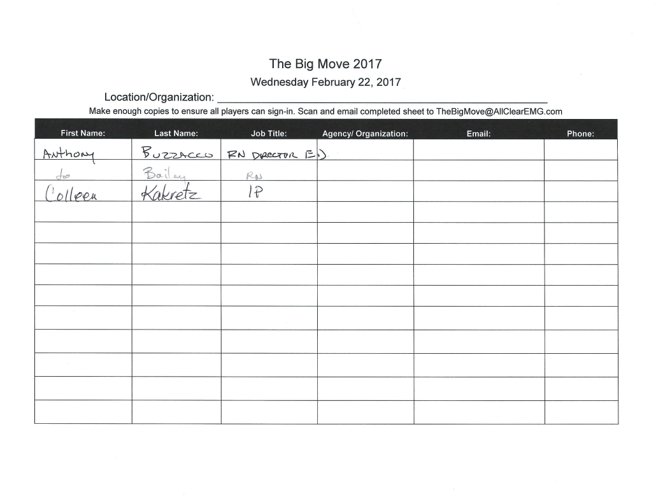

February 23, 2017
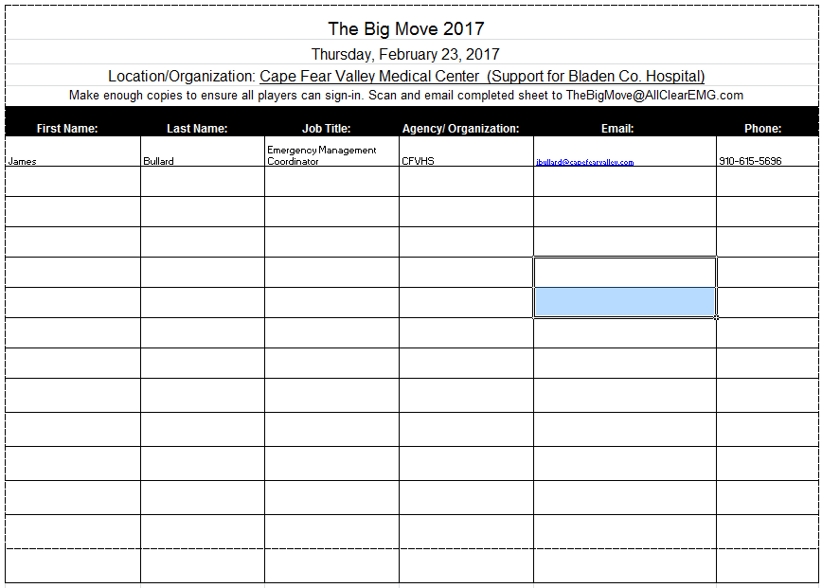

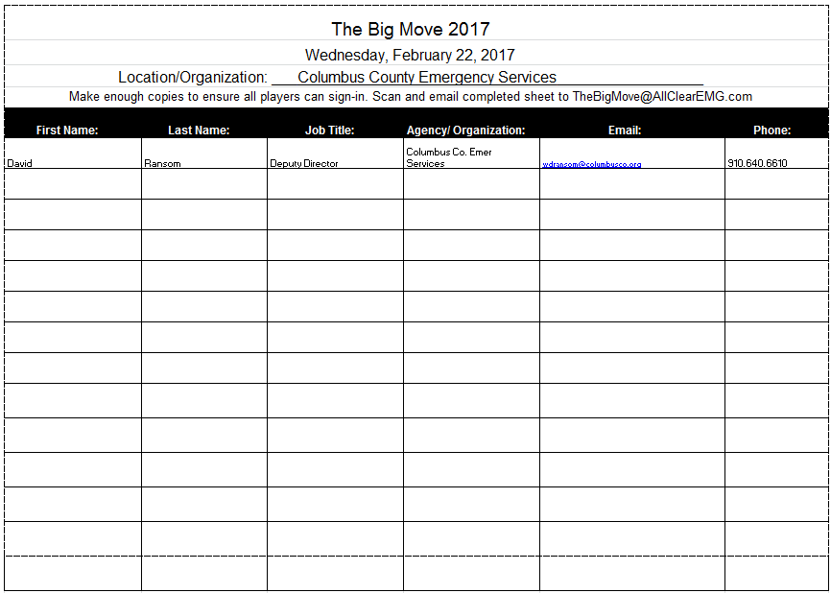

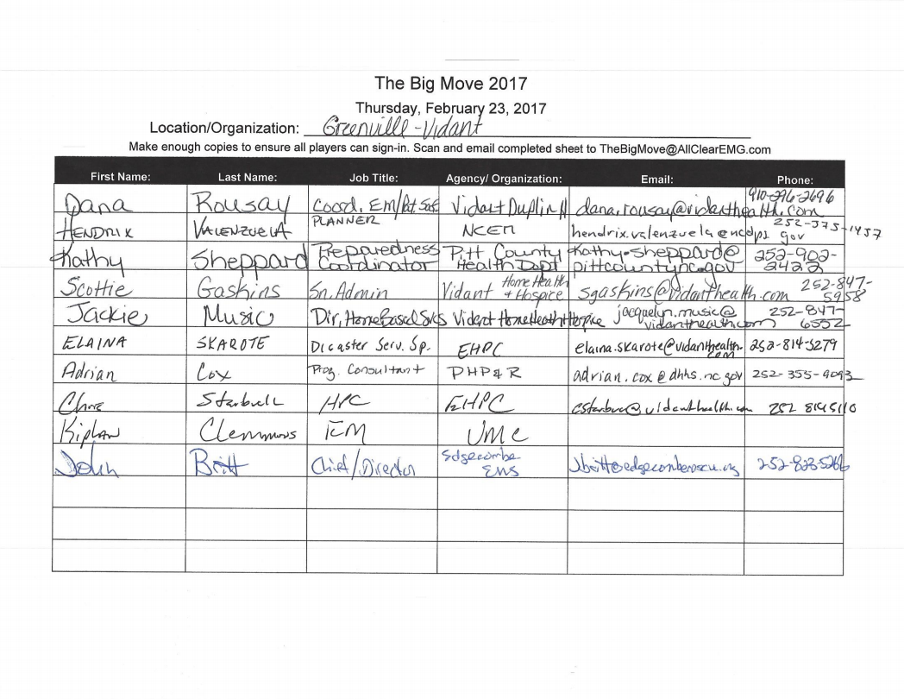

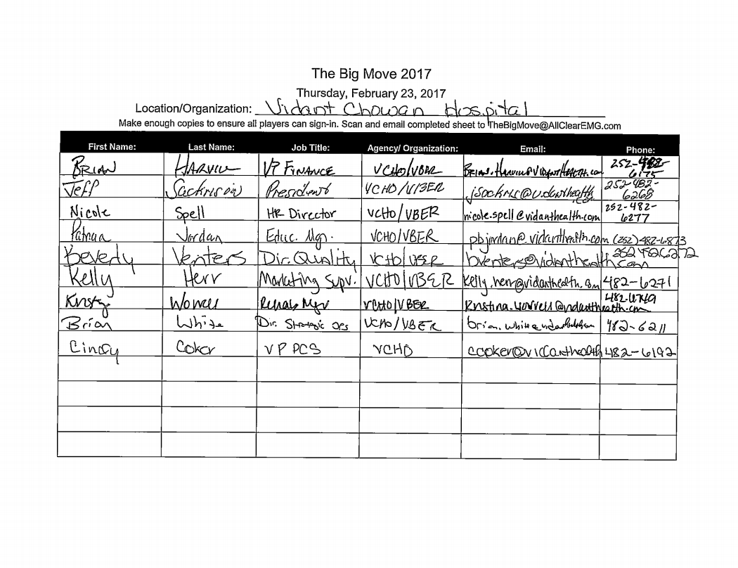

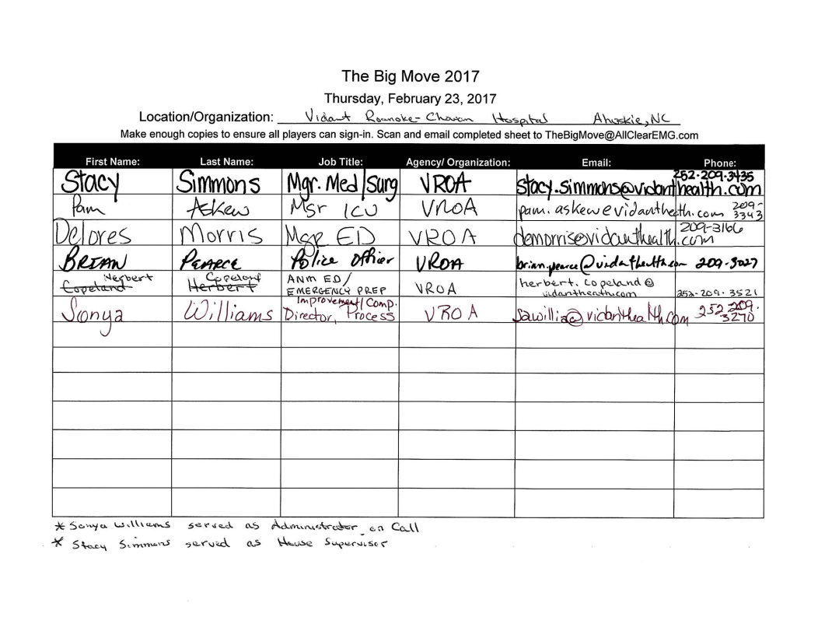

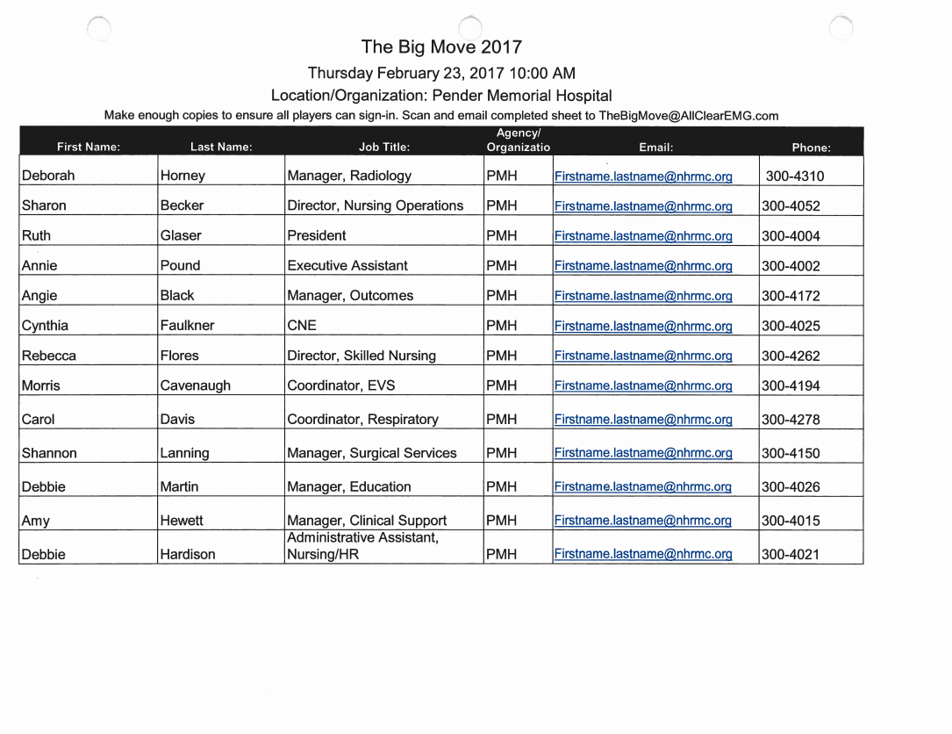
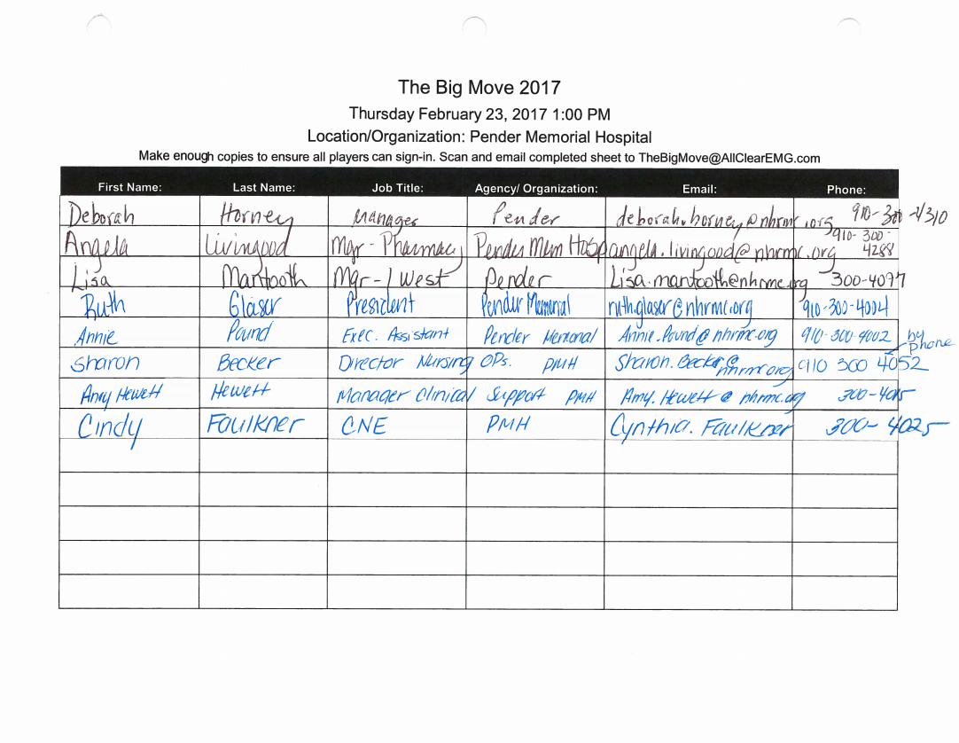

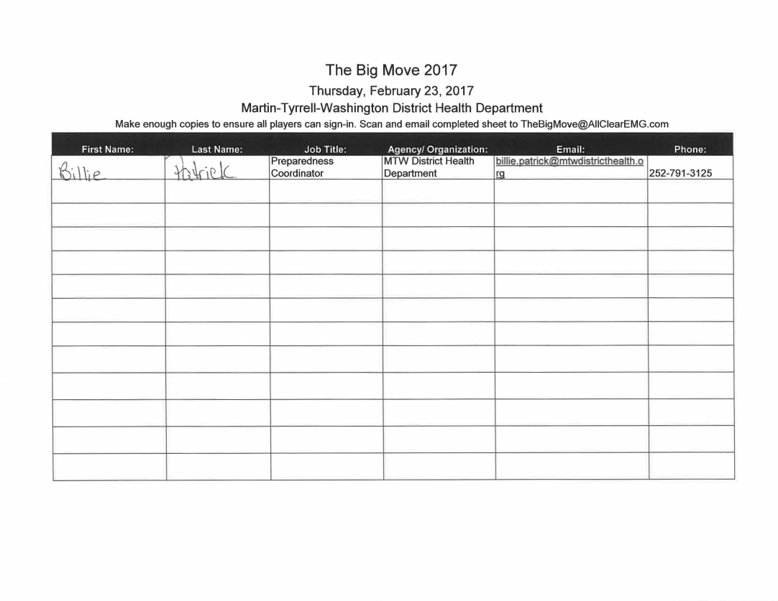
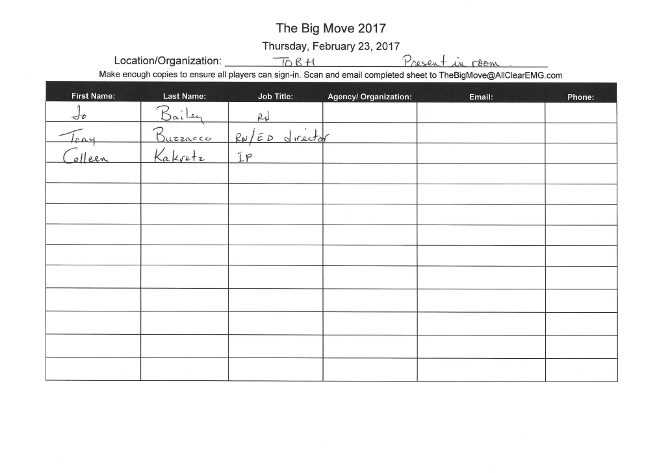
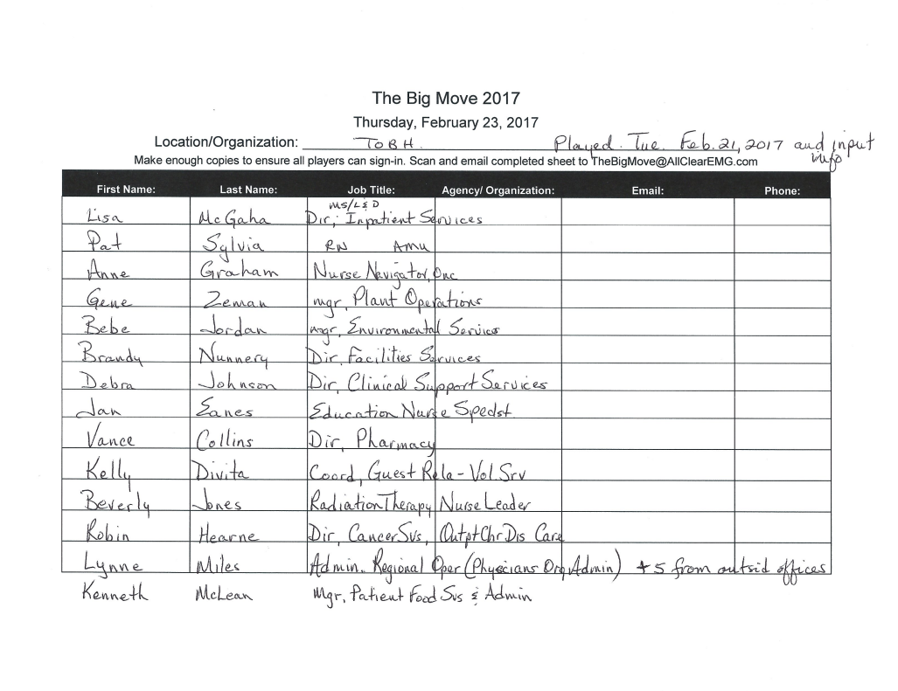

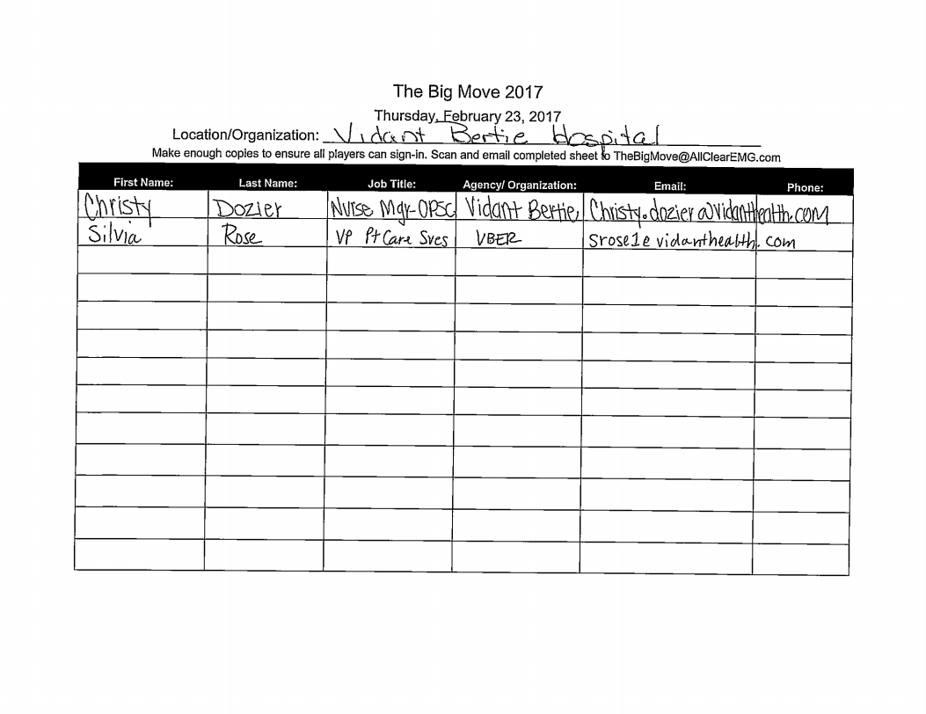

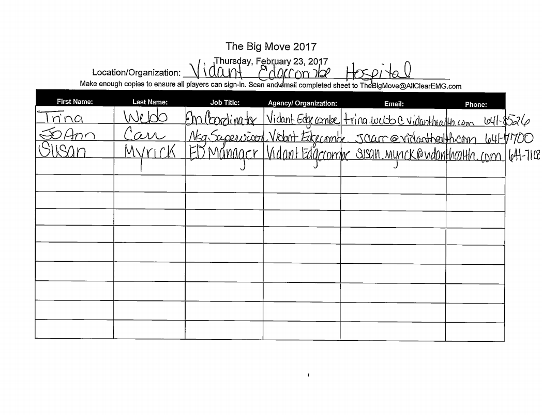

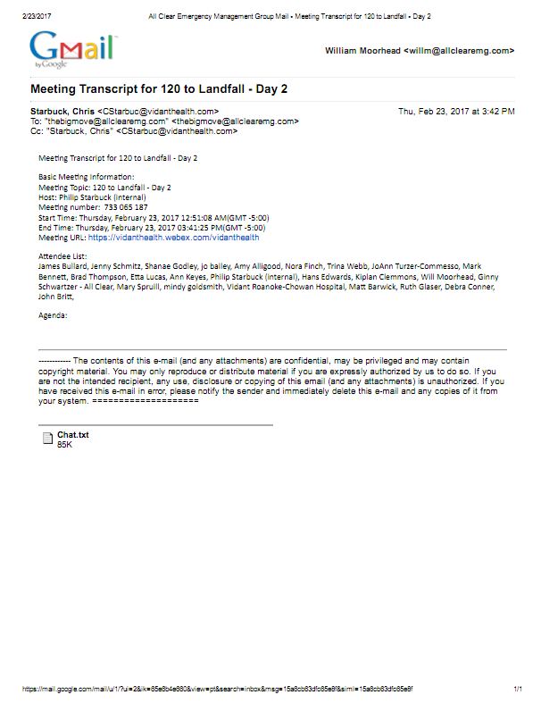

February 24, 2017 – AM
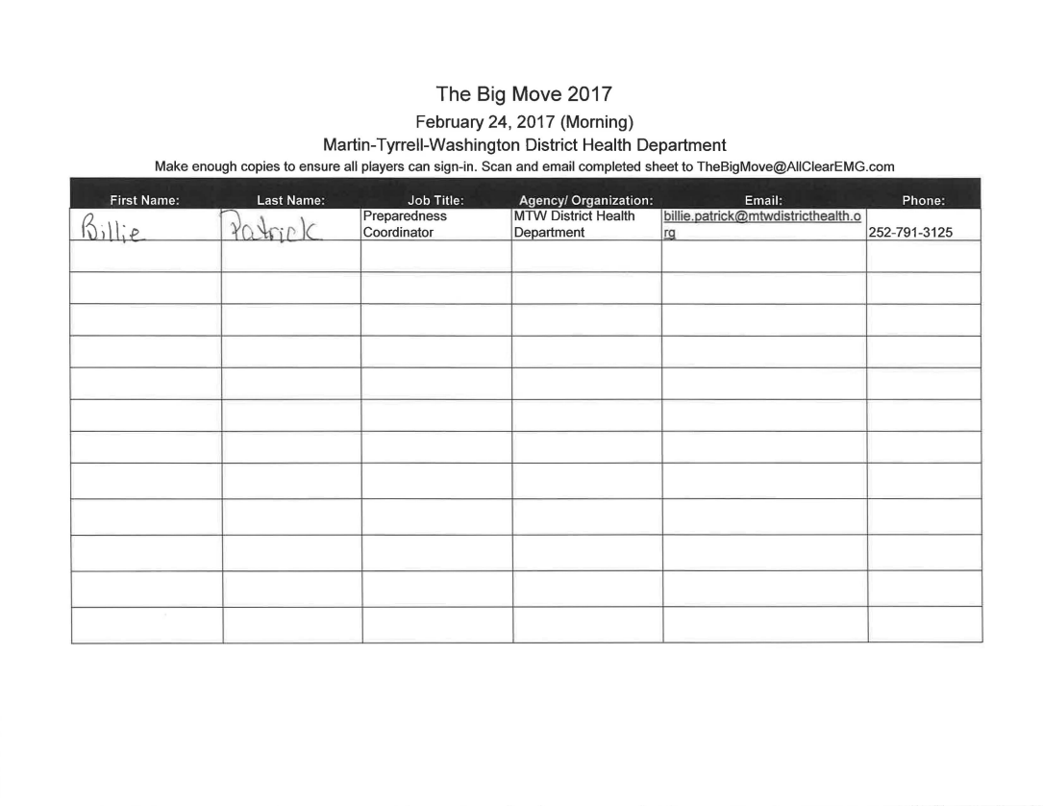

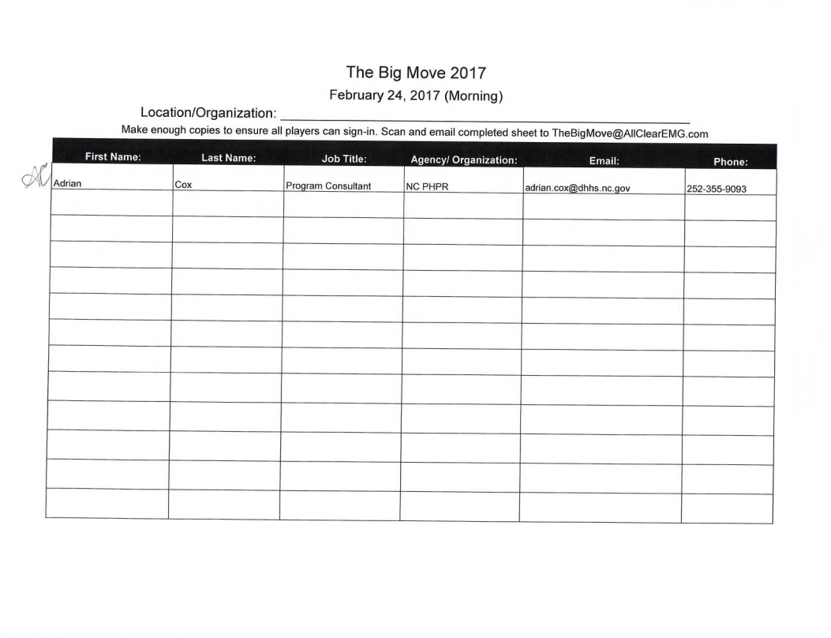

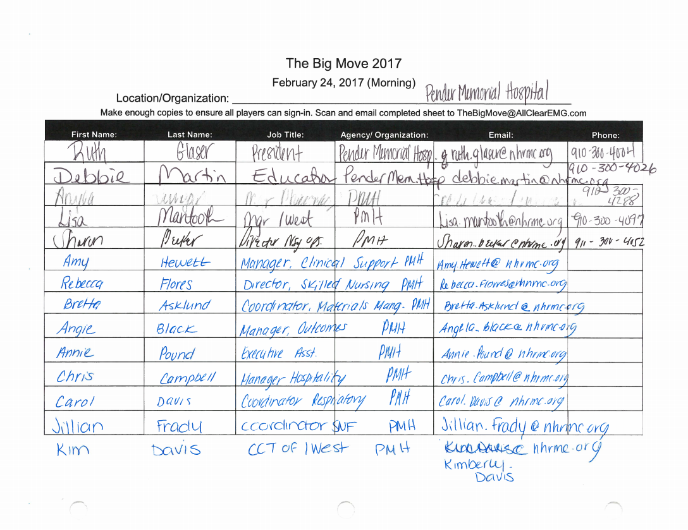

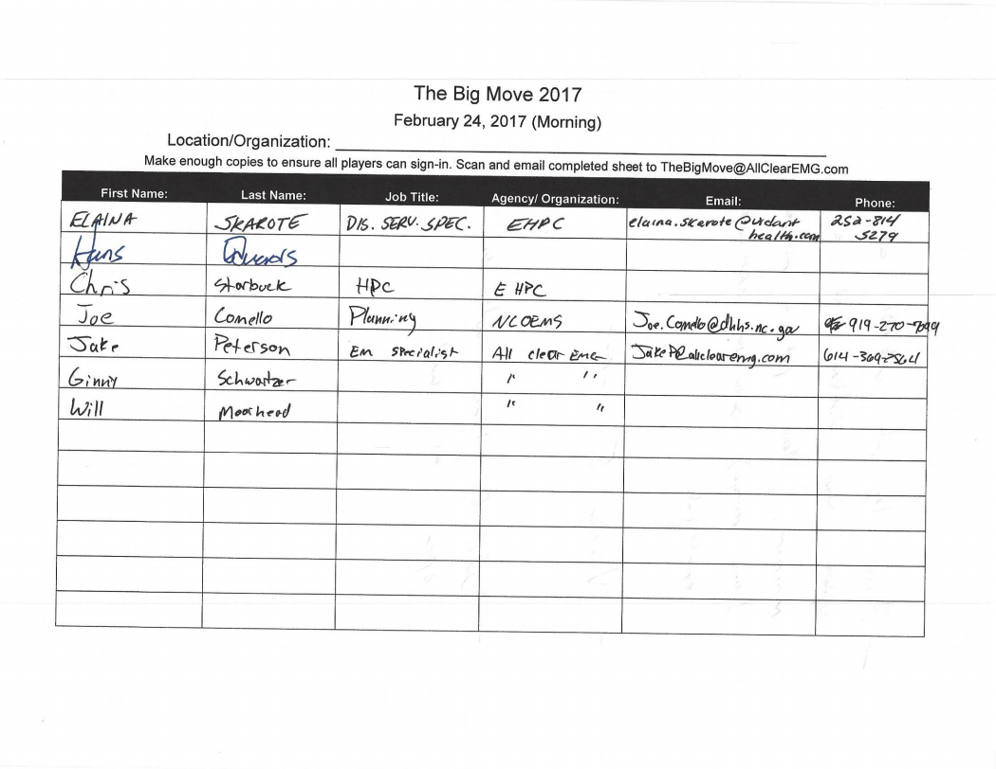

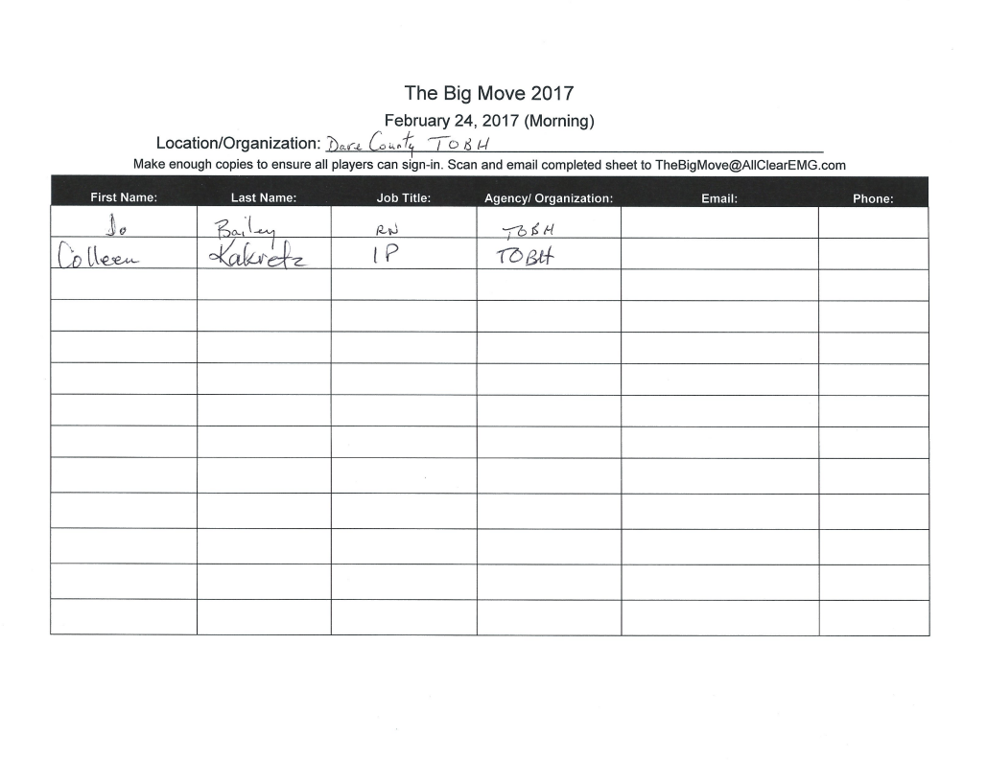

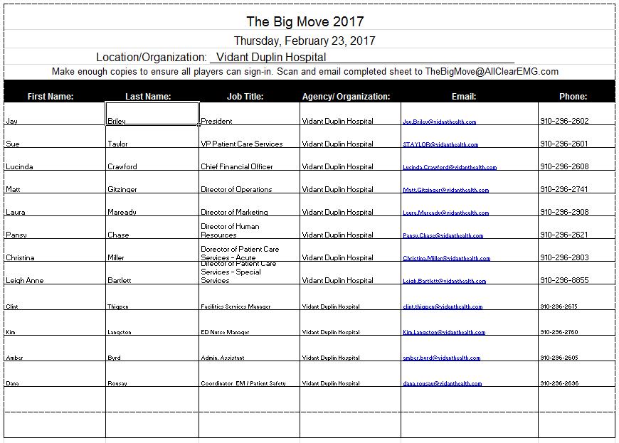

February 24, 2017 – PM
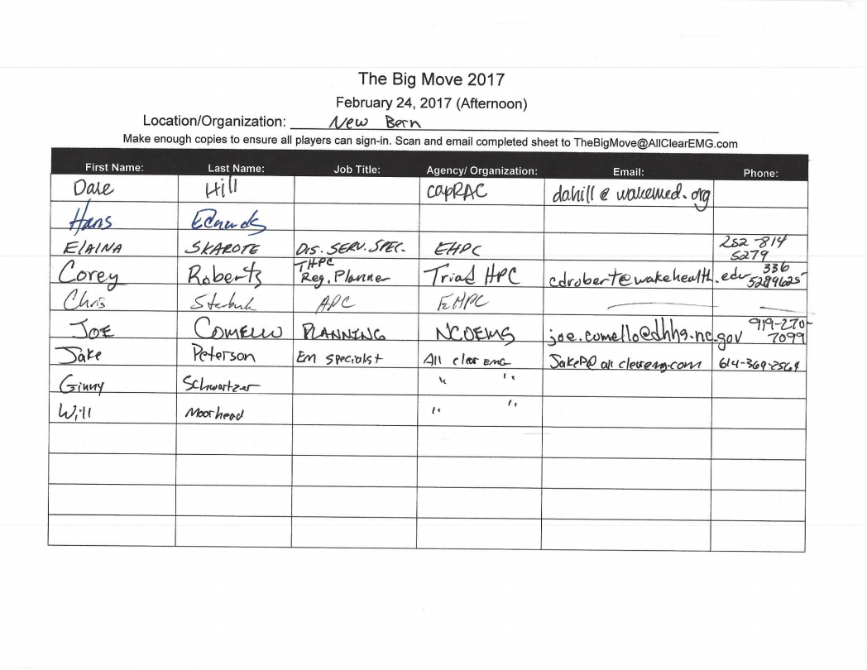

February 27, 2017 - AM
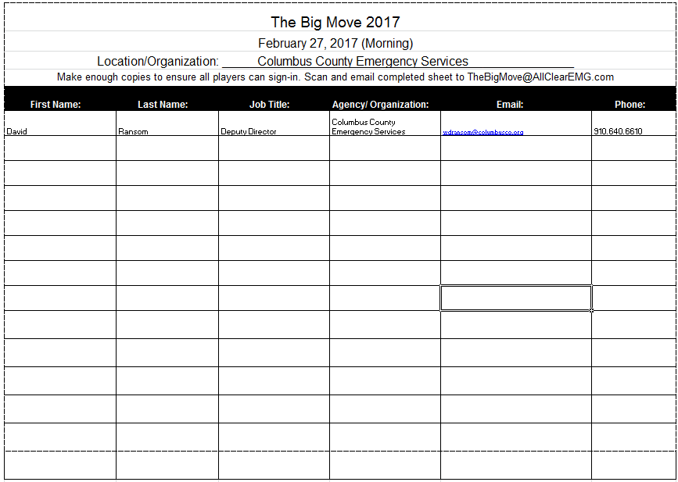

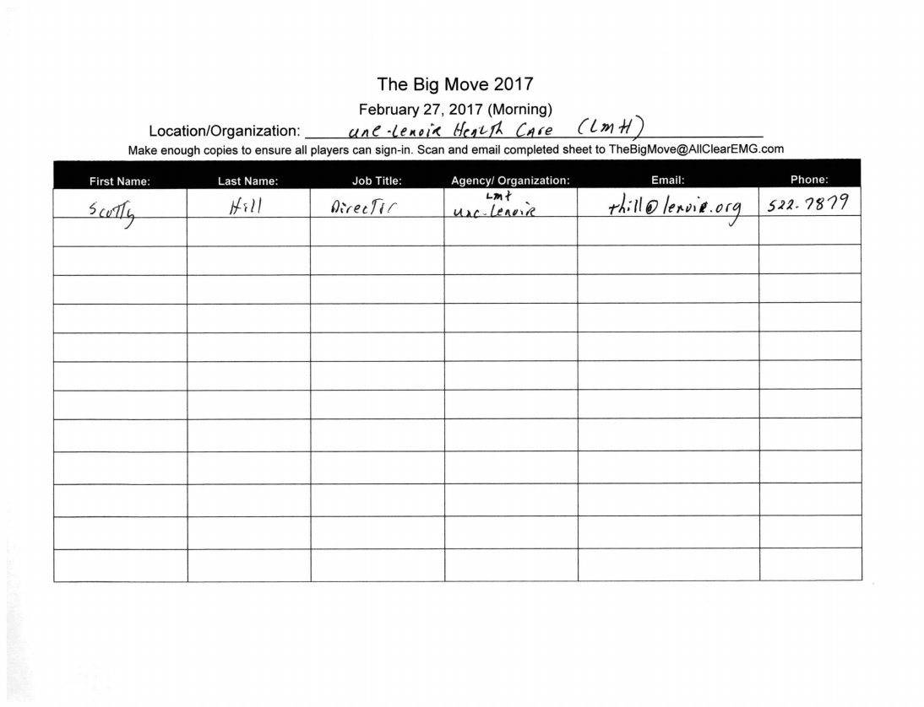

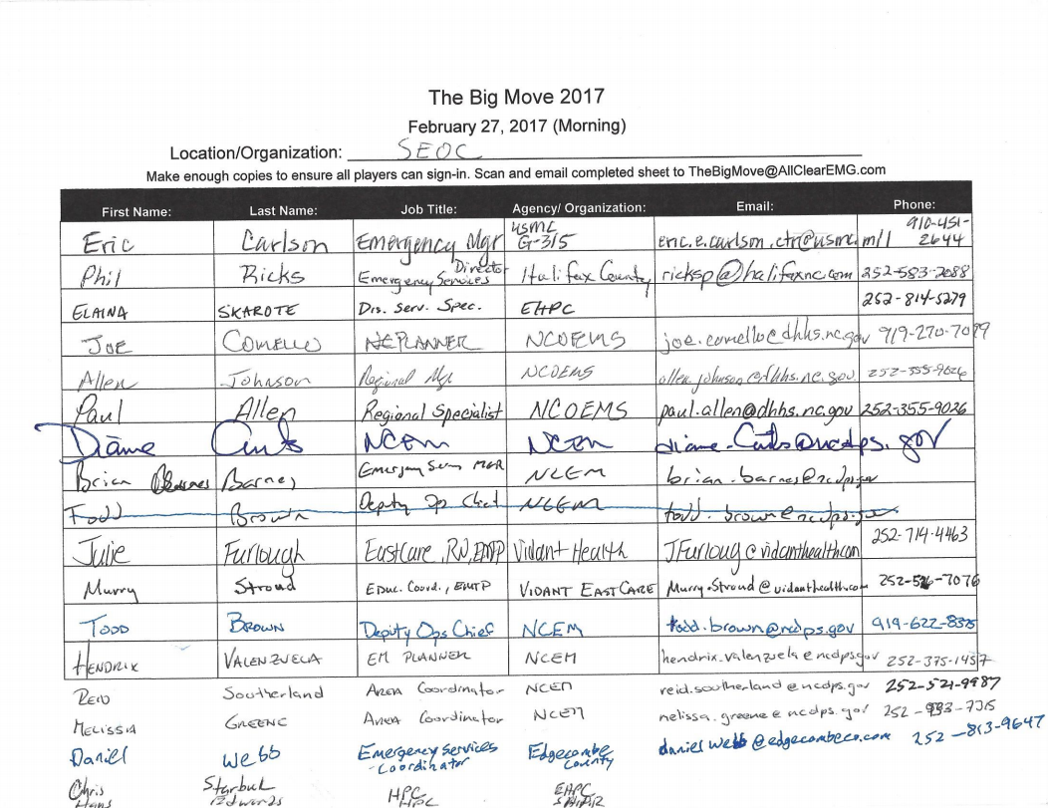

February 27, 2017 – PM

February 28, 2017
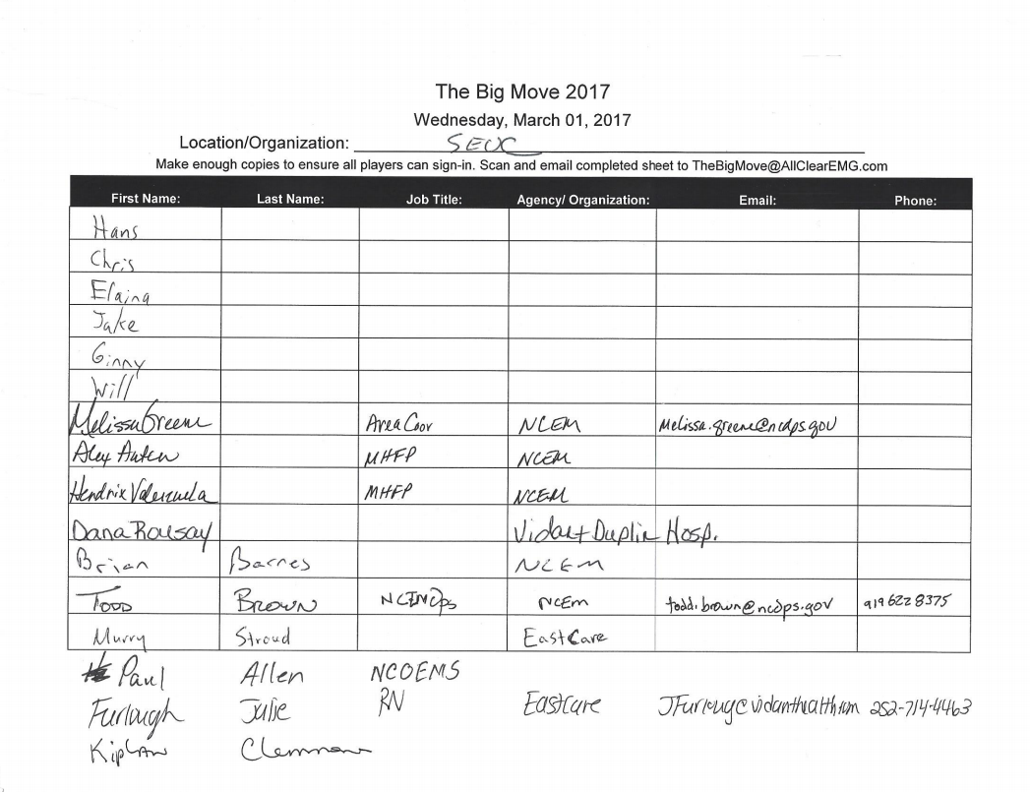

March 1, 2017
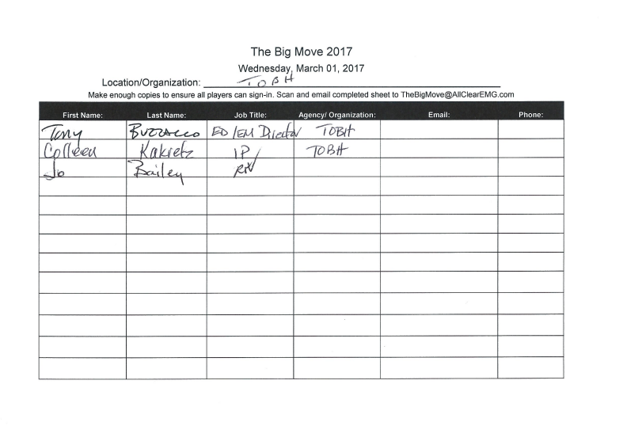

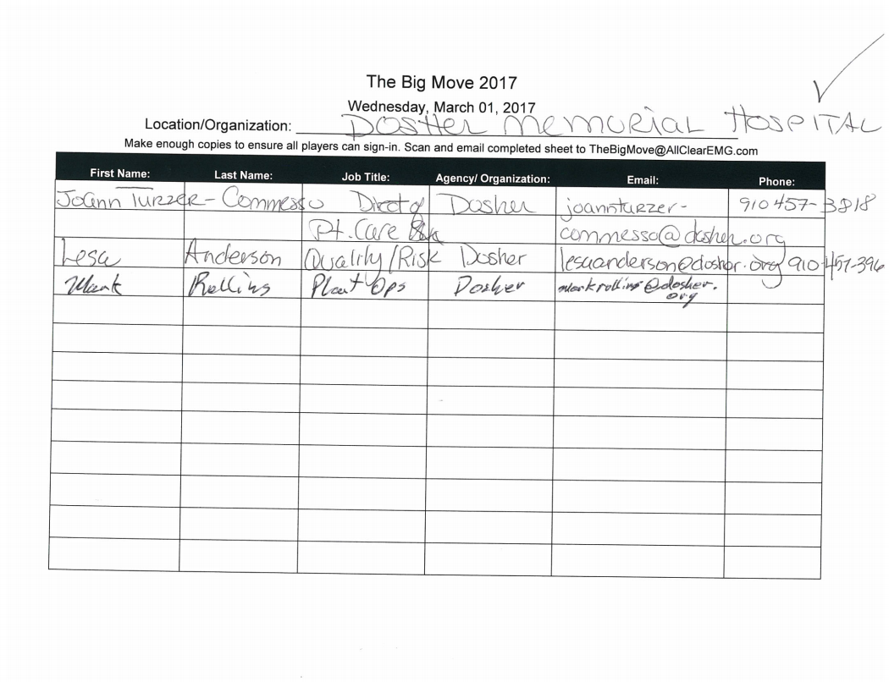

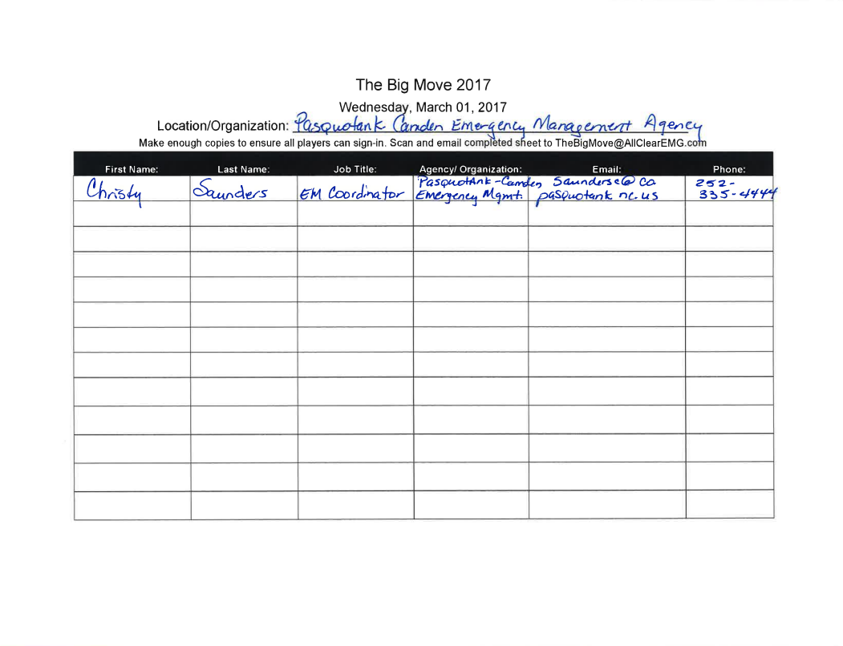

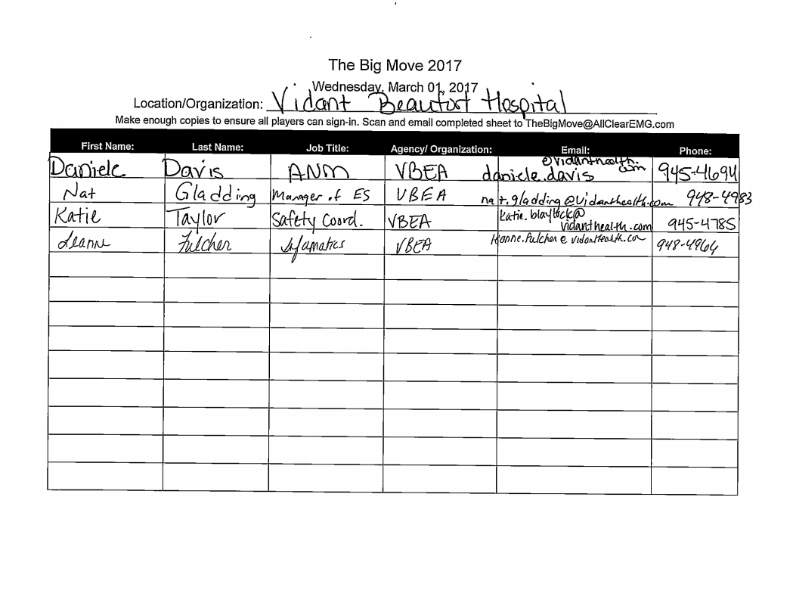

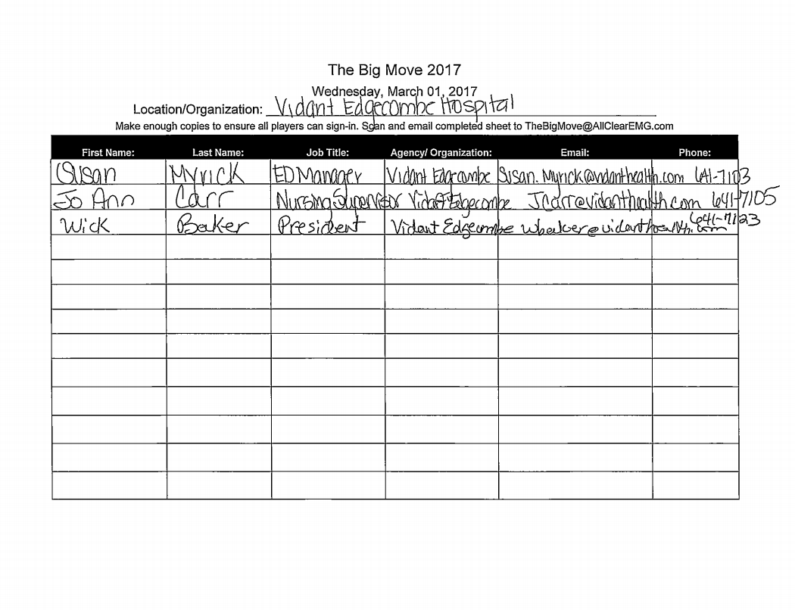

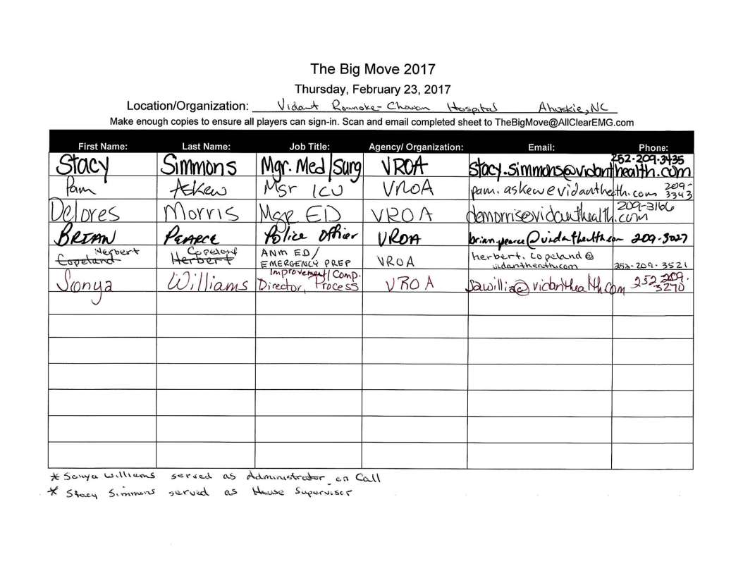

March 2, 2017
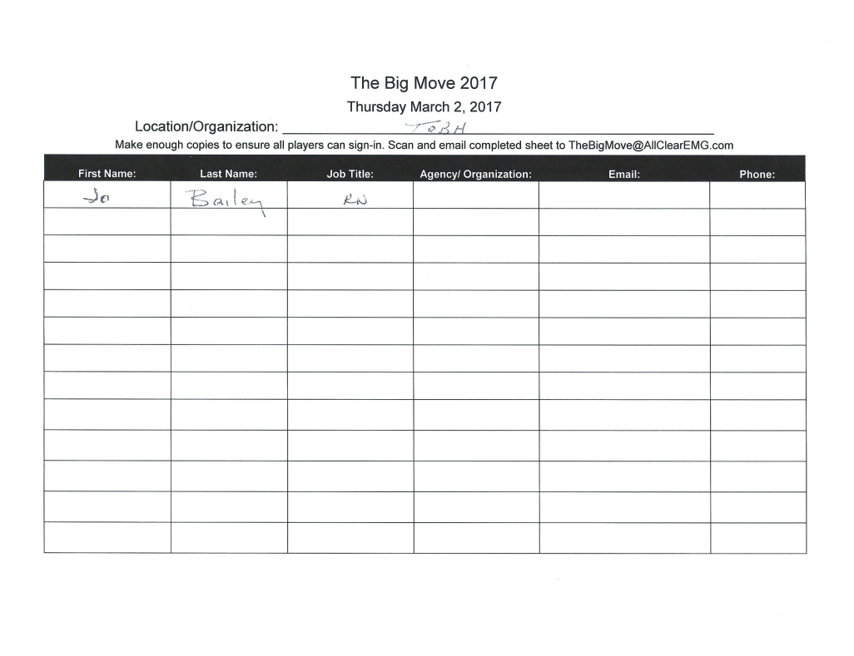

Appendix C: Exercise Feedback

February 22, 2017
The feedback below was gathered from the participants following the exercise.
Assessment Factors | 1 - Strongly Disagree | 2 | 3 | 4 | 5 - Strongly Agree
The exercise purpose and objectives were applicable to my needs. | 0 | 1 | 2 | 7 | 6
Exercise participants included the right people in terms of level and mix of disciplines or experience. | 1 | 0 | 0 | 6 | 10
Exercise facilitation engaged participants to be actively involved in the exchange of information and discussion. | 1 | 0 | 1 | 6 | 9
Exercise participation was appropriate for someone in my field with my level of experience/training. | 1 | 0 | 0 | 9 | 6
The exercise increased my understanding of this position. | 0 | 2 | 0 | 7 | 7
The materials and information provided were sufficient to meet the objectives of the exercise. | 0 | 1 | 2 | 7 | 8

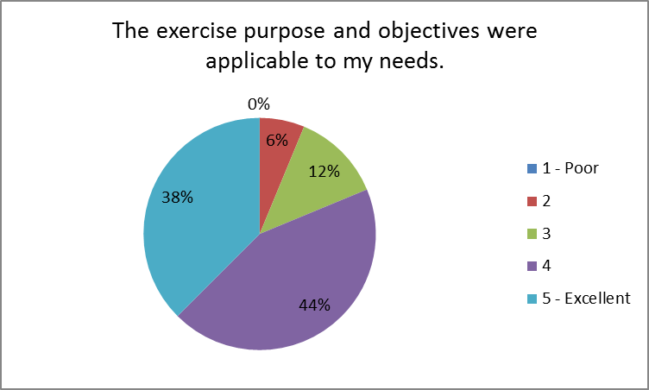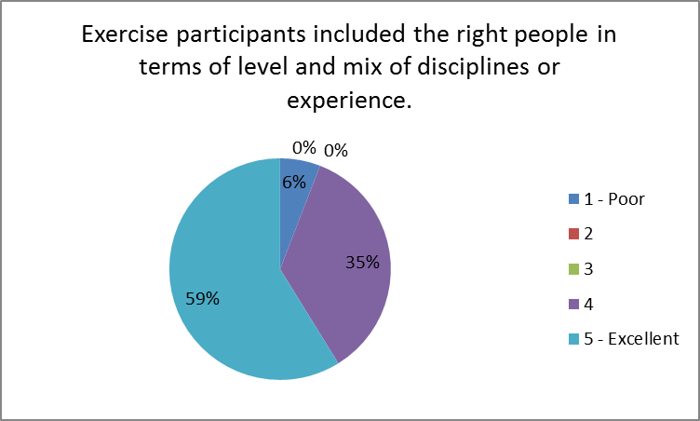

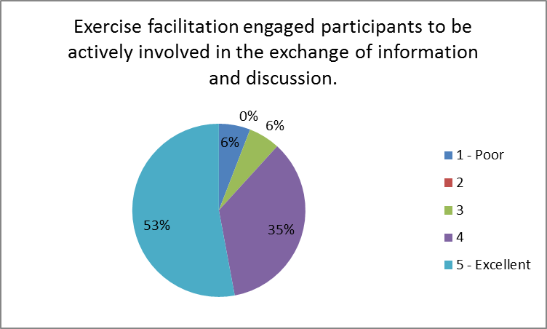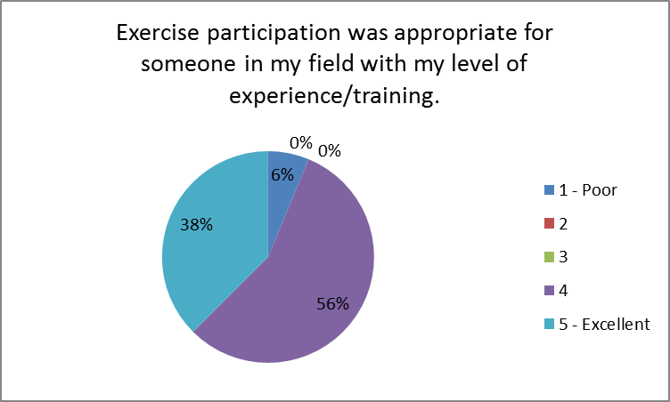

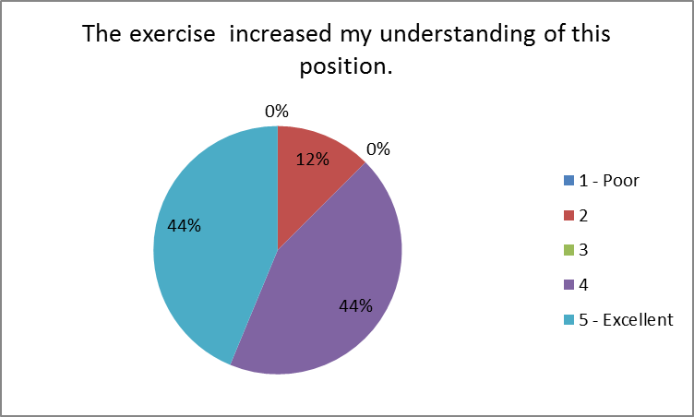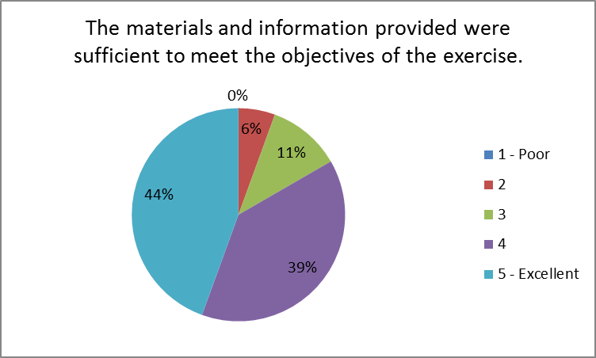

Describe information or discussion that was most helpful during this exercise.

- Hospital Politics in decision making, potential timeline, and the draft evac plan.
- Information given for local EMS and local EM was helpful and a better understanding was had as the exercise went along.
- The fact that everyone was talking.
- Information about the upcoming days.
- The overall concept of the event and how each participating relies heavily on other areas of the healthcare profession.
- The open dialogue was good and straight forward.
- I identified that ERO PHPR staff need to be on EBO's pre-landfall conference calls for situational awareness. I gained lots of information regarding what EM and OEMS are doing/thinking at 120 hours out. It may not directly apply to PH's role, but it helps information come full circle. For example, conversations on Declaration and Waivers were informational.
- Setting the goals and the time frame of the exercise.
- This was the first real overview that we had that was not paper based. documents. While our HPP gave us updates, this was the first real overview from the contractor.
- The discussion on when hospital leadership may decide to the pull the trigger on evacuation, if at all, closely mirrors the challenge we have at the military installation. That illuminating for me and I think we could gain value from providing an opportunity for key leaders to interface and discuss these challenges.
- Interesting to hear from state and local EM and OEMS on their procedures pre-storm.
- The discussion surrounding posture of each agency with the potential for a hurricane was useful as a form of situational awareness - understanding what everyone else is doing at this time. It was also comforting to understand that the posture of OEMS, PH, and EM typically mirror each other and that while we at the coalition level do not always see the conversations, there are inter agency discussions being held. Discussion surrounding the different data sets available was extremely helpful at the coalition level. Integrating the "at risk" populations into planning is a must. BUT - what is the most pertinent information from those data sets? How do we filter these massive amounts of data points? I think a best practice is collecting this data at least 120 hours out is a must in order to start sorting through some of that.
- How the exercise is going to work.
- Clearer understanding of the roles.
- Specific Team Players

Describe outstanding questions or gaps in information that remain following the exercise.

- The draft evac plan needs to be socialized and details worked through.
- No additional questions from Pitt County EM.
- Appropriate for this day.
- The entirety of the role of local county EM in the overall workings of the hospital EM because they appear to be self-sufficient in most of these areas.
- I think everyone figured out that waiting to 120 hours out to discuss several of the issues was too late in the game. Timing is something that we must get a better handle on if we are to succeed without chaos.
- CMS data usefulness.
- As a hospital that is 127 miles off the coast, we still get hit with hurricane winds and rain, increasing our chance for flooding. On Day 1, 120 hours out, clarifying the expectations and documentation for inland hospitals east of 95.
- It would have been helpful to have an example of a SITMAN to review during the webex, while the documents were sent out prior it was among multiple attachments.
- I would suggest each stakeholder review the ASPR gap analysis done last year, fit the shortfalls into this exercise scenario and produce an improvement plan with milestones to completion. Once that process has been validated each stakeholder institution should either participate in a full-scale exercise or complete their own to test out the solutions. There are a variety of communication avenues, i.e. the Regional EM conference call, the National Weather Center conference call, and conference with the stakeholders in each RAC. Key personnel from each area should get together once the conference call cycle is complete to synthesize the aggregated information and identify gaps or anticipate resource requirements before crunch time. It may be beneficial for the EM RCC to have an LNO in the RACs and vice versa if that doesn't already exist.
- Need to determine how to use the CMS data to better serve special medical needs populations.
- I still have some questions regarding waivers which affect the healthcare side of the house. While I do not think that I necessarily need a cheat sheet for day to day use - I do think that a very basic cheat sheet for this discussion would have been useful. That being said, I personally would have liked to see these discussions on waivers/declarations/notification process happen prior to "The Big Move". I understand decisions/waivers/declarations depend on the storm track becoming more concrete and the wording being disseminated by the NWS but it would be interesting to have seen county EM here talking through their trigger points based on different storm tracks and time till landfall. I mention county EM trigger points because it sounded from discussion that other than information sharing and notifications - State EM is waiting on local EM to make a request or initiate a need. Maybe just hearing from more county EM folks (some from common host sites and some from common risk sites) may have been useful. Especially risk counties with hospitals/healthcare facilities in them, hearing what conversations are being had between local EM and healthcare. (Disregard if these discussions end up happening in Day 2 when we discuss hospital notification and evacuation triggers).
- None
- None for me as a local
- Non-emergency transport companies should be involved as well.

Please provide any recommendations for future training, workshops, or exercises that would help address any identified gaps or areas for improvement.

- N/A
- None for this day.
- Workgroup to work through details of evac plan, trigger points, and executing the plan.
- Additional training on usage of local EMS resources for regional disaster evacuation or response would be helpful if applicable to future events. Otherwise this type of exercise was wide ranging, especially when paired with real life event of recent Hurricane Matthew.
- It is very important that all components of the system are working at the same time. WebEOC is a coordination tool for passing along significant events in one’s immediate area that could have a serious impact on the planning of the real thing. WebEOC is a logistical platform, however, it is so much more when kept up and utilized. EM should have been putting data in on their board and the hospital should be trained to use more than just their boards. We teach our new WebEOC personnel in training that we paint a true picture of what Beaufort County looks like and the conditions that are present, which helps the folks in Kinston and Raleigh immediately understand why we need certain types of equipment and/or personnel. We always work together with Vidant Beaufort Hospital and decisions concerning movement of patients and in some cases the methods. An example was the last river flooding following Mathew when roads were flooding, however, we still needed to get ambulances from Washington to Greenville as an example.
- How CMS data can be useful, in what format, and when.
- Perhaps there should be a subgroup of inland hospitals east of I-95 to collaborate on actions at key stages during a Hurricane
- This event was a briefing, overall it was a good briefing and contained what was needed to allow us to participate and get the information about the events to come.
- I recommend that senior leaders from the participating organizations receive some read ahead materials and at the end of the exercise process have an executive session of approximately 90 minutes for them to meet, discuss the outcomes/best practices/shortfalls to take back to their teams for process improvement. We do that in the military setting and it has yielded excellent results for us. I recommend that post-exercise, after gaps have been identified, there be a process in place to produce outcome measures for the various stakeholders. The team or teams can do focus groups, surveys, and/or review after action reports to synthesize information and refine processes. A Plan of Actions and Milestones (POA&M) can be established and tracked to verify the created outcome measures are useful and have achieved the desired results. The final products, less any intellectual property, can be shared to improve the response and the process.
- Training on use of CMS data, best practices/suggestions for use in planning and response.
- For this particular day I have not identified any training or workshops. I am not sure if we have enough information from Day 1 - but I am wondering if we could somehow develop (based on case studies) a timeline or chart on generally how long it takes for some key waivers and declarations get implemented in relation to how many hours out the hurricane is from landfall. This could help with regional planning assumptions. Understanding that each scenario is different - compiling this information with information on what local, regional, and state agencies are doing at X hours out (up until landfall) may help hospitals make decisions earlier.
- Additional exercises.
- None that I can think of right now.
- None at this time.

February 23, 2017
The feedback below was gathered from the participants following the exercise.
Assessment Factors | 1 - Strongly Disagree | 2 | 3 | 4 | 5 - Strongly Agree
The exercise purpose and objectives were applicable to my needs. | 0 | 1 | 3 | 4 | 11
Exercise participants included the right people in terms of level and mix of disciplines or experience. | 1 | 0 | 3 | 3 | 12
Exercise facilitation engaged participants to be actively involved in the exchange of information and discussion. | 1 | 1 | 1 | 4 | 12
Exercise participation was appropriate for someone in my field with my level of experience/training. | 1 | 1 | 2 | 3 | 12
The exercise increased my understanding of this position. | 1 | 1 | 3 | 6 | 8
The materials and information provided were sufficient to meet the objectives of the exercise. | 0 | 1 | 1 | 9 | 8

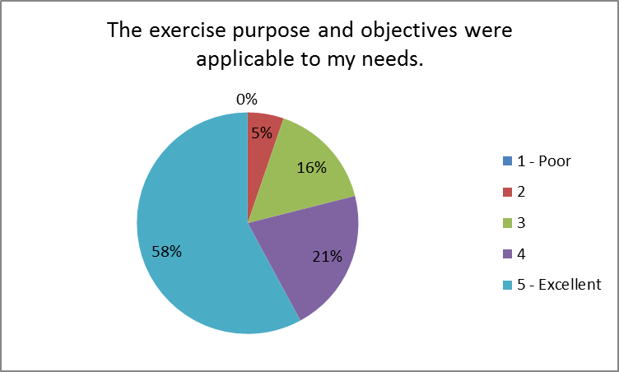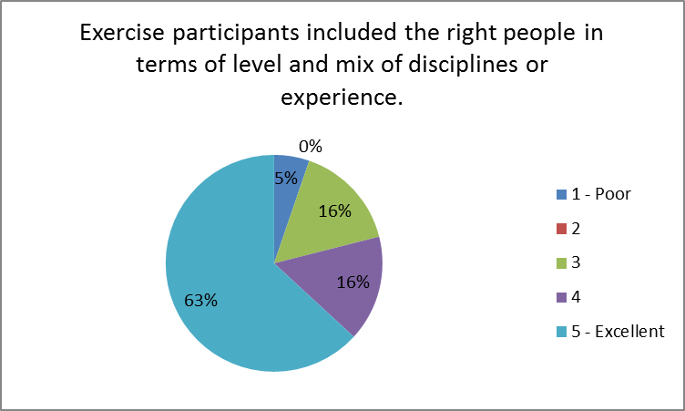

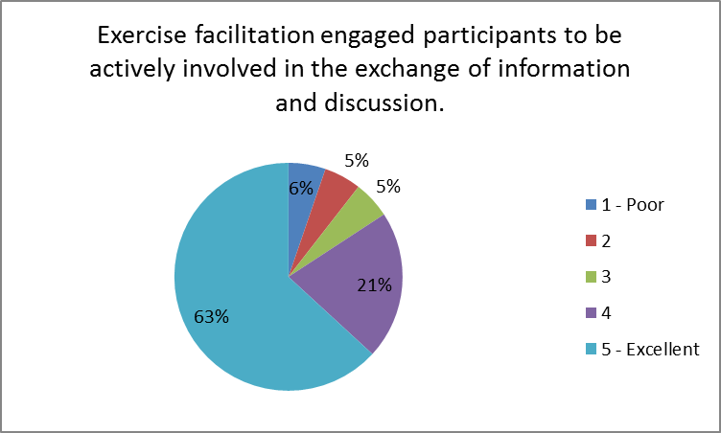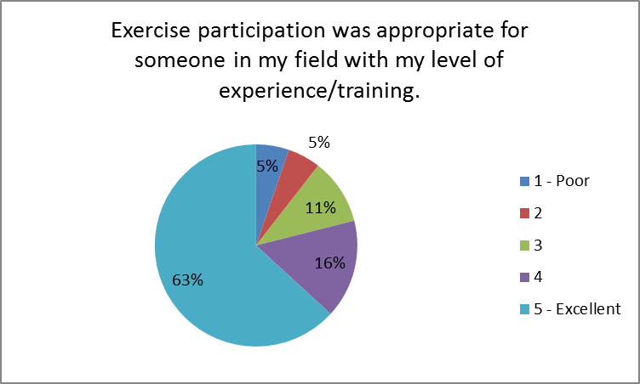

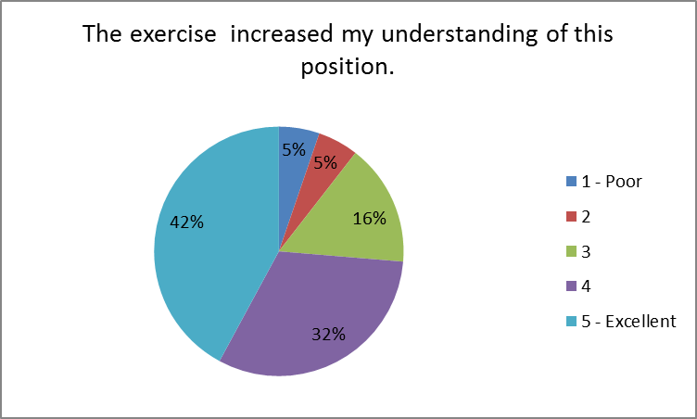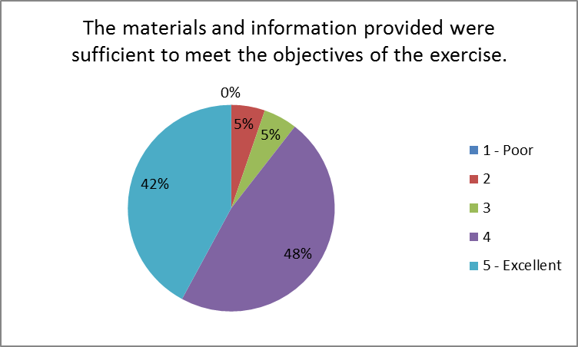

Describe information or discussion that was most helpful during this exercise.

- Understanding the triggers and timeframes that the hospital will need to meet to effectively evacuate all identified patients.
- It was helpful to understand each facilities process for communicating leading up to and throughout the event.
- I thought the questions regarding notifications and solicitation of preparedness were good. This reemphasized our communications regarding hurricane response procedures.
- Having the opportunity to discuss not only within our group, but with other facilities was very helpful.
- The scenario was given to the upper people of the facility. They were asked what they would do to prepare. Most have done this many times but, it has made some, from the outside offices think about what they would do and how. It has sparked more conversations and will be interesting to see what becomes of the information.
- The information sharing discussion got my attention.
- Sharing of information on triggers.
- Coordination of transportation.
- The overall knowledge of information gained as an outsider looking into the operations of area hospitals.
- Situational awareness.
- Discussion of the role that the HCC would play and the resources they could provide. We need to communicate with them as well as our local EM early in the planning phase.
- The discussion on information sharing and the mechanisms used to disseminate information.
- We were on standby monitoring the path of the storm. We do not evacuate but shelter in place. We assist with sheltering home ventilator patients (3) living in the community. We were in contact with the local health department for this information and coordination.
- Having multiple hospitals and agencies involved in the exercise was helpful. This was the first time something of this magnitude was attempted. Spacing things out by functional areas was helpful.
- Interesting to hear the hospitals' point of view on evacuation. Interesting to hear the differences between hospitals (i.e. patient acuity, preparedness process) even in the same system.
- Encouraging our leadership to identify trigger points for evacuation was beneficial. They had always taken a "we will never evacuate" stance, but through discussion realized that, in a Cat 4 or higher, it would be safer to evacuate inpatients and maintain a limited number of staff to operate the Emergency Department and oversee the facility.
- Exercise questions were invaluable!
- Feedback as what other entities would be doing.
- Using the WebEOC for different situations.
- From the state-level the understanding of processes and plans of hospital, health care, home care, etc. that take place during an evacuation.

Describe outstanding questions or gaps in information that remain following the exercise.

- Are "host" counties the only counties that the risk counties are evacuating to?
- Gaps: Hospitals understanding which information is most up to date and which information is credible. Common sources for information? Making sure that hospitals are sharing their significant events with the correct partners. There are disconnects between hospitals and local EM because hospitals are used to handling things on their own. Getting hospitals to make decisions earlier or report a leaning posture earlier. Making better connections with home health on the coalition staff side.
- I felt that developing a template for the facilities to communicate their preparedness efforts and resource needs to be developed.
- I have concerns that when push comes to shove that there will NOT be enough resources in ENC to meet the needs of our communities.
- Information gathering from various sources is not necessarily coordinated. There are many channels of information. Which channel should people tune-in to for the most accurate information? Not everyone has access to NC SMARTT. The hospital and EMS sides don't connect. Not 100% participation. There is an info sharing gap. Some agencies are preparing earlier than a week from landfall (e.g. home health, hospice, etc.). There is a need to formalize and maximize use of WebEOC.
- Patient acuity is different for each facility.
- Based on the days that I participated, I did not have any problems.
- We need to have an evacuation procedure readily available. Certain staff could verbalize actions taken but worry if certain individuals were not available at the time.
- What is Armerilet, a tool used for staff notification? (used by Bladen County) Do the mechanisms listed cross cut with information sharing for public health?
- No questions
- There was no actual engagement or feedback to the online participants. We needed to be asked questions, and receive feedback instantaneously. Example: Do hospitals have a written plan for evacuation that includes a timeline to request evacuation resources? Y or N A online polling question would allow us to respond, and then when we get feedback showing that 60% of the hospitals do not have said plan, we know where we stand as well as everyone else. Then building off the first question, if you had a plan, when would you need to send your RAC or OEMS a list of patients you were planning on evacuating? A. 72 hours before landfall B. 48 hours before landfall C. 36 hours before landfall D. we have no clue... Knowing the expected answer should be 48 hours, how many responded that way?
- Understanding how to account for home health and hospice, LTC and home bound special needs patients is a gap.
- Still have concerns about bed coordination in the event of a large-scale evacuation. We would normally call individual hospitals to locate beds, get acceptance, give a patient report and then arrange transportation. If numerous hospitals are following the same procedure, it will create a huge communication issue and frustration for receiving hospitals, not to mention delays on our end.
- Communication between hospital/local county emergency management/EMS/ coalition, etc. - when it occurs/who is called first depending on situation/who reports information to whom, etc.
- Bed/transport coordination system? Clear definitions, i.e. acuity of patient and transport need.
- Influx of patients that have special needs from the community that present to the hospital.
- Coordination and communication with external stakeholders. Bridge the gap with definitions, trigger points, transport capabilities.

Please provide any recommendations for future training, workshops, or exercises that would help address any identified gaps or areas for improvement.

- N/A
- Hospitals need education on diversion - the definition and the actions that coincide. EHPC can improve on producing sit reps which consolidate the most up to date pertinent information.
- Virtual resource allocation.
- 0
- I think partner calls with everyone in the healthcare system (including public health) are very helpful for situational awareness.
- Training on WebEOC - need to increase staff who can access system and understand how/why.
- Strong suggestion of more training and partnerships for small, rural hospitals.
- Hospital WebEOC, that public health can attend and gain access to the system
- Perhaps consider exercising components such as communication to make sure all know when and where to document.
- Just involve more feedback.
- Engaging the LTC, home health, DME agencies.
- Definitely need to include area nursing homes and community agencies in an exercise. I think the number of patients will be surprisingly large.
- It was difficult to hear anyone but the moderator.
- Streamlined process for notification and priority of steps: EM, EHPC, WebEOC for evacuation whether planned for hurricane or no notice event. Information gathered from this exercise would help determine this.
- How can we get special needs patients to the shelters that have the appropriate equipment they need?

February 24, 2017 - AM
The feedback below was gathered from the participants following the exercise.
Assessment Factors | 1 - Strongly Disagree | 2 | 3 | 4 | 5 - Strongly Agree
The exercise purpose and objectives were applicable to my needs. | 0 | 0 | 1 | 2 | 2
Exercise participants included the right people in terms of level and mix of disciplines or experience. | 0 | 0 | 0 | 2 | 3
Exercise facilitation engaged participants to be actively involved in the exchange of information and discussion. | 0 | 0 | 0 | 3 | 2
Exercise participation was appropriate for someone in my field with my level of experience/training. | 0 | 0 | 0 | 2 | 3
The exercise increased my understanding of this position. | 0 | 0 | 0 | 2 | 3
The materials and information provided were sufficient to meet the objectives of the exercise. | 0 | 0 | 0 | 2 | 3

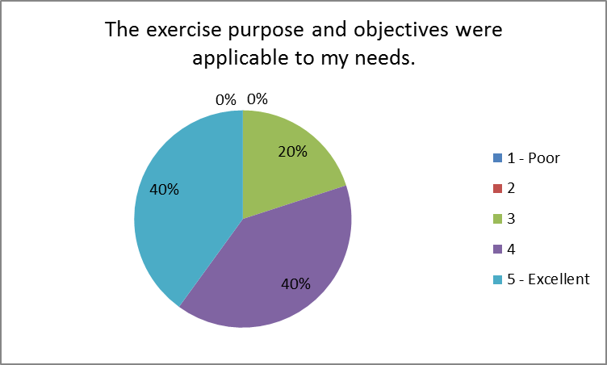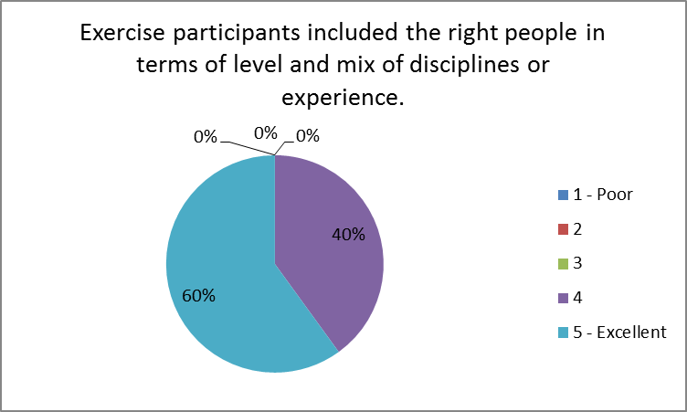

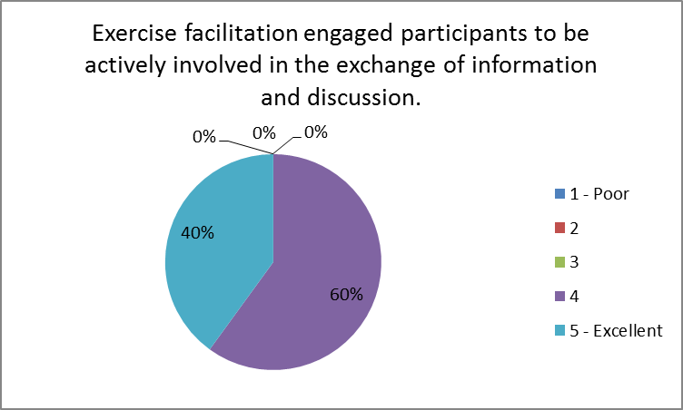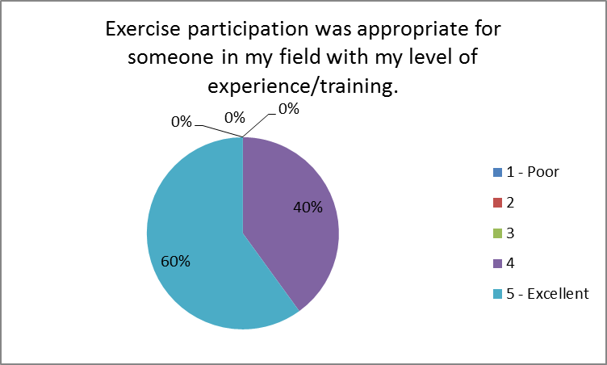

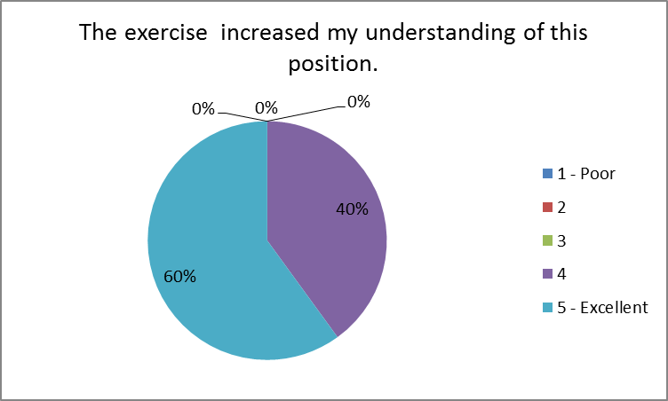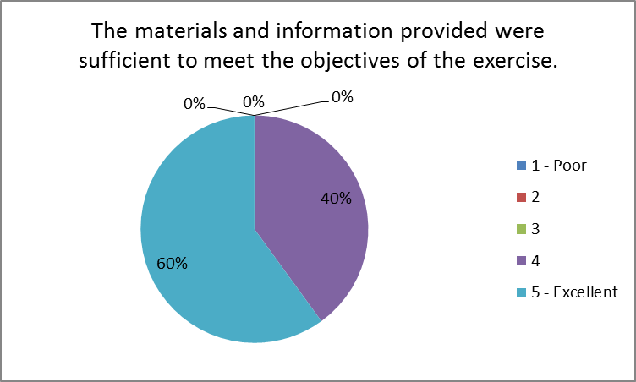

What were the positive things your organization identified about its planning for an evacuation?

- Early request of state assets (AST).
- Early recognition of need.
- The team worked well together and the EOP helped a lot with the planning.

What were the strengths your organization identified about the response activities it would employ during an evacuation?
- Ability to move patients out of the facility using local resources and not having to wait for the ambulance strike team deployment.
- We have utilized many items in past with storms.
- The team working together to ensure our patients were safe. Also the knowledge of the EOP.

Explain and issues or concerns that created challenges or hindrances for the organization's response.

- The hospital identified high acuity patients to be transported out of the facility. These patients require the most resources per patient. Does it make sense to move a smaller amount of the "sicker" patients vs. the ability to move larger amounts of lower acuity?
- The patient evacuation form was confusing.
- Need for hospital to talk to other hospitals about evacuation and patient acceptance.
- None at this time.

List specific actions that can be taken to address any concerns or improve the organization's emergency management capability.

- N/A
- More employees who know how to access WebEOC on hospital board and county board in an emergency.
- To make sure night shift knows how to access and update SMARTT system.
- None at this time.

Provide suggestions for improving regional collaboration among healthcare providers.

- N/A
- Feels that we have excellent collaboration.
- None

February 27, 2017 - AM
The feedback below was gathered from the participants following the exercise.
Assessment Factors | 1 - Strongly Disagree | 2 | 3 | 4 | 5 - Strongly Agree
The exercise purpose and objectives were applicable to my needs. | 0 | 0 | 1 | 4 | 1
Exercise participants included the right people in terms of level and mix of disciplines or experience. | 0 | 0 | 1 | 3 | 2
Exercise facilitation engaged participants to be actively involved in the exchange of information and discussion. | 0 | 0 | 1 | 3 | 2
Exercise participation was appropriate for someone in my field with my level of experience/training. | 0 | 0 | 1 | 4 | 1
The exercise increased my understanding of this position. | 0 | 0 | 3 | 1 | 2
The materials and information provided were sufficient to meet the objectives of the exercise. | 0 | 0 | 2 | 2 | 2

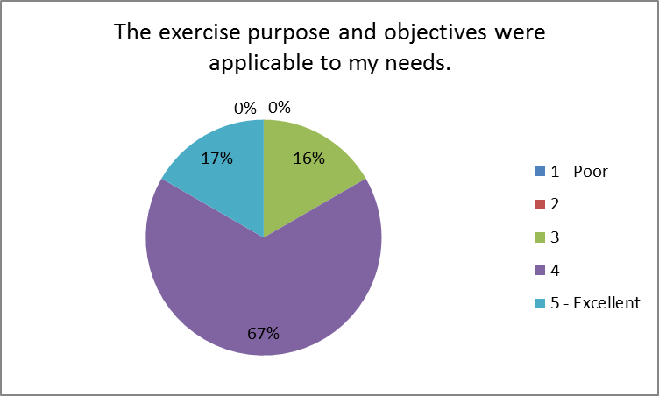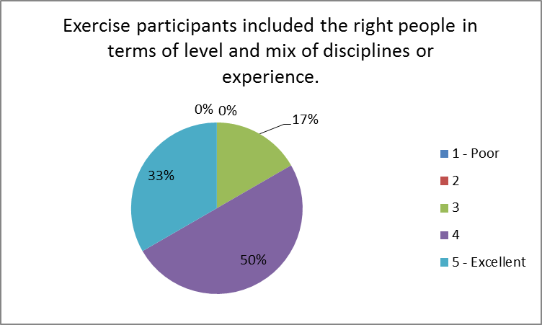

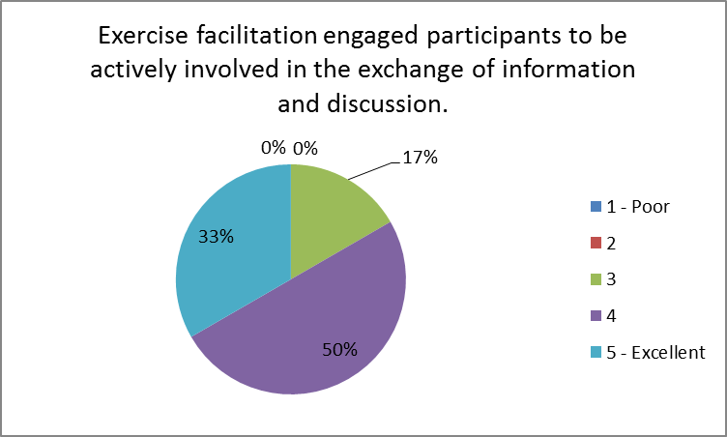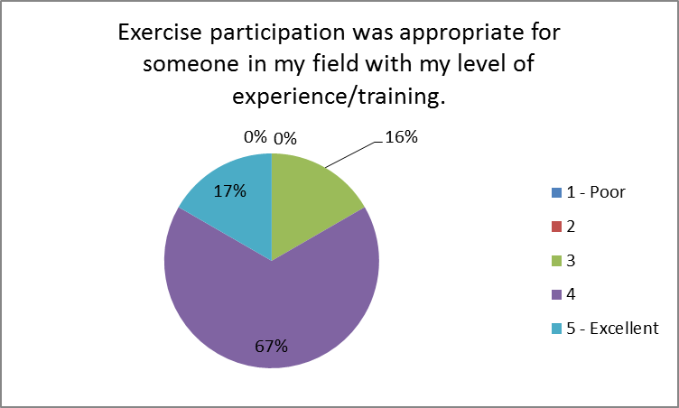

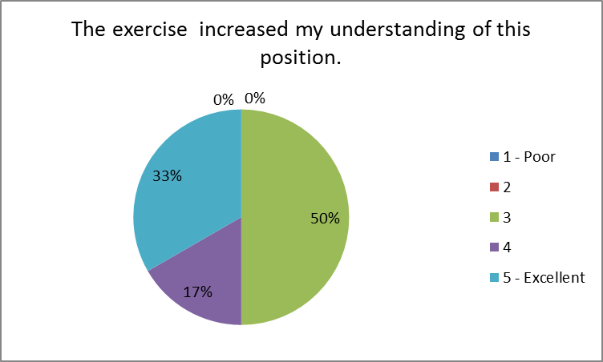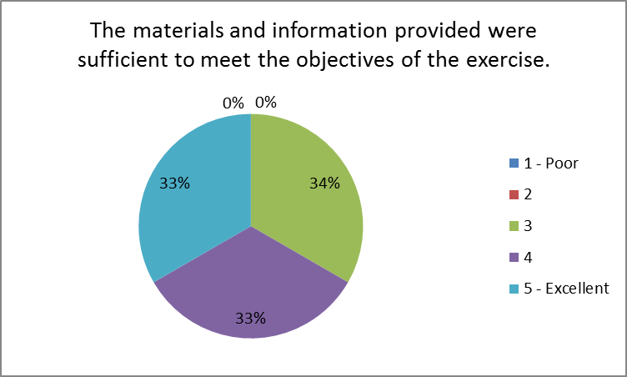

Describe information or discussion that was most helpful during this exercise.

- N/A
- Resource challenges and shortfalls.
- Discussion on when to pull the string on federal assets and accessibility of state assets. (MAB, AST.....)
- It was nice to see what numbers that were going to need to be transported.
- The understanding of each external stakeholder’s procedures during hospitals/healthcare evacuations. From the basic request at the local level all the way to the state level and all agencies involved during decision making.

Describe outstanding questions or gaps in information that remain following the exercise.

- N/A
- Working through the logistics of mobilizing a large number of medical assets for mass evac of hospitals.
- None at this time.
- Morning discussion was slow. Identifying resources was slow.
- Common terminology still needed to bring all stakeholders under the same umbrella.
- Accountability and tracking of resources at the State EOC/OEMS level once a mission to location have been assigned.

Please provide any recommendations for future training, workshops, or exercises that would help address any identified gaps or areas for improvement.

- Conversations at the host site seemed to get side tracked and focused on solving smaller issues and took longer to meet the objectives of the exercise. I would like to see a seminar type exercise involving all participants to participate in person vs. webinar/phone exercise.
- A workshop focused on logistical plan and command and control of assets during evac.
- None at this time.
- There needs to be a better way to contact resources.
- More local EM agencies participation.

February 27, 2017 - PM
The feedback below was gathered from the participants following the exercise.
Assessment Factors | 1 - Strongly Disagree | 2 | 3 | 4 | 5 - Strongly Agree
The exercise purpose and objectives were applicable to my needs. | 0 | 0 | 1 | 2 | 0
Exercise participants included the right people in terms of level and mix of disciplines or experience. | 0 | 0 | 1 | 2 | 0
Exercise facilitation engaged participants to be actively involved in the exchange of information and discussion. | 0 | 1 | 0 | 2 | 0
Exercise participation was appropriate for someone in my field with my level of experience/training. | 0 | 0 | 0 | 3 | 0
The exercise increased my understanding of this position. | 0 | 0 | 1 | 1 | 1
The materials and information provided were sufficient to meet the objectives of the exercise. | 0 | 0 | 0 | 2 | 1

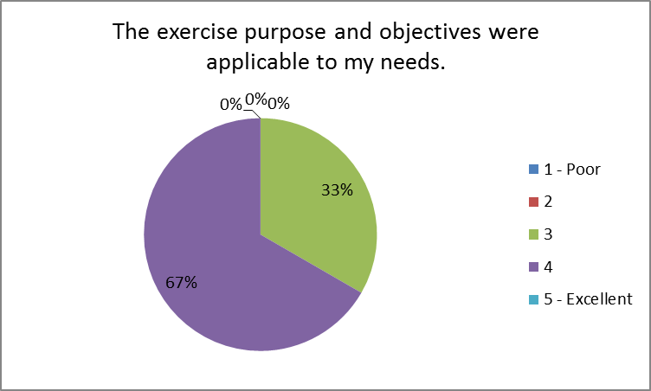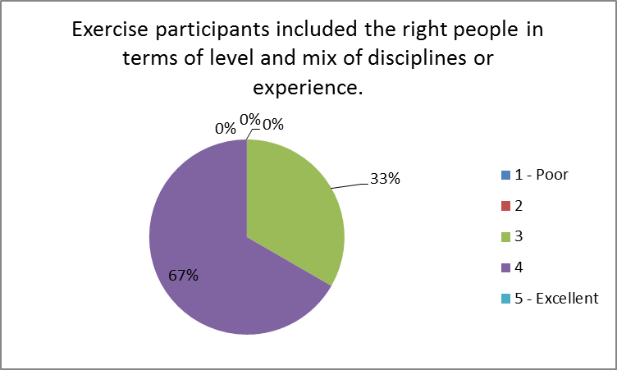

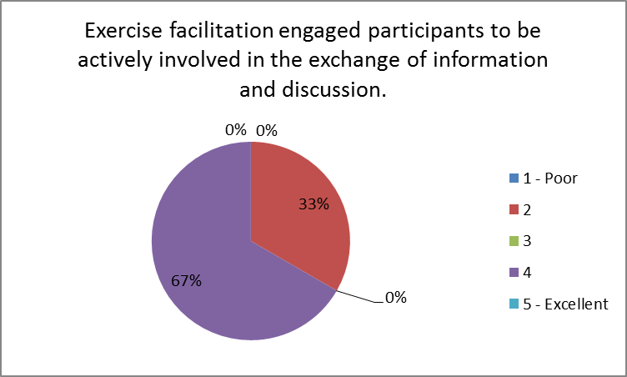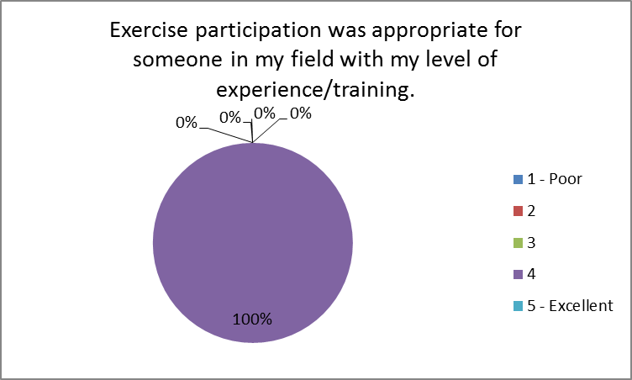

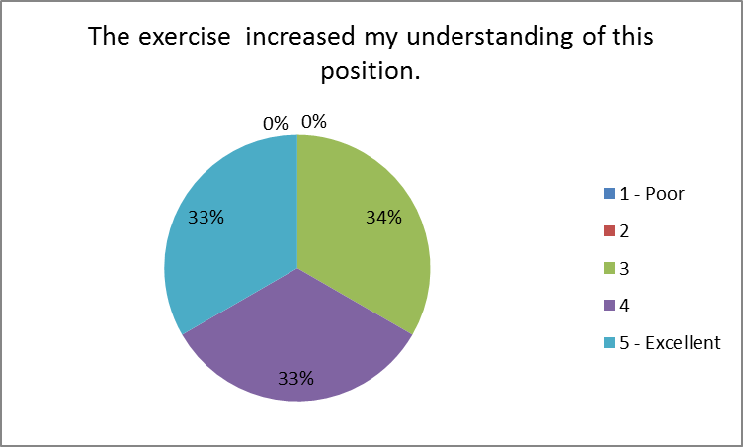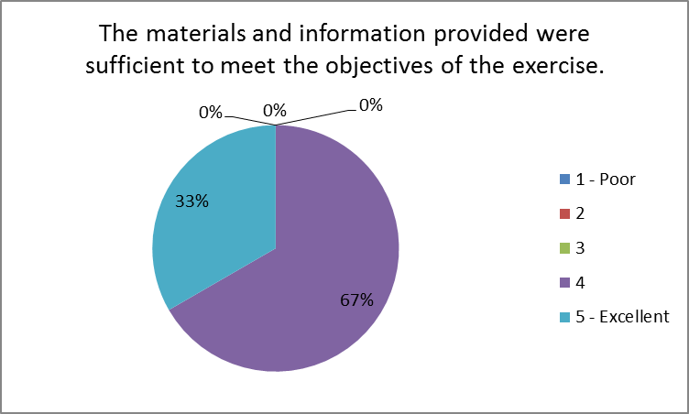

Describe information or discussion that was most helpful during this exercise.

- Details of national EMS contract.
- None

Describe outstanding questions or gaps in information that remain following the exercise.

- Details of integrating outside resources from national contract and EMAC. Need to work through this and integrate in comprehensive logistics plan.
- There should have been more info on the National EMS contract. I felt as though no one really knew much about the resources.

Please provide any recommendations for future training, workshops, or exercises that would help address any identified gaps or areas for improvement.

- Workshop to focus on evac planning details, executive summary for state and hospital leadership, and logistics plan for big move. All should be put into comprehensive Field Operating Guide (FOG) for distribution to local, regional, and state staff like CRES Plan.
- None

March 1, 2017
The feedback below was gathered from the participants following the exercise.
Assessment Factors | 1 - Strongly Disagree | 2 | 3 | 4 | 5 - Strongly Agree
The exercise purpose and objectives were applicable to my needs. | 0 | 2 | 2 | 5 | 3
Exercise participants included the right people in terms of level and mix of disciplines or experience. | 0 | 2 | 2 | 4 | 4
Exercise facilitation engaged participants to be actively involved in the exchange of information and discussion. | 1 | 1 | 1 | 4 | 5
Exercise participation was appropriate for someone in my field with my level of experience/training. | 0 | 2 | 2 | 2 | 6
The exercise increased my understanding of this position. | 0 | 2 | 2 | 4 | 4
The materials and information provided were sufficient to meet the objectives of the exercise. | 0 | 2 | 1 | 6 | 3

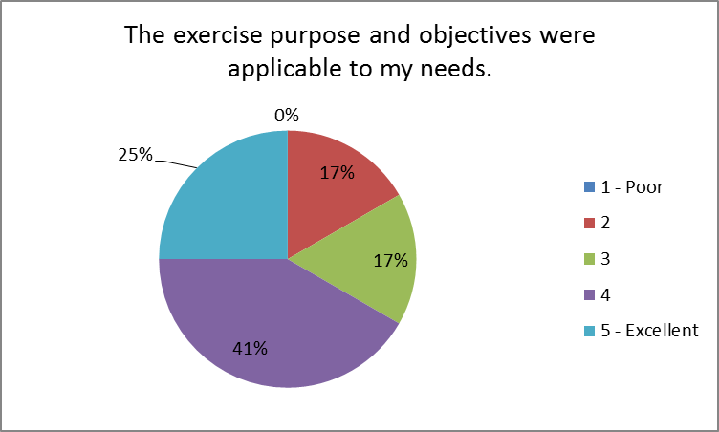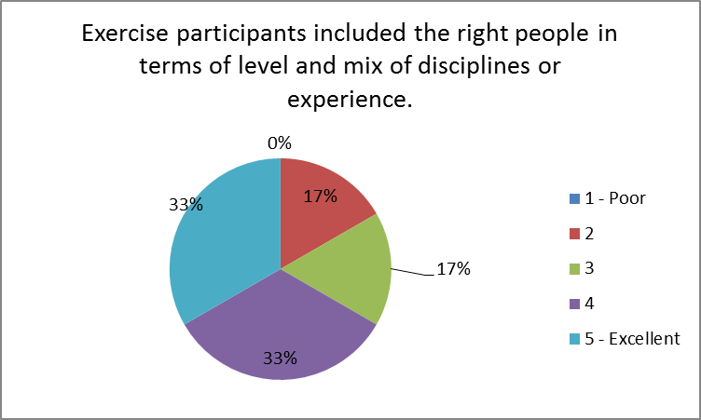

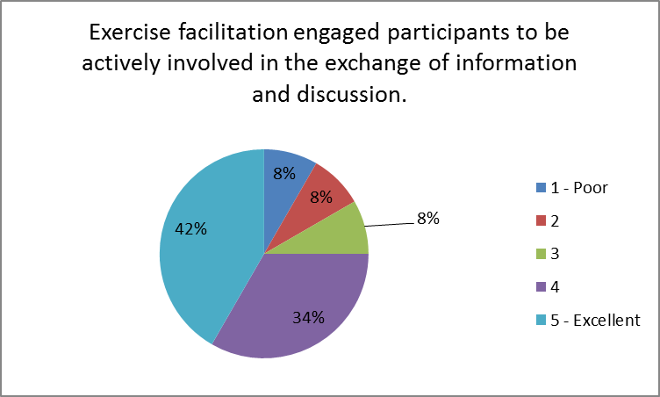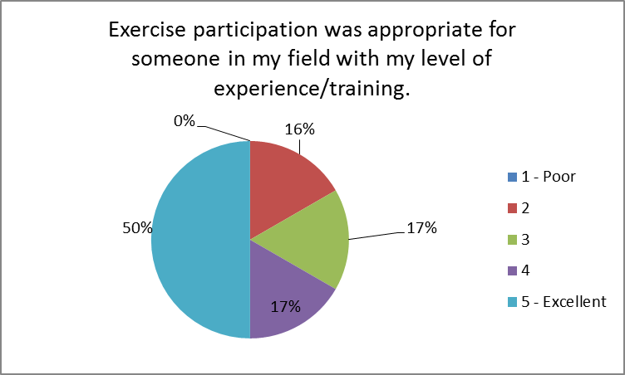

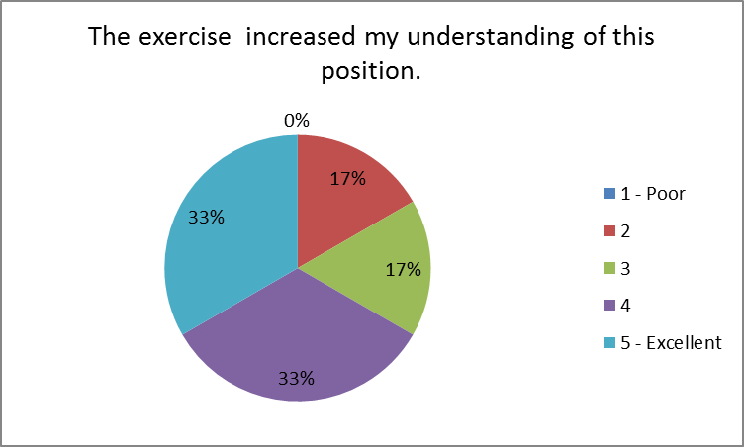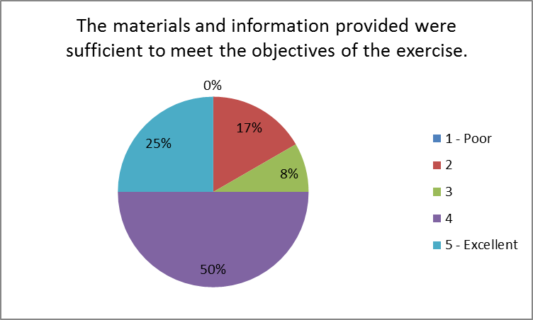

Describe information or discussion that was most helpful during this exercise.

- This exercise helped others that are new to the EM role to understand how evacuations and bed placement works.
- n/a
- Learning more about WebEOC and utilizing it.
- Able to talk with EMS and finding out that some things we are able to do and keeping the communication open.
- I gained a better understanding of how area hospitals view patient evacuation, the struggles with decision making and their transportation requirements. I viewed this process against the structures and needs we use in the military hospital system.
- Coordination with Vidant Beaufort.
- Having the SitMan's was helpful. Some facilities had to hold our discussions at times other than what was scheduled and we did not receive the injects that were presented during the actual session (ie: updated storm paths, etc).
- Overview on WebEx prior to exercise was most helpful.
- Testing the information sharing on WebEOC exercise through week helped brush up on documentation skills on WebEOC.
- The injects encouraged organizations to work together.
- Coordination
- All of the information was helpful for me to gain a better understanding of each players’ role in the overall process of evacuation and moving patients in this type of incident.

Describe outstanding questions or gaps in information that remain following the exercise.

- Found we need more training on the WebEOC for those that are new to EM.
- I still have questions about the viability to transport critical care patients or any other level of patients for that matter, within the 24-hour period of projected landfall. For a CAT IV or greater weather event there will probably have been a mandatory citizen evacuation order by state leadership which I believe will greatly complicate the ability to move patients in a timely manner. I also believe you will stretch the working day and transport times for any ambulance crews attempting to support the requirements. I think another exercise like this one should take place and include a meteorologist from the National Weather Service who could provide rain, river flood issues, and wind speeds using models from past hurricane events. This would add realism and hopefully identify any gaps in time to distance for evacuation. I strongly encourage a session for senior leaders based on lessons learned from this exercise to discuss timing challenges, the potential volume of patients to move versus the transportation available and the impact on staff and patients if you wait too long to make an evacuation decision that mandates sheltering in place. (Example; Southeastern Regional Medical Centers’ challenges during Hurricane Matthew which wasn't even a CAT II.) I believe most leaders envision a best case scenario plan versus the requirement of EMs and key staff to view the worst case scenario plan to better prepare their facilities for any contingency.
- Early on decision for staging of equipment and personnel.
- I think bed coordination is a huge issue. Currently, our facilities will have to call other facilities searching for beds. This will cause frustration (on both ends of the call since there will be numerous calls made) and most likely will result in significant delays. There is also a very large nursing home/assisted living population that was not included in the exercise but will have a major impact on transportation. Another group would be mental health patients, both inpatient and outpatient. It would also be interesting to have DOT involved to determine their triggers for reversing traffic, etc. during a large-scale evacuation
- Emergency Management not be able to have access to Health WebEOC - this resulted in not having basically any of the information regarding the movement of patients, movement of resources, status of resources, etc. This needs to be addressed...not for an exercise as much as for a real event.
- Defining a specific format for when and where to document especially on bed coordination or request. SMARTT System or WebEOC.
- None
- I believe the hotwash and review of the drill will answer any outstanding questions.
- N/A

Please provide any recommendations for future training, workshops, or exercises that would help address any identified gaps or areas for improvement.

- Training on WebEOC and SMARTT. This will be helpful for the new ER manager.
- 1) Have a solid communications back up plan for any exercise to include slide deck distribution for those unable to access WebEx and as a backup for connectivity issues.
- 2) Have State OEMS, at a minimum, require all affected area hospitals participate in the patient transfer day exercise to receive future support and as a means to validate future planning.
- 3) Incorporate a State Highway Patrol rep in patient movement day at either 48 or 24 hours to inject realism in traffic management challenges based on prior experience. This would allow you to better predict probable transport times at each 24-hour mark and then with 24 and 12 hours of landfall.
- 4) With any mass movement of critical care patients there is a strong possibility of loss of life during transport. A DMORT section should be included to consider those challenges.
- 5) The after action/hot wash lessons learned from this exercise should be presented to key leaders so the RAC leads can identify desired stakeholder outcomes. This should be followed by the development of outcome measures and finally another TTX to validate the selected outcome measures were realistic and solutions were viable. The ASPR gap analysis could be included as a starting reference point.
- Bottom Line Up Front (BLUF): Unless a majority of the medical facilities are willing to actively participate and provide meaningful feedback, any evacuation consideration will continue to frustrate planners! Senior leadership buy-in and involvement is critical to making the process a success!!
- Allow EM and County EOC participation on WebEOC not the health side. We believe this can be done and would have enhanced the amount of participation.
- See above.
- Communication vehicles when and where and what.
- None
- WebEOC training as I have a need to train others to have access.
- N/A

Appendix D: February 24, 2017 – Morning Worksheet Summary

- Organization name:

The Outer Banks Hospital
Vidant Duplin Hopital
NHRMC
Vidant Beaufort
Dosher Memorial Hospital
Vidant Home Health and Hospice
Bladen Healthcare, LLC

- Point-of-contact name:

Jo Bailey
Dana Rousay
Mark Bennett
Nat Gladding RN
JoAnn Turzer-Commesso
Scottie Gaskins
Traci Priest

- Point-of-contact job title:

RN
EM Coordinator
Emergency Manager
ED Nurse Manager, Chair Emergency Management
Director of Patient Care Services
Sn. Admin
Director of ED/ICU/Med-Surg

- Point-of-contact email address:

joanne.bailey@vidanthealth.com
dana.rousay@vidanthealth.com
Mark.Bennett@nhrmc.org
nat.gladding@vidanthealth.com
joannturzercommesso@dosher.org
sgaskins@vidanthealth.com
tprie@capefearvalley.com

- What are the considerations for deciding to evacuate (full or partial) or shelter-in-place?

Outside Coordination
Three facilities said that they will coordinate with county, regional, or state emergency management in deciding whether to evacuate or shelter in place. Additionally, two facilities have input from their corporate IC/EOC.

Weather and Impact
Two facilities said that part of their decision is made based on the predicted impact of the storm, while other facilities mentioned the storm track, the confidence in the forecast, and past experience during weather events. One facility said that one of their considerations would be whether the external environment posed a greater danger to patients, staff and visitors.

Structure
One facility said that the structural stability of their buildings is taken into consideration and another spelled out their organization’s plan, with specific references to which buildings were rated for what level of storm, and what their evacuation/shelter plan is depending on the predicted severity

Capabilities
One facility considered whether there was adequate and timely facility and/or mutual aid resources available or accessible, and whether that hospital has the capabilities adequate to care for the patients and staff.

- At what point prior to landfall do discussions about pre-landfall actions begin to take place?

Three facilities reported that their discussions begin at 96-120 hours, and one facility said 72-96 hours. Three facilities mentioned other factors such as soon as a storm is named or when a storm is identified which has a potential impact/threat to their area.

- How do you decide which patients will be evacuated or sheltered?

All of the facilities reported that they would evaluate their patients; one facility said that the hospitalist(s) would perform this review, another said that input would be gathered from providers, case management, and nursing and a third facility said that coordinated discussions would be with each office manager, case managers and patients/family, the rest of the facilities did not specify the decision makers.

Three facilities said that patients healthy enough to be discharged would be before the storm hit. One of those facilities said that for any patient that continued to need in-hospital care, they would then coordinate transfer. Another one of those facilities said that they would determine which patients could possibly deteriorate during the storm for possible movement to higher level of care. The third facility specified their tiered triage plan, with Tier 1 patients being too sick to move, and the numbers would be reduced prior to the storm by cancelling surgeries a specified time before a storm. Tier 2 patients would be the ones evacuated, and they were the ones who are stable enough for transportation, but are critical in nature and very susceptible to power fluctuation, such as vent dependent, chest tubes, etc. Tier 3 patents are stable, able to assist in their daily care, but are unable to be discharged. They would be sheltered in place. The lowest tier, Tier 4 are the patients who would be discharged.

Another facility said that they would evacuate most critical (ICU), total care, GCS less than 15, and/or unable to ambulate first. They would shelter observation patients that are ambulatory and A&O x4.

One facility said their determination would be by acuity, viability and bed availability at other facilities. This was the only facility that referenced the receiving facilities’ capabilities.

- What criteria are involved in the decision of which patients will be evacuated or sheltered?

Evacuation Destination
Two facilities indicated that characteristics of the destination(s) would be part of the criteria – is the facility safe (no history of flooding)? Are there caregivers present? One of those facilities also mentioned whether the receiving destination can meet the special needs of the patients.

Facility Dependent
One facility said that their criteria would be if a Category 4 hurricane threatened to impact the facility, and that threat being defined as being within the error cone of the hurricane. Another facility said that the ability to meet the need is one of their criteria. Another facility stated that the services their facility would be able to provide would be a considering factor. One facility also said that caregiver status would be a consideration.

Patient Criteria
Three facilities specifically stated that patient acuity would be a consideration and one of facilities specified that mother/baby couplets would be the second tier of patients evacuated after critical patients and before less critical. One facility said that the special needs (vent, IV, O2, Bedbound, extensive wound care) of the patient would be a factor in determining whether they are evacuated or sheltered in place.

Other
One facility said that they do not shelter in place at the beginning of a storm – all patients would either be evacuated or discharged, and that they would only shelter in place during or after a storm if new patients present to facility. Another facility said that they would evacuate all patients or would shelter in place any who could not be discharged.

- Who is involved in the selection of each group of patients (those to be evacuated and those to be sheltered)?

Five facilities listed physicians, hospitalists, intensivists, or providers as being involved in the decision. Case management or patient care services were listed by three facilities. Charge nurse and other nursing staff were listed by two facilities. Clinical leadership, department leadership, Chief of Staff, CNO, and Chief Medical Officers were listed by five facilities. Three facilities listed incident command, the logistics officers from IC and the local county’s emergency management.

- How is the priority of which patient leaves first determined?

Acuity of patients, the placement location, patients’ priority level/critical patients first and availability of transportation resources were each listed by two facilities as factors determining priority. One facility said that the distance the patient has to travel versus the predicted onset of conditions that will prevent travel is one of the determining factors. Another facility said that the priority for their Tier 2 patients was determined based on the greatest risk of mortality by staying behind. Other factors mentioned were providers and bed availability.

- What agencies or individuals outside of the hospital need to be contacted about your decision to evacuate and/or shelter in place?
The top outside agencies listed by facilities were the County/Local Emergency Management and EMS, ambulance/transportation services or rescue groups. They were each listed by five facilities. The next most common organizations to notify were corporate offices or other corporate facilities and home health agencies or individual caregivers. Other agencies/individuals listed by facilities included the placement facility, long term care facilities, regional HPP, surrounding hospitals, NC SMARTT, Eastern HPC contact, the town, medical staff, NCHA, DME company, pharmacy, SNFs for potential placement of patients, and shelters. One facility said that their PIO would disseminate their decision to other agencies.

- Who makes these notifications to agencies or individuals outside the hospital?
- Case manager
- Clinical Leadership
- CNO, Incident Command and Hospital administration
- Command staff
- Hospital command center and liaison position
- Logistics Section Chief
- PIO or IC as needed
- Staff in hospital

- Which hospital services would be suspended during an evacuation?
- All elective/non-emergent services
- All non-emergent procedures and admissions
- All outpatient and support services such as urgent and primary care offices.
- Elective surgeries
- Eye or pain clinic
- No new admissions (i.e. no discharges from hospital to home based service)
- Nonessential service departments would be suspended (Cardiac Rehab and other outpatient scheduled procedures may be suspended)
- Outpatient care would be suspended including clinics, surgeries, lab, radiology, respiratory, etc. Inpatient med/surg, ICU, L&D, Surgeries would be staffed but new admissions wouldn't be taken.
- Routine visits to patients
- Supply deliveries

- Which hospital services would be suspended during shelter in place?
- All elective /nonemergent services
- All non-emergent procedures and admissions
- Cancer Center and any outpatient services completed on campus. Business support center operations such as billing,
- Elective surgeries, nonessential service departments would be suspended (Cardiac Rehab and other outpatient scheduled procedures may be suspended)
- No new admissions (i.e. no discharges from hospital to home based service)
- Outpatient care would be suspended including clinics, surgeries, lab, radiology, respiratory, etc. Inpatient Med-surg, ICU, L&D, surgeries would be staffed but new admissions wouldn't be taken.
- Routine visits to patients
- Supply deliveries
- We shelter staff for all regular services. ED, Medical, L & D, OR, Radiology, Registration, Materials, Housekeeping, Food services, Physicians for each medical area

- How quickly can a list of patients for evacuation be developed?
- Minutes
- As soon as the information is obtained, within 30 minutes. The census information would have been collected earlier in the preparation process and updated once evacuation was decided.
- 60 minutes
- One hour
- 12 hours
- 24 hours
- It depends on the census, acuity of patients, and which Provider is on duty.

- What steps are necessary to prepare a patient to move?
- Acceptance at another facility, doctor to doctor, then call EMS for transport.
- Caregiver prepare home Medications, supplies, O2, clothing. Determine destination based on special needs. Arrange transportation. Plan for caregiver?
- Discuss with patient and family. Locate receiving facility and provider. Package all paperwork (print chart if patient not going to a facility that has EPIC). Arrange transportation
- Evaluation of equipment needs, discussion with patient, bed availability
- Prepare patient, contact family, obtain accepting facility and obtain transport.
- 1. Provider assessment 2. Patient and family communication 3. identification and acceptance by transferring facility 4. transportation arrangements and ETA complete transfer form 5. prep of needed supplies to go with patient 6. prep of needed medical record information (transport packet (labs, med list, problem list, pertinent findings etc.))
- Verification by primary physician, notification of available transport. Patient is moved to evacuation staging area (Surgery Pavilion) approximately 30 minutes prior to transports arrival. Patients will be moved to staging in waves based on known transport unit availability.

- What paperwork is needed to prepare a patient to move?
- Agency contact information
- Contact primary MD
- Copy of labs, x-rays, EKGs, etc.
- Copy of plan of care for receiving facility
- DNR if applicable
- Identification
- Medication lists
- Normal transfer paperwork/ EMTALA Transfer form
- Patient record
- Printed chart
- Summary, MAR, etc.

- What contacts need to be made to prepare a patient to move?
- County Emergency Management
- DME company
- Family member
- In home aid providers/caregivers
- Patient
- Pharmacy
- Receiving facility
- Shelters (who coordinates?)
- SNFs for potential placement
- Transportation asset/EMS

- What equipment will go with each patient?
- Assistive devices – walkers/wheelchair
- Depends on patient acuity, patient needs, and transportation distance
- Depends on supplies on transportation vehicle
- Diabetic supplies
- Equipment needed to maintain patient at same level of care
- Extra batteries
- IV pumps if on fluids
- Medications
- None
- Personal belongings
- Portable O2
- Tube feeding/nutrition supplies
- Wound vac and/or wound care supplies

- Who is responsible for moving patients?
- Assigned patient care staff and other assistance as needed
- EMS
- Facility to facility – as directed by receiving facility and based on available transports
- Incident Command, DON and department director to authorize movement and assigned RN facilitates transfer
- Nurses caring for patient
- Patient/Caregiver – Agency is responsible to education them on evacuation need, assist with plan and coordination as needed
- Staff
- Transporters

- How many patients can staff move per hour?
- 2 safely
- Approximately 4 per hour/ depending transport availability
- Depends on method of transportation, acuity level of patient, functionality of elevators
- Depends upon staging and arrival of transport units and number of patients per transport unit
- N/A
- Not an issue for this facility.
- Unknown, assuming 25/hr

- How long can staff carry out the task of moving patients before fatigue impacts them?
- 8 hours
- 8-10 hour shift
- Depends on method of transportation, acuity level of patient, functionality of elevators
- N/A, not an issue at this facility
- Rotating staff
- Unknown

- Will a staging area within the hospital be utilized for patients waiting for evacuation?
- Due to being a smaller hospital, we would be able to coordinate from the units.
- N/A
- No
- Not for a staged evacuation
- Not for weather related event
- Yes
- Yes, surgical pavilion

- Where / how will patient movement and transportation assets be obtained?
- Contact system resources (East Care)
- Contract with transport companies, request assistance from EMS for special needs transport
- County/local EMS. Outside EMS
- local and state level resources
- Local critical care division along with resources provided through mutual aid and state
- Managed through incident command and coordination with our corporate Emergency management at Cape Fear Valley
- Via phone, viper scanner in the ED and via emergency management routes, BC and regional updates, WebEOC

- How are patient transportation assets requested?
Most facilities said that patient transportation would be requested by calling those transportation agencies directly. Other facilities said that they would work through local, county regional and state level resources/incident command. One facility said that only in a large event evacuation would Emergency Management or a regional committee be involved, otherwise the Charge nurse would coordinate via phone or viper. One facility said they would contact their system resources. One facility said that critical care via vendor contracts (Air Methods National mutual aid contract) and NCEM Assignments.

- Who manages patient transportation?
- Case Management
- Clinical Manager
- Hospital staff gives report to EMS personnel
- Logistics Officer/Logistics Branch of EOC
- Physician who has assumed care for patient
- Transport Officer in coordination with Staging Officer

- Who decides the evacuation route once patients leave the hospital?
- DOT director, County Emergency Management Director, county & regional incident command in collaboration
- EM
- EMS/driver/transport asset
- Local law enforcement
- NC Highway Patrol

- Who will determine the destination for each patient?
- Based on NCOEMSs approved bed availability. Patients will be assigned to a transport unit in staging and that patient will be transported to the facility that was matched with the bed needed/provided by NCOEMS/EM/BCC.
- Destination, by hospital staff, physician, and bed availability. Obtained prior to calling for transport.
- DON
- Patient Care Services/Case Management based on availability of beds, patient preference, or previous/established care with other facility.
- Patient/caregiver may arrange their own destination; if unable to secure appropriate site, agency will assist. Based upon clinical need /special needs.
- Planning section chief
- System support will be requested, local and state level EM

- What is role of hospital staff in patient transport?
- Communication, support patient and family, patient safety and care until released to responsible agency, provide verbal and written report. transfer forms etc.
- Moving patient from room to staging
- N/A
- Other than making sure patient gets placed on EMS stretcher and paperwork given --- NONE
- Preparation of patient, may have to provide care during transport.
- Prepare patients and paperwork, handoff communication, patient tracking
- Provide complete paperwork, transfer forms, report to receiving facility to transfer care.

- What is the role of hospital staff with patient families?
The primary responsibility is communication – making sure the families know the decision making, patient destination, etc. Other roles can include providing support and connecting families to resources at the receiving facilities, education, assisting in coordination of resources, assure supplied. PIO can be involved in communication within HIPPA compliance.

- Will hospital staff travel with any patients during transport?
Typically, no, unless special circumstances – Coast Guard providing transport, patient needs higher level of care than what is available, staff being Critical Care Transport Staff, to maintain appropriate level of care, or if needed.

- If staff travel, where will staff go once the transfer of the patient is complete?
- Dependent on need- if the transport was returning the staff would return to assist with needs at facility. If transport wasn't returning, they would report to incident command at the accepting facility.
- In the past the staff has been picked up from where the helicopter has taken the patient. There has been no contingency made for any other staff travel.
- N/A
- Plan is to complete transporting via local assets, 12 hours prior to landfall.
- Staff may be assigned to continue taking care of patient in receiving facility (volunteer privileges) or may return to Hospital. Not sure how?
- They will return with ambulance.

- How are potential patient destinations located (e.g. open beds)?
- Based on table top local and state level EM Eastern PAC, NC Smartt and identified system resources
- Call SNF/ Hospital/ ALF to see options for placement of patients
- Calling the hospital that has the appropriate services the patient requires. If no bed then patients go on to the next facility until an appropriate bed is located. Usually a physician to physician call.
- Case Management personnel call facilities that are located in our health system or are close to the patient’s home or facilities that the patient has previously established care with.
- Inland hospitals contacted. Columbus County, then westward. Use of WebEOC , contact with regional partners.
- NC SMARTT system
- Per the Bed Coordination Center

- How are patient destinations assigned?
- Assigned by facility inland ability to accept and treat patients.
- At Staging, based on assigned bed types at available facilities, then next truck in line will transport said patient. Plan is to fill all assigned facility beds at the same time. IE: 12 patients to Wake Med 2-Critical Care, 2 ALS, 3 Peds, 4 NICU, 1 Psych. This will allow the next 12, or so, trucks assigned will travel together as a unit
- Availability
- Based on availability and travel time versus onset of severe weather
- Case by case
- See above
- Through CFV and Southeastern Trauma Regional Advisory Committee

- What impact will outside factors like road closures, widespread utility failure in the community, or evacuation of other community healthcare facilities have on evacuation of the hospital?
- All evacuations should happen 12 hours prior to landfall to eliminate this as much as possible. Other evacuating facilities will cause multiple requests for resources.
- All may slow or prevent our ability to evacuate.
- Could hinder accepting facilities and bed availability.
- Inability for patients to leave home on their own which may result in emergency transport to evac. If hospital, SNF, etc. evacuated, would impact our ability to place patients from home to facilities leaving patients at risk in the home.
- Road closures are a big threat. We attempt to make sure the patient is well on their way prior to any closures. We have two bridges and that is all. If they are closed and there is no flight then the patient would have to stay until other arrangements could be made. We have two generators that are tested regularly, if there is flooding then the generators may be compromised as they are on the ground. Our hospital base is 14 ft. above sea level and the flooding would almost have to be a tidal wave.
- Unknown
- Will limit resource availability. Community facilities may request to evacuate to the hospital.

- What were the positive things your organization identified about its planning for an evacuation?
- Decision made that we would not evacuate early but would consider patient movement if there was a facility wide utility failure
- Historical event experiences have prepared
- Our policy and procedures are in place and streamlined to easily follow.
- Verified our process for identifying patients, and prioritizing. Formal process to be build following this exercise.
- We are proactive in preparing a plan, we have appropriate leadership involved, early collaboration with our corporate entity.
- We got this. Everyone knows their role and it is easy to instruct the new staff. We do a lot of information sharing at the beginning of the season. We encourage staff to have a plan – for self, family, pets, etc.
- We have never evacuated this facility so this opened multiple conversations on layers of command and communication.

- What were the strengths your organization identified about the response activities it would employ during an evacuation?
- All the staff pitches in. We have teams – to stay, to come back and take over, to come back and work their regular shifts.
- Collaboration with local, regional and corporate Emergency Management teams.
- Good communication between internal departments and external agencies
- We are well prepared to decompress and shelter in place. Would need to drill as a system to work on full evacuation of a facility we usually receive instead of sending.
- We would closely monitor storm and have several planning meetings both internally and with the community to discuss preparation.
- When we planned on doing is functional and can be met.

- Explain issues or concerns that created challenges or hindrances for the organization's response.
- Concerned that any event that prompts evacuation would take place during or after the storm when conditions would make it very difficult or impossible to move patients to other facilities.
- Concerns regarding who is the established backup person for the county Emergency management director in his absence. Also, persons assigned to receive and have access to update WebEOC and NC Smartt system.
- Inability to locate employees via call tree, needing more people who know/comfortable with operation of communication systems. Inconsistent internal communication with employees. "All employees need to get same message."
- None identified at this time.
- Populating patient evacuation form is difficult without a EPIC report available to populate said information from existing table fields. searching the chart for this information is not viable option.
- Some duplication of patient census across programs
  - Not all able to pull into single list.
  - Limited information accessible in report form i.e. IV, Vent, Wound, Bedbound
  - Limited knowledge about special needs shelters and resources.
- Used to much more detail on weather and county EM involvement earlier in the process.

- List specific actions that can be taken to address any concerns or improve the organization's emergency management capability.
- Education on a regular basis for employees.
- Establish and maintain communication with community agencies when preparation begins.
- Establish standard emergency census report Establish internal command center structure for HHH and better coordination within Vidant system entities in common territories.
- Finalizing a process for a patient evacuation identification and submitting information requested to NCOEMS.
- None Identified at this time.
- Review persons responsible and plan for updating WebEOC and NC SMARTT system.
- System level - one call to system level EOC. Continue to drill routinely

- Provide suggestions for improving regional collaboration among healthcare providers.
- Education on a regular basis for healthcare providers.
- Hold county wide emergency management collaboration meetings twice a year to review countywide plan to include nursing homes, hospitals, home care, and group homes. At least an annual collaboration at the regional level to address all of the same entities.
- More coordinated communication - early in process with hospitals, EMS, facilities.
- Need more exercises like this, but these need to be done as a region, not multiple regions....
- None
- Use various methods for communicating and establish communication in the planning stage.

Appendix E: Schedule of Events

The Big Move Full Scale Exercise
Multi-day Exercise Play Schedule
Note: The details within several of the days has changed based on player input and availability. Please review each day.

Scenario: A weather advisory is issued on September 16th that indicates the development of a tropical depression in the Caribbean. Hurricane Hans strengthens to a Major Hurricane on September 18th (120 Hours). During the track of the storm, initial land fall occurs in Haiti as a Category 4 Hurricane on September 19th, then hits lower Florida on the early morning of September 22nd as a Category 3 Hurricane. The last advisory demonstrates the land fall of Hurricane Hans as a Category 4 storm near Topsail Beach on September 23rd with wind speeds of 130 mph.

The last advisory also reports that the Hurricane will decrease in forward movement and remain a strong hurricane as it moves inland. Coastal storm surge is expected to be 15 to 20 feet above mean sea level. This projection will prompt the activation of the Coastal Region Evacuation and Sheltering Plan as well as trigger agencies to perform their pre-landfall operations for a severe hurricane threat. The impact from the storm is predicted to be widespread on Eastern North Carolina’s healthcare and critical infrastructure.

Day 1 – Wednesday, February 22, 2017
1 PM – 2 PM – Exercise Briefing
Location: The Chelsea (335 Middle St, New Bern)
Participants are welcome to come in-person or participate by webinar (information below). Exercise control, evaluation, and logistics will be discussed.

Note: The Hospital Disaster Patient Transfer Form will be disseminated by email to all hospitals for completion by the morning of Day 3 (February 24).

2 PM – 4 PM – Tabletop Discussion: Notification and Declaration Process (120 hours to landfall)
Location: The Chelsea (335 Middle St, New Bern)
Players: Local and State EM, Healthcare Preparedness Coordinators (HPC), OEMS
Objectives:
- Test the actions taken after state level declarations of an emergency.
- Ensure sufficient communication takes place and appropriate resources are mobilized with the declaration of emergency.
- Examine the local and state emergency managers and OEMS decision-making process and considerations for evacuation at 120 hours to landfall.
- Discuss the process to assess current hospital status with WebEOC and SMARTT requests. Establish a time for completion of the assessment.
- Identify at-risk populations within the potentially impacted areas of the State.
Process: Facilitated discussion with in-person participants.
Evaluation: Assigned evaluators will use an Exercise Evaluation Guide (EEG) to document discussion. Participant Feedback will be gathered by SurveyMonkey.

Day 2 – Thursday, February 23
No morning activity

1PM – 3PM – Tabletop Discussion: Hospital Evacuation Triggers (120-72 hours to landfall)
Location: In-person at the Monroe Center (2000 Venture Tower Drive, Greenville, NC) or by webinar at each facility (webinar information below).
Players: Hospitals, OEMS, Local and State EM
Objectives:
- Activate hospital command centers.
- Examine the various triggers and considerations before hospital evacuation.
- Determine if local agencies, facilities, special needs populations, and communities are provided sufficient time to respond once evacuation is initiated.
- Implement internal and external communications systems to coordinate the evacuation.
Process: The exercise will be facilitated from a central location in Greenville. The scenario, injects, and other discussion questions will be provided by webinar and conference call to all virtual players. Once information is presented, sufficient time will be allowed for real-time discussion at each participating facility. After the discussion, the “chat” feature will be used to report back discussion items and to gather information. Participating hospitals will need the ability to participate by webinar and by conference call.
Evaluation: A Recorder Handbook will be provided to participating hospitals. Documentation of discussion and communications will be conducted by evaluators at hospitals who will monitor exercise discussion or activity. Evaluators will return their Recorder Handbooks to TheBigMove@AllClearEMG.com. Participant Feedback will be gathered by SurveyMonkey.

Day 3 – Friday, February 24
9AM – 1130 AM – Tabletop Discussion with Functional Components: Hospital Decompression and Evacuation Planning (72 hours to landfall)
Location: Each Hospital
Players: Hospitals, HPCs, OEMS
Objectives:
- Using a real-time scenario, determine the number of patients requiring outside resources for evacuation.
- Submit completed Hospital Disaster Patient Transfer Form to HPCs (forms distributed on Day 1).
- Utilize normal and backup methods of communication to share information among regional partners about the number and type of patients evacuating.
- Participate on a regional conference call to discuss data and communication needs.
- Query for open beds in other regions.
Process: All participants will join the webinar for a short exercise briefing. The exercise will start with the decision to evacuate all or part of the facility. During the briefing, a list of questions will be provided to each facility along with instructions for completion. Each facility will then break off and gather the information requested. After the allotted work time (or when hospitals complete the worksheet), facilities will use a conference call and WebEOC to report back their information (see webinar information below). Facilities will also have to submit their answers per the instructions on the worksheet. Participating hospitals will need the ability to participate by webinar and by conference call.
Evaluation: A Recorder Handbook will be provided to participating hospitals. Evaluation will be conducted by evaluators at hospitals who will monitor exercise discussion or activity. Participant Feedback will be gathered by SurveyMonkey.

1PM – 3:30 PM – Functional Exercise: Bed Coordination (72 hours to landfall)
Location: The Chelsea (335 Middle St, New Bern)
Players: Bed Coordination Center, OEMS, HPCs
Objectives:
- Gather and analyze patient information and resources from the Hospital Disaster Patient Transfer Forms.
- Coordinate the transport and placement of healthcare patients to by determining destination facilities and routes of travel.
- Conduct a conference call to determine gaps and next steps.
Process: Based on the information provided in the morning session, participants will simulate the state ESF-8 desk to coordinate bed availability, patient placement, and patient transport.
Evaluation: Assigned evaluators will use an Exercise Evaluation Guide (EEG) to document discussion and activities. Participant Feedback will be gathered by SurveyMonkey.

No Exercise Activity on Saturday, February 25 and Sunday, February 26

Day 4 – Monday, February 27
9AM – 11:30 AM – Tabletop Discussion with Functional Components: Transportation Resource Identification (48 hours to landfall)
Location: RCC East (Hwy 58, Kinston)
Players: OEMS, local EMS, local EM, State EM
Objectives:
- Assess the available transportation assets to support the requested healthcare evacuation needs (based on information from Day 3).
- Obtain real-time data from local transport agencies about actual availability of transport assets.
- Based on the real-time data collected, determine available transportation assets statewide, including the impacted region.
- Determine the amount of local coordination taking place prior to State assistance being provided.
Process: Participating agencies will be provided with data gathered during the previous days of exercise. Communication and coordination will take place as it would during a real event. The RCC East will simulate events that would take place in the State EOC.
Evaluation: Assigned Evaluators will use an Exercise Evaluation Guide (EEG) to document discussion and activities. Participant Feedback will be gathered by SurveyMonkey.

12:30 PM – 3:30 PM – Tabletop Discussion with Functional Components: National EMS Contract and Resources (48 hours to landfall)
Location: RCC East (Hwy 58, Kinston)
Players: OEMS, Local and State EM, HPCs
Objectives:
- Discuss the national EMS contract and where possible conduct the necessary steps to request those assets.
- Discuss the process for resource check-in.
Process: Resources will be allocated and communications made as if the event were real. Resources will be represented on a status board. Resources will not be driven from site to site.
Evaluation: Assigned evaluators will use an Exercise Evaluation Guide (EEG) to document discussion and activities. Participant Feedback will be gathered by SurveyMonkey.

Day 5 – Tuesday, February 28 (Simultaneous with Statewide Exercise)
Time TBD -
Location: State EOC in Raleigh
Players: State and regional coordinators
Objectives: From Statewide Exercise
Process: Evaluation of RHPC and OEMS involvement in statewide discussion. Will take place at the State EOC.
Evaluation: Assigned Evaluators will use an Exercise Evaluation Guide (EEG) to document discussion and activities. Participant Feedback will be gathered by SurveyMonkey.

Day 6 – Wednesday, March 1 (Simultaneous with Statewide Exercise)
Based on player input there have been recent changes to the activity for this day.
9AM – 12:30 PM – Functional Exercise: Hospital Evacuation (24 hours to landfall)
Location: Participating hospitals
The Big Move Exercise control location - 0830-1500
State Emergency Operations Center, Raleigh, NC
Players: Hospitals, HPCs, local EM, State EM, OEMS, local EMS
Objectives:
- Activate the patient preparation process for hospital evacuation.
- Utilize an exercise environment to practice the communications and information sharing steps required to move and track patients between hospitals.
- Determine gaps in evacuation processes and communications.
- Test the communication and coordination capability among healthcare providers within their respective region.
Process: Test the process for preparing and coordinating movement and tracking of patients among facilities. Hospitals and regional coordinators will engage in two-way, real-time communication to test mechanisms for communication, resource requests, and other needs that would occur as a hospital prepares to evacuate.
Participating organizations will either stand up a command center or simulate a command center. Requests for information, status updates, and situational information will be exchanged and tracked within the regions. The intent of this activity is to test healthcare coordination when one or more facilities are impacted and require assistance from regional partners or the State.
Local emergency managers may be participating in the statewide exercise. It will be helpful to know which agencies are participating so that injects and communications can be simulated or provided through normal operational channels.
Evaluation: Each participating organization will be provided with an Exercise Evaluation Guide (EEG) to document discussion and activities. Participant Feedback will be gathered by SurveyMonkey.

Day 7 – Thursday, March 2
10:30 AM – 12:00 PM – Exercise Hotwash
Location: The Chelsea (335 Middle St, New Bern)
Players: All participants
Process: Participants are welcome in person. For those that cannot make it, a webinar and conference call information will be provided.

Capability Elements are: Planning, Organization, Equipment, Training, or Exercise.

