Strategic Plan
Eastern Healthcare Preparedness Coalition
Fiscal Year 2017 - 2022

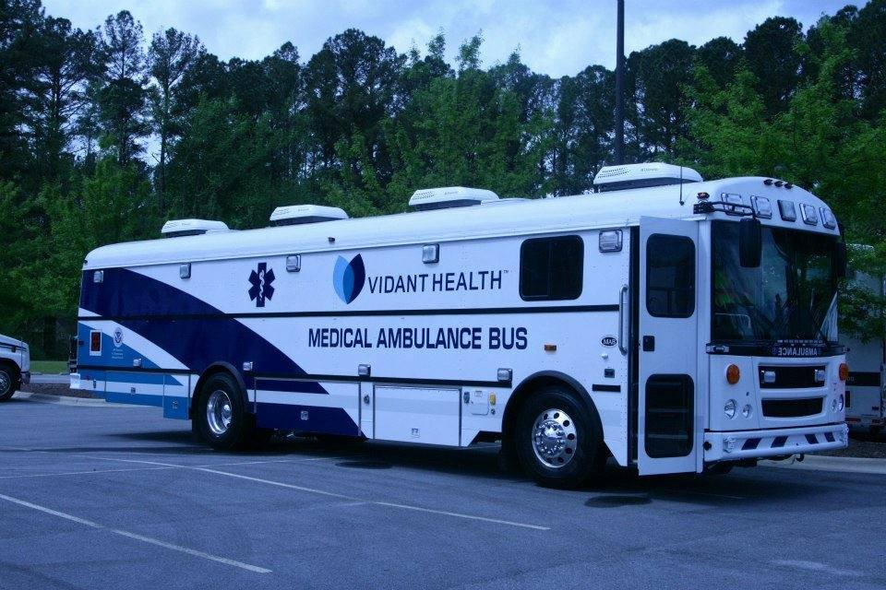

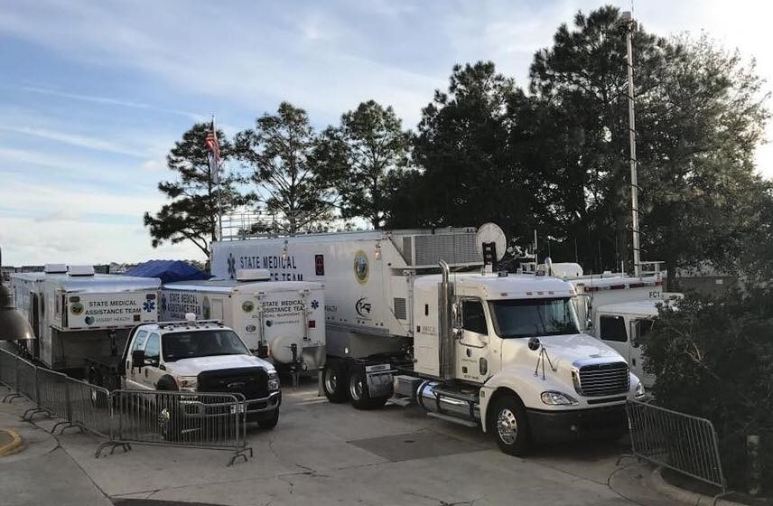
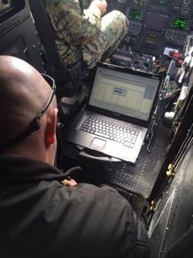

Table of Contents

Table of Contents 2
Executive Summary 3
Purpose of Strategic Plan 3
Development and Implementation of the EHPC Strategic Plan 3
Goals and Activities 3
Goal 1: Develop and grow a foundation for Health Care and Medical Readiness through developing strong relationships, identifying hazards and risks, and prioritizing and addressing gaps through planning, training, exercising, and managing resources. 4
Goal 2: Develop and grow the Healthcare and medical Response Coordination throughout eastern North Carolina. 5
Goal 3: Develop and support continuity of health care service delivery methods to assist in providing uninterrupted, optimal medical care to all populations in the face of damaged or disabled health care infrastructure. 6
Goal 4: Evaluate medical surge capabilities and Support and Coordinate Medical Surge Planning and Response operations. 6
Goal 5: Assist in the identification and planning efforts for at risk populations located in eastern North Carolina. 7
Outcomes 7
Appendix A: Acronym List 9
Appendix B: EHPC Strategic Plan at a Glance 10

Executive Summary
The Eastern Healthcare Preparedness Coalition is a network of health care organizations, providers and regional partners that are committed to strengthening the resiliency of the healthcare community in eastern North Carolina. The purpose of the Coalition is to develop a coordinated and effective response to all hazards through the following:
- Creating a foundation for health care and medical readiness.
- Improving health care and medical response coordination.
- Improving continuity of health care service delivery.
- Improving medical surge capabilities.
Membership in the Coalition is open to eastern North Carolina health care providers and partner organizations who agree to work collaboratively and coordinate prevention, mitigation, preparedness, emergency response and recovery activities. The Coalition’s work to develop emergency preparedness and response systems and resources will be of benefit to the entire community, not just Coalition members.

Purpose of Strategic Plan
The purpose of this strategic plan is to guide the work of the Eastern Healthcare Preparedness Coalition from the fiscal years 2017 - 2022. It is intended to be a dynamic document which will continue to evolve as necessary to ensure the Coalition is effective and able to sustain its efforts.

Development and Implementation of the EHPC Strategic Plan

The EHPC Strategic Plan is guided by the priorities of the coalition members and approved by the coalition executive committee. All EHPC partners were leveraged in the initial development of this strategic plan and each partner continues to play a critical role in supporting and developing the plan. All elements of this strategic plan align with and support the capabilities as listed by the Assistant Secretary of Preparedness and Response (ASPR). EHPC collaborates across all operating coalition partners to integrate preparedness into the daily routine of the healthcare community.
EHPC will implement this strategic plan with full leadership involvement and commitment to transform the strategy into action, tracking progress, and implementing course correction as needed. The strategic plan maps out the organizations broad direction, and the action plan provides detailed actions and outcomes that are needed to achieve the goals as described. This strategic plan will be published online and updated annually to reflect evolving activities and progress towards goals.

Goals and Activities

For a complete breakdown of each goal, objective, activity, and outcome by sector type, please refer to the EHPC Strategic Plan at a Glance Document. Appendix B.

Goal 1: Develop and grow a foundation for Health Care and Medical Readiness through developing strong relationships, identifying hazards and risks, and prioritizing and addressing gaps through planning, training, exercising, and managing resources.

Objective 1: Identify regional hazards and risks to be used as a basis for coalition and sector planning purposes.

Activity 1.1 - Complete and Review Annually the EHPC Hazard Vulnerability Analysis

Objective 2: Identify and address coalition and sector identified gaps through planning, training, exercising, and managing resources.

Activity 2.1 - Annual HSEEP Course

Activity 2.2 - Annual COOP Training for partners

Activity 2.3 - Pediatric Preparedness and Response Courses

Activity 2.4 – ABLS/ADLS and Train the Trainer Courses

Activity 2.5 - CMS Emergency Preparedness Rule training and education

Activity 2.1 – Attend and assist during healthcare agency exercises as requested

Activity 2.2 – Attend Eastern Branch Office Training Week

Objective 3: Identify and develop relationships between healthcare and response agencies.

Activity 3.1 – Annual North Carolina Disaster Symposium

Activity 3.2 - Attend and Support Stakeholder travel to annual conferences

Activity 3.3 - Support Quarterly Coalition Meetings

Activity 3.4 - Support Quarterly Subcommittee Meetings

Activity 3.5 - Continue building Email distribution List

Activity 3.4 - Attend Sector Meetings as requested

Objective 4: Engage membership and executive leadership in the development and maintenance of the EHPC Coalition.

Activity 4.1 - Annual Impact Report

Activity 4.2 - 5 Year Impact Report

Activity 4.3 - Develop new initiatives relevant to members’ needs

Activity 4.4 – Facility outreach and coalition overview presentations

Goal 2: Develop and grow the Healthcare and medical Response Coordination throughout eastern North Carolina.

Objective 1: Serve as a resource to coalition sectors for situational awareness and operational support

Activity 1.1 - Monthly Communications Testing

Activity 1.2 - WebEOC Training

Activity 1.3 - Continued Update of EHPC Website

Objective 2: Develop and Enhance a Healthcare Coalition that is considered essential to emergency preparedness and response and engage in sustainment efforts

Activity 2.1 - Partner with neighboring Healthcare Coalitions to better leverage planning and education resources.

Activity 2.3 – Regional Response Plan Update

Objective 3: Engage clinical leadership and garner executive level engagement

Activity 3.1 - Annual Impact Report

Activity 3.2 - 5 Year Impact Report

Activity 4.3 - Develop initiatives relevant to members’ needs

Activity 4.4 – Agency outreach and coalition overview presentations

Goal 3: Develop and support continuity of health care service delivery methods to assist in providing uninterrupted, optimal medical care to all populations in the face of damaged or disabled health care infrastructure.

Objective 1: Serve as a regional resource for Responder Safety & Health Training and Exercises for coalition partners.

Activity 1.1 - Annual Critical Incident Stress Management Course

Objective 2: Assist partners with COOP Planning that addresses essential healthcare services

Activity 2.1 - EHPC COOP Plan

Objective 3: Integrate capability assessments and resource assessments into resource planning to identify or develop processes to address gaps or limitations.

Activity 3.1 - First Receiver Decontamination Training

Activity 3.2 - Decontamination Capability Assessment

Activity 3.3 - Supply chain assessment

Activity 3.4 – Regional Response Plan Update

Activity 3.5 – Coalition Capability Assessment

Activity 3.6 - Healthcare Evacuation Toolkits

Activity 3.7 - Annual COOP Training for partners

Activity 3.8 - Annual Critical Incident Stress Management Course

Goal 4: Evaluate medical surge capabilities and Support and Coordinate Medical Surge Planning and Response operations.

Objective 1: Evaluate the regional medical surge capabilities.

Activity 1.1 - Annual Coalition Surge Test

Activity 1.2 - Regional Exercise Series (120 to Landfall Continuation)

Objective 2: Assist healthcare agencies with surge capacity and capability.

Activity 2.1 - Regional Patient Coordination Planning

Activity 2.2 - SMAT III Operational Support

Activity 2.3 - AST Operational Support

Activity 2.4 – Distribute capabilities document

Activity 2.1- Regional capabilities assessment

Goal 5: Assist in the identification and planning efforts for at risk populations located in eastern North Carolina.

Objective 1: Enhance preparedness of Licensed Care Facilities.

Activity 1.1 - Regional Exercise Series

Objective 2: Integrate planning and training that addresses the appropriate care of at-risk individuals with special medical needs.

Activity 2.1 - Offer training with a focus on at-risk individuals

Activity 2.2 – Update the coalition preparedness plan and regional response plan.

Outcomes

Outcome 1: Increased and strengthened relationships between regional healthcare agencies and regional response agencies in eastern North Carolina
Outcome 2: Hazard and risk identification that is able to be used for regional planning purposes.
Outcome 3: Regional collaboration and information analysis during planning, preparedness, and response to an emergency or a planned event.
Outcome 4: Regional coordination of resources and strategies which deliver medical care to all populations during emergencies and planned events.
Outcome 5: Emergency Response and Health Care workers are well trained, well-educated, and well-equipped to care for patients during emergencies.
Outcome 6: Simultaneous response and recovery operations result in a return to normal or, ideally, improved operations following an emergency.
Outcome 7: Deliver timely and efficient care to patients even when the demand for healthcare services exceeds available supply during an emergency.
Outcome 8: Information and resource coordination throughout the region to maintain conventional surge response during an emergency.
Outcome 9: Support of the health care delivery system’s transition to contingency and crisis surge response during an emergency.
Outcome 10: Timely returns to conventional standards of care as soon as possible following an emergency.
Outcome 11: Increased preparedness for Licensed Care Facilities with consideration to the CMS Emergency Preparedness requirements.
Outcome 12: Increased engagement and participation in the coalition by Licensed Care facilities.

Appendix A: Acronym List

Acronym | Meaning
ABLS | Advanced Burn Life Support
ADLS | Advanced Disaster Life Support
ASPR | Assistant Secretary of Preparedness and Response
AST | Ambulance Strike Team
CMS | Centers for Medicare and Medicaid Services
COOP | Continuity of Operations Planning
EHPC | Eastern Healthcare Preparedness Coalition
HSEEP | Homeland Security Exercise and Evaluation Program
SMAT | State Medical Assistance Team

Appendix B: EHPC Strategic Plan at a Glance

FY 2017-2022
Hospitals
Goal |  | Objectives | Activities | Outcomes
Goal 1: Develop and grow a foundation for Health Care and Medical Readiness through developing strong relationships, identifying hazards and risks, and prioritizing and addressing gaps through planning, training, exercising, and managing resources. |  | Objective 1: Identify regional hazards and risks to be used as a basis for hospital planning purposes.  Objective 2: Identify and address hospital identified gaps through planning, training, exercising, and managing resources.  Objective 3: Identify and develop relationships between hospitals and other healthcare and response agencies. | Activity 1.1 - Complete and Review Annually EHPC Hazard Vulnerability Analysis  Activity 2.1 - Annual HSEEP Course  Activity 2.2 - Annual COOP Training for partners  Activity 2.3 - Pediatric Preparedness and Response Courses  Activity 3.1 – Annual North Carolina Disaster Symposium  Activity 3.2 - Attend and Support Stakeholder travel to annual conferences.  Activity 3.3 - Support Quarterly Coalition Meetings | Outcome 1: Increased and strengthened relationships between regional hospitals and other healthcare and response agencies in eastern North Carolina.  Outcome 2: Hazard and risk identification that is able to be used for regional hospital planning purposes.
Goal 2: Develop and grow the Healthcare and medical Response Coordination throughout eastern North Carolina. |  | Objective 1: Serve as a resource to hospitals for Situational Awareness and Operational Support  Objective 2: Develop and Enhance a Healthcare Coalition that is considered essential to emergency preparedness and response and Engage in Sustainment Efforts.  Objective 3: Engage Clinical Leader and Executive Engagement | Activity 1.1 - Monthly Communications Testing  Activity 1.2 - WebEOC Training  Activity 1.3 - Continued Update of EHPC Website  Activity 2.1 - Partner with neighboring Healthcare Coalitions better leverage planning and education resources.  Activity 2.2 – Regional Response Plan Update  Activity 3.1 - Annual Impact Report  Activity 3.2 - 5 Year Impact Report | Outcome 1: Regional collaboration and information analysis during planning, preparedness, and response to an emergency or a planned event.  Outcome 2: Regional coordination of resources and strategies which deliver medical care to all populations during emergencies and planned events.
Goal 3: Develop and support Continuity of Health Care Service Delivery methods to assist in providing uninterrupted, optimal medical care to all populations in the face of damaged or disabled health care infrastructure. |  | Objective 1: Serve as a regional resource for Responder Safety & Health Training and Exercises for hospitals.  Objective 2: Assist partners with COOP Planning that addresses essential healthcare services  Objective 3: Integrate capability assessments and resource assessments into resource planning to identify or develop processes to address gaps or limitations. | Activity 1.1 - Annual Critical Incident Stress Management Course  Activity 2.1 - EHPC COOP Plan  Activity 2.2 – COOP Education and Training  Activity 3.1 - First Receiver Decontamination Training  Activity 3.2 - Decontamination Capability Assessment  Activity 3.3 - Supply chain assessment  Activity 3.4 – Regional Response Plan Update | Outcome 1: Hospitals and Health Care workers are well trained, well-educated, and well-equipped to care for patient during emergencies.  Outcome 2: Simultaneous response and recovery operations result in a return to normal or, ideally, improved operations following an emergency.
Goal 4: Evaluate medical surge capabilities and Support and Coordinate Medical Surge Planning and Response operations. |  | Objective 1: Evaluate the regional medical surge capabilities.  Objective 2: Assist healthcare agencies with surge capacity and capability. | Activity 1.1 - Annual Coalition Surge Test  Activity 1.2 - Regional Exercise Series (120 to Landfall Continuation)  Activity 2.1 - Regional Patient Coordination Planning | Outcome 1: Delivery timely and efficient care to patients even when the demand for healthcare services exceeds available supply during an emergency.  Outcome 2: Information and resource coordination throughout the region to maintain conventional surge response during an emergency.  Outcome 3: Support of the health care delivery system’s transition to contingency and crisis surge response during an emergency.  Outcome 4: Timely returns to conventional standards of care as soon as possible following an emergency.
Long Term Care
Goal 1: Develop and grow a foundation for Health Care and Medical Readiness through developing strong relationships, identifying hazards and risks, and prioritizing and addressing gaps through planning, training, exercising, and managing resources. | Objective 1: Identify regional hazards and risks to be used as a basis for Long Term Care planning purposes.  Objective 2: Identify and address Long Term Care identified gaps through planning, training, exercising, and managing resources.  Objective 3: Identify and develop relationships between Long Term Care facilities and other healthcare and response agencies.  Objective 4: Engage membership and executive leadership in the development and maintenance of the EHPC Coalition. |  | Activity 1.1 - Complete and Review Annually EHPC Hazard Vulnerability Analysis  Activity 2.1 - Annual HSEEP Course  Activity 2.2 - Annual COOP Training for partners  Activity 2.3 - CMS Emergency Preparedness Rule training and education for Long Term Care Facilities  Activity 3.1 - Annual North Carolina Disaster Symposium  Activity 3.2 - Support Quarterly Coalition Meetings  Activity 3.3 - Support Quarterly Subcommittee Meetings  Activity 3.4 - Continue building Email distribution List  Activity 3.5 - Attend Long Term Care conferences and engagements throughout the region.  Activity 4.1 - Annual Impact Report  Activity 4.2 - 5 Year Impact Report  Activity 4.3 - Develop initiatives relevant to members’ needs.  Activity 4.4 – Facility Outreach and coalition overview presentations | Outcome 1: Increased and strengthened relationships between regional Long Term Care facilities and other healthcare and response agencies in eastern North Carolina.  Outcome 2: Hazard and risk identification that is able to be used for regional Long Term Care planning purposes.
Goal 2: Develop and grow the Health Care and medical Response Coordination throughout eastern North Carolina. | Objective 1: Serve as a resource to Long Term Care facilities for Situational Awareness and Operational Support  Objective 2: Develop and Enhance a Healthcare Coalition that is considered essential to emergency preparedness and response and Engage in Sustainment Efforts. |  | Activity 1.1 - Monthly Communications Testing  Activity 1.2 - Continued Update of EHPC Website  Activity 2.1 - Partner with neighboring Healthcare Coalitions to better leverage planning and education resources  Activity 2.2 – Regional Response Plan Update | Outcome 1: Regional collaboration and information analysis during planning, preparedness, and response to an emergency or a planned event.  Outcome 2: Regional coordination of resources and strategies which deliver care to all populations during emergencies and planned events.  Outcome 3: Information and resource coordination throughout the region to maintain conventional response during an emergency.
Goal 3: Develop and support Continuity of Health Care Service Delivery methods to assist in providing uninterrupted, optimal medical care to all populations in the face of damaged or disabled health care infrastructure. | Objective 1: Assist Long Term Care partners with COOP Planning that addresses essential healthcare services  Objective 2: Integrate capability assessments and resource assessments into resource planning to identify or develop processes to address gaps or limitations. |  | Activity 1.1 - EHPC COOP Plan  Activity 1.2 – COOP Education and Training  Activity 2.1 - Supply chain assessment  Activity 2.2 - Update capability assessment  Activity 2.3 - Healthcare Evacuation Toolkit | Outcome 1: Long Term Care facilities and workers are well trained, well-educated, and well-equipped to care for residents during emergencies.  Outcome 2: Simultaneous response and recovery operations result in a return to normal or, ideally, improved operations following an emergency  Outcome 4: Delivery timely and efficient care to residents even when the demand for healthcare services exceeds available supply during an emergency.  Outcome 5: Support of the health care delivery system’s transition to contingency and crisis response during an emergency.  Outcome 6: Timely returns to conventional standards of care as soon as possible following an emergency.
Goal 4: Assist in the identification and planning efforts for at risk populations located in eastern North Carolina. | Objective 1: Enhance preparedness of Long Term Care facilities.  Objective 2: Integrate planning and training that addresses the appropriate care of at-risk individuals with special medical needs. |  | Activity 1.1 - Regional Exercise Series (120 to Landfall Continuation)  Activity 2.1 - Offer training with a focus on at-risk individuals  Activity 2.2 – Update the coalition preparedness plan and regional response plan. | Outcome 1: Increased preparedness with consideration to CMS Emergency Preparedness requirements for Long Term Care Facilities.  Outcome 2: Increased engagement and participation in the coalition by Long Term Care facilities.
Emergency Medical Services
Goal 1: Develop and grow a foundation for Health Care and Medical Readiness through developing strong relationships, identifying hazards and risks, and prioritizing and addressing gaps through planning, training, exercising, and managing resources. | Objective 1: Identify regional hazards and risks to be used as a basis for EMS planning purposes.  Objective 2: Identify and address EMS identified gaps through planning, training, exercising, and managing resources.  Objective 3: Identify and develop relationships between EMS and other healthcare and response agencies. |  | Activity 1.1 - Complete and Review Annually EHPC Hazard Vulnerability Analysis  Activity 2.1 - Annual HSEEP Course  Activity 2.2 - Pediatric Preparedness and Response Courses  Activity 2.4 – ABLS/ADLS and Train the Trainer Courses  Activity 3.1 – Annual North Carolina Disaster Symposium  Activity 3.2 - Attend and Support Stakeholder travel to annual conferences.  Activity 3.3 - Support Quarterly Coalition Meetings  . | Outcome 1: Increased and strengthened relationships between EMS and other healthcare and response agencies in eastern North Carolina.  Outcome 2: Hazard and risk identification that is able to be used for regional EMS planning purposes.
Goal 2: Develop and grow the Health Care and medical Response Coordination throughout eastern North Carolina. | Objective 1: Serve as a resource to EMS agencies for Situational Awareness and Operational Support  Objective 2: Develop and Enhance a Healthcare Coalition that is considered essential to emergency preparedness and response and Engage in Sustainment Efforts.  Objective 3: Engage Clinical Leadership and Executive Engagement |  | Activity 1.1 - Monthly Communications Testing  Activity 1.2 - WebEOC Training  Activity 1.3 - Continued Update of EHPC Website  Activity 2.1 - Partner with neighboring Healthcare Coalitions better leverage planning and education resources.  Activity 2.2 – Regional Response Plan Update  Activity 3.1 - Annual Impact Report  Activity 3.2 - 5 Year Impact Report | Outcome 1: Regional collaboration and information analysis during planning, preparedness, and response to an emergency or a planned event.  Outcome 2: Regional coordination of resources and strategies which deliver medical care to all populations during emergencies and planned events.
Goal 3: Develop and support Continuity of Health Care Service Delivery methods to assist in providing uninterrupted, optimal medical care to all populations in the face of damaged or disabled health care infrastructure. | Objective 1: Serve as a regional resource for Responder Safety & Health Training and Exercises for hospitals.  Objective 2: Assist partners with COOP Planning that addresses essential healthcare services  Objective 3: Integrate capability assessments and resource assessments into resource planning to identify or develop processes to address gaps or limitations. |  | Activity 1.1 - Annual Critical Incident Stress Management Course  Activity 2.1 - EHPC COOP Plan  Activity 2.2 – COOP Education and Training  Activity 3.1 - First Receiver Decontamination Training  Activity 3.2 - Decontamination Capability Assessment  Activity 3.3 - Supply chain assessment  Activity 3.4 – Regional Response Plan Update | Outcome 1: EMS and Health Care workers are well trained, well-educated, and well-equipped to care for patient during emergencies.  Outcome 2: Simultaneous response and recovery operations result in a return to normal or, ideally, improved operations following an emergency.
Goal 4: Evaluate medical surge capabilities and Support and Coordinate Medical Surge Planning and Response operations. | Objective 1: Evaluate the regional medical surge capabilities.  Objective 2: Assist healthcare agencies with surge capacity and capability. |  | Activity 1.1 - Annual Coalition Surge Test  Activity 1.2 - Regional Exercise Series (120 to Landfall Continuation)  Activity 2.1 - Regional Patient Coordination Planning  Activity 2.2 - SMAT III Operational Support  Activity 2.3 - AST Operational Support | Outcome 1: Delivery timely and efficient care to patients even when the demand for healthcare services exceeds available supply during an emergency.  Outcome 2: Information and resource coordination throughout the region to maintain conventional surge response during an emergency.  Outcome 3: Support of the health care delivery system’s transition to contingency and crisis surge response during an emergency.  Outcome 4: Timely returns to conventional standards of care as soon as possible following an emergency.
Public Health
Goal 1: Develop and grow a foundation for Health Care and Medical Readiness through developing strong relationships, identifying hazards and risks, and prioritizing and addressing gaps through planning, training, exercising, and managing resources. | Objective 1: Identify regional hazards and risks to be used as a basis for public health planning purposes.  Objective 2: Identify and address public health identified gaps through planning, training, exercising, and managing resources.  Objective 3: Identify and develop relationships between public health and other healthcare and response agencies. |  | Activity 1.1 - Complete and Review Annually EHPC Hazard Vulnerability Analysis  Activity 2.1 - Annual HSEEP Course  Activity 2.2 - Annual COOP Training for partners  Activity 2.3 – Attend and assist during Public Health exercises.  Activity 3.1 – Annual North Carolina Disaster Symposium  Activity 3.2 - Attend and Support Stakeholder travel to annual conferences.  Activity 3.3 - Support Quarterly Coalition Meetings  Activity 3.4 - Attend Public Health PC Meetings | Outcome 1: Increased and strengthened relationships between regional hospitals and other healthcare and response agencies in eastern North Carolina.  Outcome 2: Hazard and risk identification that is able to be used for regional hospital planning purposes.
Goal 2: Develop and grow the Health Care and medical Response Coordination throughout eastern North Carolina. | Objective 1: Serve as a resource to public health for Situational Awareness and Operational Support  Objective 2: Develop and Enhance a Healthcare Coalition that is considered essential to emergency preparedness and response and Engage in Sustainment Efforts. |  | Activity 1.1 - Monthly Communications Testing  Activity 1.2 - Continued Update of EHPC Website  Activity 2.1 - Partner with neighboring Healthcare Coalitions to better leverage planning and education resources.  Activity 2.2 – Regional Response Plan Update  Activity 2.3 - Annual Impact Report  Activity 2.4 - 5 Year Impact Report | Outcome 1: Regional collaboration and information analysis during planning, preparedness, and response to an emergency or a planned event.  Outcome 2: Regional coordination of resources and strategies which deliver medical care to all populations during emergencies and planned events.
Goal 3: Develop and support Continuity of Health Care Service Delivery methods to assist in providing uninterrupted, optimal medical care to all populations in the face of damaged or disabled health care infrastructure. | Objective 1: Assist partners with COOP Planning that addresses essential healthcare services  Objective 2: Integrate capability assessments and resource assessments into resource planning to identify or develop processes to address gaps or limitations. |  | Activity 1.1 - EHPC COOP Plan  Activity 2.1 - Supply chain assessment  Activity 2.2 – Regional Response Plan Update | Outcome 1: Public health and Health Care workers are well trained, well-educated, and well-equipped to care for patient during emergencies.  Outcome 2: Simultaneous response and recovery operations result in a return to normal or, ideally, improved operations following an emergency.
Goal 4: Evaluate medical surge capabilities and Support and Coordinate Medical Surge Planning and Response operations. | Objective 1: Evaluate the regional medical surge capabilities for Public Health.  Objective 2: Assist healthcare and Public Health agencies with surge capacity and capability. |  | Activity 1.1 - Annual Coalition Surge Test  Activity 2.1- Regional capabilities assessment.  Activity 2.2 – Distribute capabilities document. | Outcome 1: Delivery timely and efficient care to patients even when the demand for healthcare services exceeds available supply during an emergency.  Outcome 2: Information and resource coordination throughout the region to maintain conventional surge response during an emergency.  Outcome 3: Support of the health care delivery system’s transition to contingency and crisis surge response during an emergency.  Outcome 4: Timely returns to conventional standards of care as soon as possible following an emergency.
Emergency Management
Goal 1: Develop and grow a foundation for Health Care and Medical Readiness through developing strong relationships, identifying hazards and risks, and prioritizing and addressing gaps through planning, training, exercising, and managing resources. | Objective 1: Identify regional hazards and risks to be used as a basis for Emergency Management planning purposes.  Objective 2: Identify and address Emergency Management identified gaps through planning, training, exercising, and managing resources.  Objective 3: Identify and develop relationships between Emergency Management and other healthcare and response agencies. |  | Activity 1.1 - Complete and Review Annually EHPC Hazard Vulnerability Analysis  Activity 2.1 – Attend and assist during Emergency Management exercises.  Activity 2.2 – Attend Eastern Branch Office Training Week  Activity 3.1 – Annual North Carolina Disaster Symposium  Activity 3.2 - Attend and Support Stakeholder travel to annual conferences.  Activity 3.3 - Support Quarterly Coalition Meetings | Outcome 1: Increased and strengthened relationships between regional EM and other healthcare and response agencies in eastern North Carolina.  Outcome 2: Hazard and risk identification that is able to be used for Emergency Management planning purposes.
Goal 2: Develop and grow the Health Care and medical Response Coordination throughout eastern North Carolina. | Objective 1: Serve as a resource to Emergency Management for Situational Awareness and Operational Support  Objective 2: Develop and Enhance a Healthcare Coalition that is considered essential to emergency preparedness and response and Engage in Sustainment Efforts. |  | Activity 1.1 - Monthly Communications Testing  Activity 1.2 - Continued Update of EHPC Website  Activity 2.1 - Partner with neighboring Healthcare Coalitions to better leverage planning and education resources.  Activity 2.2 – Regional Response Plan Update  Activity 2.3 - Annual Impact Report  Activity 2.4 - 5 Year Impact Report | Outcome 1: Regional collaboration and information analysis during planning, preparedness, and response to an emergency or a planned event.  Outcome 2: Regional coordination of resources and strategies which deliver medical care to all populations during emergencies and planned events.
Goal 3: Develop and support Continuity of Health Care Service Delivery methods to assist in providing uninterrupted, optimal medical care to all populations in the face of damaged or disabled health care infrastructure. | Objective 1: Assist partners with COOP Planning that addresses essential healthcare services  Objective 2: Integrate capability assessments and resource assessments into resource planning to identify or develop processes to address gaps or limitations. |  | Activity 1.1 - EHPC COOP Plan  Activity 1.2 - Annual COOP Training for partners  Activity 2.1 - Supply chain assessment  Activity 2.2 – Regional Response Plan Update | Outcome 1: Emergency Management personnel and Health Care workers are well trained, well-educated, and well-equipped to care for patient during emergencies.  Outcome 2: Simultaneous response and recovery operations result in a return to normal or, ideally, improved operations following an emergency.
Goal 4: Evaluate medical surge capabilities and Support and Coordinate Medical Surge Planning and Response operations. | Objective 1: Evaluate the regional medical surge capabilities for healthcare facilities and the assistance that Emergency Management can provide.  Objective 2: Assist healthcare agencies with surge capacity and capability. |  | Activity 1.1 - Annual Coalition Surge Test  Activity 2.1- Regional capabilities assessment.  Activity 2.2 – Distribute capabilities document. | Outcome 1: Delivery timely and efficient care to patients even when the demand for healthcare services exceeds available supply during an emergency.  Outcome 2: Information and resource coordination throughout the region to maintain conventional surge response during an emergency.  Outcome 3: Support of the health care delivery system’s transition to contingency and crisis surge response during an emergency.  Outcome 4: Timely returns to conventional standards of care as soon as possible following an emergency.
Additional Licensed Care Providers
Goal 1: Develop and grow a foundation for Health Care and Medical Readiness through developing strong relationships, identifying hazards and risks, and prioritizing and addressing gaps through planning, training, exercising, and managing resources. | Objective 1: Identify regional hazards and risks to be used as a basis for Licensed Care planning purposes.  Objective 2: Identify and address Licensed Care identified gaps through planning, training, exercising, and managing resources.  Objective 3: Identify and develop relationships between Licensed Care facilities and other healthcare and response agencies.  Objective 4: - Engage membership and executive leadership in the development and maintenance of the EHPC Coalition. |  | Activity 1.1 - Complete and Review Annually EHPC Hazard Vulnerability Analysis  Activity 2.1 - Provide access to HSEEP courses within the region  Activity 2.2 - Provide access to COOP training for partners within the region  Activity 2.3 - CMS Emergency Preparedness Rule training and education for Licensed Care Facilities  Activity 2.4 - Attend Licensed Care conferences and engagements throughout the region.  Activity 3.1 - Annual North Carolina Disaster Symposium  Activity 3.2 - Support Quarterly Coalition Meetings  Activity 3.3 - Support Quarterly Subcommittee Meetings  Activity 3.4 - Continue building Email distribution List  Activity 4.1 - Annual Impact Report  Activity 4.2 - 5 Year Impact Report  Activity 4.3 - Develop initiatives relevant to members’ needs.  Activity 4.4 – Facility Outreach and coalition overview presentations | Outcome 1: Increased and strengthened relationships between regional Licensed Care facilities and other healthcare and response agencies in eastern North Carolina.  Outcome 2: Hazard and risk identification that is able to be used for regional Licensed Care planning purposes.
Goal 2: Develop and grow the Health Care and medical Response Coordination throughout eastern North Carolina. | Objective 1: Serve as a resource to Long Term Care facilities for Situational Awareness and Operational Support  Objective 2: Develop and Enhance a Healthcare Coalition that is considered essential to emergency preparedness and response and Engage in Sustainment Efforts. |  | Activity 1.1 - Monthly Communications Testing  Activity 1.2 - Continued Update of EHPC Website in regards to Licensed Care information – Specific page development  Activity 2.1 - Partner with neighboring Healthcare Coalitions to better leverage planning and education resources  Activity 2.2 – Regional Response Plan Update | Outcome 1: Regional collaboration and information analysis during planning, preparedness, and response to an emergency or a planned event.  Outcome 2: Regional coordination of resources and strategies which deliver care to all populations during emergencies and planned events.  Outcome 3: Information and resource coordination throughout the region to maintain conventional response during an emergency.
Goal 3: Develop and support Continuity of Health Care Service Delivery methods to assist in providing uninterrupted, optimal medical care to all populations in the face of damaged or disabled health care infrastructure. | Objective 1: Provide Licensed Care partners with COOP Planning that addresses essential healthcare services  Objective 2: Integrate capability assessments and resource assessments into resource planning to identify or develop processes to address gaps or limitations. |  | Activity 1.1 - EHPC COOP Plan  Activity 2.1 - Supply chain assessment  Activity 2.2 - Update capability assessment  Activity 2.3 - Healthcare Evacuation Toolkit | Outcome 1: Licensed Care facilities and workers are well trained, well-educated, and well-equipped to care for residents during emergencies.  Outcome 2: Simultaneous response and recovery operations result in a return to normal or, ideally, improved operations following an emergency  Outcome 4: Deliver timely and efficient care to residents even when the demand for healthcare services exceeds available supply during an emergency.  Outcome 5: Support of the health care delivery system’s transition to contingency and crisis response during an emergency.  Outcome 6: Timely returns to conventional standards of care as soon as possible following an emergency.
Goal 4: Assist in the identification and planning efforts for at risk populations located in eastern North Carolina. | Objective 1: Enhance preparedness of Licensed Care facilities including ALF, NH, ESRD, HH, and Hospice as well as Community Health Centers.  Objective 2: Integrate planning and training that addresses the appropriate care of at-risk individuals with special medical needs. |  | Activity 1.1 - Regional Exercise Series  Activity 2.1 - Offer training with a focus on at-risk individuals  Activity 2.2 – Update the coalition preparedness plan and regional response plan. | Outcome 1: Increased preparedness with consideration to CMS Emergency Preparedness requirements for Long Term Care Facilities.  Outcome 2: Increased engagement and participation in the coalition by Long Term Care facilities.

